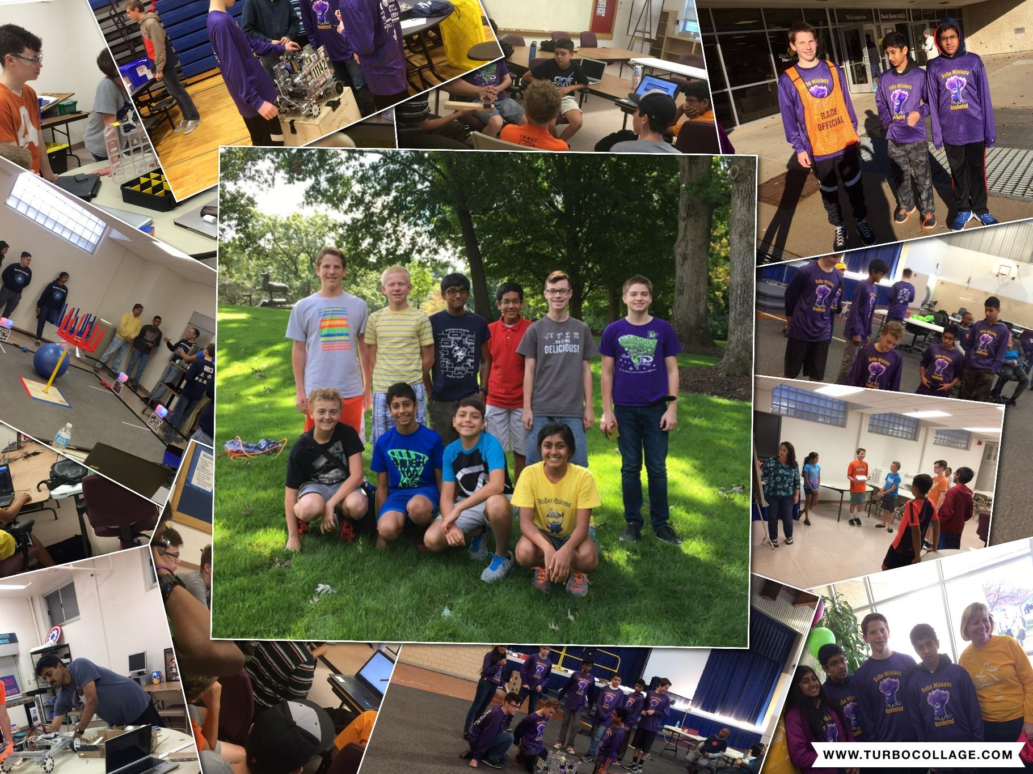

**#11142 RoboMinions Rebooted**

**Engineering Notebook**

**Our Journey through FTC: 2016-17 Velocity Vortex**

Thanks to Our Sponsors

  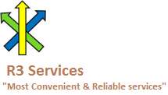    

We are affiliated with



Thanks to our coaches and mentors. Special thanks to our parents.

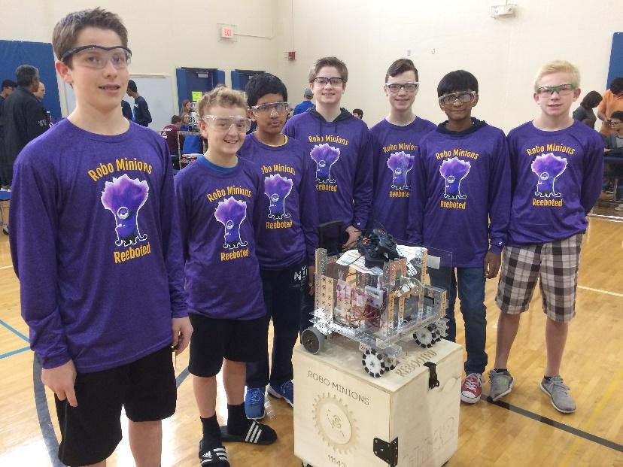

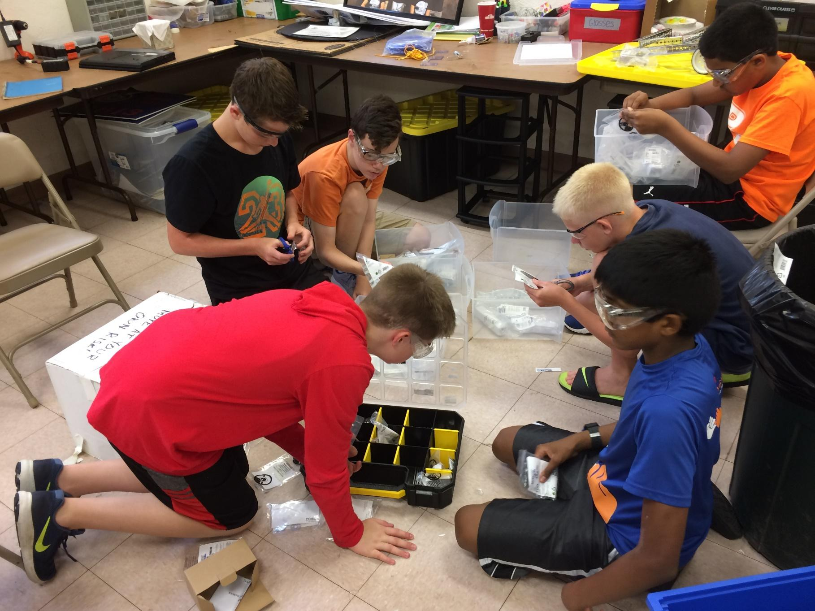



|  |  |  |  |  |  |
| --- | --- | --- | --- | --- | --- |
| [**I**](#_30j0zll) | | [**Summary**](#_30j0zll) | |  | |
| **1** | | [**About Us - The RoboMinions**](#_3znysh7) **. . . . . . . . . . . . . . . . . . . . . . . . . . . . . . . . . . .** | | **12** | |
| **1.1** | | [**Our Story**](#_3znysh7) | | **12** | |
| **1.2** | | [**Our FIRST Journey**](#_3dy6vkm) | | **12** | |
| **1.3** | | [**Season Highlights: Our Timeline**](#_302dr9l) | | **14** | |
| **2** | | [**RoboMinions: Team Members**](#_4d34og8) **. . . . . . . . . . . . . . . . . . . . . . . . . . . . . . . . . .** | | **15** | |
| **2.1** | | [**Max**](#_4d34og8) **Broussalian** | | **15** | |
| **2.2** | | [**Tarun**](#_3rdcrjn) **Vedula** | | **16** | |
| **2.3** | | [**Vishnu**](#_lnxbz9) **Challa** | | **16** | |
| **2.4** | | [**Owen**](#_1ksv4uv) **Devore** | | **16** | |
| **2.5** | | [**Ezra**](#_2jxsxqh) **Lauritzson** | | **17** | |
| **2.6** | | [**Uma**](#_3j2qqm3) **Kasichainula** | | **17** | |
| **2.7** | | [**Nikhil**](#_4i7ojhp) **Ramaraju** | | **17** | |
|  | |  | |  | |
| **2.8** | | [**Jake**](#_1ci93xb) **Gneiting** | | **17** | |
| **2.9** | | [**Kyle**](#_3whwml4) **Shelin** | | **17** | |
| **2.10** | | [**Vinay**](#_49x2ik5) **Joshi** | | **18** | |
| **3** | [**RoboMinions: Team Mentors & Coach**](#_147n2zr) **. . . . . . . . . . . . . . . . . . . . . . . . . .** | | **19** | |
| **3.1** | [**Ram**](#_147n2zr) **Vedula** | | **19** | |
| **3.2** | [**Radhika**](#_ihv636) **Kasichainula** | | **20** | |
| **3.3** | [**Sumukh**](#_1hmsyys) **Bahulekar** | | **20** | |
| **3.4** | **Srilatha Challa** | | **20** | |
| **3.5** | **Jackie Jordon** | | **20** | |
| [**II**](#_vx1227) | [**Engineering Summaries: Pre-Season**](#_vx1227) | |  | |
| **4** | [**Season Kickoff**](#_1v1yuxt) **. . . . . . . . . . . . . . . . . . . . . . . . . . . . . . . . . . . . . . . . . . . . . . . .** | | **20** | |
| **5** | [**Meeting**](#_19c6y18) **#2 . . . . . . . . . . . . . . . . . . . . . . . . . . . . . . . . . . . . . .** | | **23** | |
| **6** | [**Meeting**](#_19c6y18) **#3. . . . . . . . . . . . . . . . . . . . . . . . . . . . . . . .** | | **25** | |
| **7** | [**Meeting**](#_19c6y18) **#4 . . . . . . . . . . . . . . . . . . . . . . . . . . . . . . . . . . . . . . . . . . .** | | **27** | |
| **8** | [**Meeting**](#_19c6y18) **#5 . . . . . . . . . . . . . . . . . . . . . . . . . . . . . . . . . . . . . .** | | **28** | |
| **9** | [**Meeting**](#_19c6y18) **#6. . . . . . . . . . . . . . . . . . . . . . . . . . . . . . . . . . . . . . . . . . . . . . . . . . . .** | | **33** | |
| **10** | [**Meeting**](#_19c6y18) **#7. . . . . . . . . . . . . . . . . . . . . . . . . . . . . . . . .** | | **37** | |
| [**III**](#_2dlolyb) | [**Engineering Summaries: Early Season**](#_2dlolyb) | |  | |
| **11** | [**Kick**](#_1f7o1he) **off . . . . . . . . . . . . . . . . . . . . . . . . . . . . . . . . . . . . . . . . . .** | | **45** | |
| **12** | [**Brainstorm Ideas**](#_3cqmetx) **. . . . . . . . . . . . . . . . . . . . . . . . . . . . . . . . . . . . . . . . . .** | | **48** | |
| **13** | [**Prototype Ideas**](#_3z7bk57) **. . . . . . . . . . . . . . . . . . . . . . . . . . . . . . . . . . . . . . . . . . .** | | **51** | |
| **14** | [**Outreach kickoff**](#_2eclud0) **. . . . . . . . . . . . . . . . . . . . . . . . . . . . . . . . . . . . . . . . . . . . . . . .** | | **52** | |
| **15** | [**Design Team Review**](#_thw4kt) **. . . . . . . . . . . . . . . . . . . . . . . . . . . . . . . . . . . . . . . .** | | **55** | |
| **16** | [**Ball Picker**](#_3dhjn8m) **. . . . . . . . . . . . . . . . . . . . . . . . . . . . . . . . . . . . . . . . . . . . . . .** | | **58** | |
| **17** | [**Catapult**](#_1smtxgf) **. . . . . . . . . . . . . . . . . . . . . . . . . . . . . . . . . . . . . . . . . . . . . . . . . . . .** | | **59** | |

|  |  |  |
| --- | --- | --- |
| **18** | [**Outreach Details**](#_4cmhg48) **. . . . . . . . . . . . . . . . . . . . . . . . . . . . . . . . . . . . . . . . . . . . . . . .** | **61** |
| **19** | [**Things before scrimmage**](#_2rrrqc1) **. . . . . . . . . . . . . . . . . . . . . . . . . . . . . . . . . . . . . . . . . . .** | **62** |
| **20** | [**Preparing for Scrimmage**](#_16x20ju) **. . . . . . . . . . . . . . . . . . . . . . . . . . . . . . . . . . . . . .** | **63** |
| [**IV**](#_1664s55) | [**Engineering Summaries: League Season**](#_1664s55) |  |
| **21** | [**Scrimmage One**](#_3qwpj7n) **. . . . . . . . . . . . . . . . . . . . . . . . . . . . . . . . . . . . . . . .** | **67** |
| **22** | [**Bane Bot Motors**](#_261ztfg) **. . . . . . . . . . . . . . . . . . . . . . . . . . . . . . . . . . . . . . . . . . . .** | **69** |
| **23** | [**Color Sensor testing**](#_l7a3n9) **. . . . . . . . . . . . . . . . . . . . . . . . . . . . . . . . . . . . . .** | **70** |
| **24** | [**Field and perimeter Setup**](#_356xmb2) **. . . . . . . . . . . . . . . . . . . . . . . . . . . . . . . . . . . . . . . . . . . . . . . .** | **71** |
| **25** | [**Ball Shooter**](#_1kc7wiv) **. . . . . . . . . . . . . . . . . . . . . . . . . . . . . . . . . . . . . . . .** | **72** |
| **26** | [**Beacon Pusher**](#_44bvf6o) **. . . . . . . . . . . . . . . . . . . . . . . . . . . . . . . . . . . . . . . . . . . . . . . . .** | **73** |
| **27** | [**Ball lift**](#_2jh5peh)**. . . . . . . . . . . . . . . . . . . . . . . . . . . . . . . . . . . . . .** | **75** |
| **28** | [**Second Scrimmage**](#_ymfzma) **. . . . . . . . . . . . . . . . . . . . . . . . . . . . . . . .** | **76** |
| **29** | [**Scrimmage Analysis**](#_3im3ia3) **. . . . . . . . . . . . . . . . . . . . . . . . . . . . . . . . . .** | **78** |
| **30** | [**Beacon Pusher Changes**](#_1xrdshw) **. . . . . . . . . . . . . . . . . . . . . . . . . . . . . . . . .** | **79** |
| **31** | [**Third Scrimmage**](#_4hr1b5p) **. . . . . . . . . . . . . . . . . . . . . . . . . . . . . . . . . . . . . . . . . . . . . .** | **81** |
| **32** | [**Scrimmage Analysis**](#_3im3ia3) **. . . . . . . . . . . . . . . . . . . . . . . . . . . . . . . . . . . . . . . . . . . . . . . . . . .** | **84** |
| **33** | [**Ball Shooter & Macanum Wheels**](#_2wwbldi) **. . . . . . . . . . . . . . . . . . . . .** | **85** |

|  |  |  |
| --- | --- | --- |
| [**V**](#_25b2l0r) | [**Team Summaries: Pre-Season**](#_25b2l0r) |  |
| **34** | [**Engineering Note book - Online**](#_34g0dwd) **. . . . . . . . . . . . . . . . . . . . . . . . . . . . . . . . . . .** | **94** |
| **35** | [**3D printer overview**](#_1c1lvlb) **. . . . . . . . . . . . . . . . . . . . . . . . . . . . . . . . . . .** | **98** |
| **36** | [**Android programming**](#_3w19e94) **. . . . . . . . . . . . . . . . . . . . . . . . . . . . . . . . . . . . . . . . . . .** | **100** |
| **37** | [**Core Components**](#_2b6jogx) **. . . . . . . . . ……………………………………….. . . . . . . .** | **101** |
| [**VI**](#_43ky6rz) | [**Team Summaries: Early Season**](#_43ky6rz) |  |
| **38** | [**PTC ThingWorx - IOT**](#_xvir7l) **. . . . . . . . . . . . . . . . . . . . . . . . . . . . . . . . . . . . . . . . . . . . . . . . .** | **104** |
| **39** | [**Outreach Guest Talk**](#_qbtyoq) **. . . . . . . . . . . . . . . . . . . . . . . . . . . . . . . . . . . . . . . . . . . . . . .** | **107** |
| **40** | [**FLL Mentoring**](#_3abhhcj) **. . . . . . . . . . . . . . . . . . . . . . . . . . . . . . . . . . . . . . . . . . . . . . . . .** | **109** |
| [**VII**](#_1x0gk37) | [**Team Summaries: League Season**](#_1x0gk37) |  |
| **41** | [**Girls on the Run**](#_2w5ecyt)**. . . . . . . . . . . . . . . . . . . . . . . . . . . . . . . . . . . . . . . . . . . . . . . . . . .** | **114** |
| **42** | **FLL Scrimmage. . . . . . . . . . . . . . . . . . . . . . . . . . . . . . . . . . . . . . . . . . . . . . . . . . . .** | **187** |
| **43** | [**FLL Regionals Volunteering**](#_pkwqa1) **. . . . . . . . . . . . . . . . . . . . . . . . . . . .** | **121** |
| **44** | [**Bake Sale**](#_pkwqa1)**. . . . . . . . . . . . . . . . . . . . . . . . . . . . . . . . . . . . . . .** | **123** |
| [**VIII**](#_1opuj5n) | [**Robot Design Process & Research**](#_1opuj5n) |  |
| **45** | [**Electrical Aspects**](#_2nusc19) **. . . . . . . . . . . . . . . . . . . . . . . . . . . . . . . . . . . . . . . . . . .** | **127** |
| **45.1** | [**Electrical Wiring**](#_37m2jsg) |  |
| **45.2** | [**Encoder Wiring**](#_46r0co2) |  |
| **45.3** | [**USB Connectivity**](#_4k668n3) |  |
| **45.4** | [**Battery Power Options**](#_3mzq4wv) |  |
| **46** | [**Mechanical Aspects**](#_haapch) **. . . . . . . . . . . . . . . . . . . . . . . . . . . . . . . . . . . . . . . . .** | **141** |
| **46.1** | [**Servo Motors**](#_1gf8i83) |  |

#### [Wheels](#_2fk6b3p)

#### [Gears](#_3ep43zb)

#### 46.4 [Screws](#_4du1wux)

#### [Robot Design Process](#_184mhaj) 145

#### 47.1 Process

#### 47.2 [Bill of Material](#_1pgrrkc)

|  |  |  |
| --- | --- | --- |
| [**IX**](#_49gfa85) | [**Programming:**](#_49gfa85) **Autonomous & Teleop** |  |
| **48** | [**Programming Basics**](#_zu0gcz) **. . . . . . . . . . . . . . . . . . . . . . . . . . . . . . . . . . . . . . . . .** | **155** |
| **48.1** | [**Finite State Machine**](#_1yyy98l) |  |
| **48.2** | [**Intelligent Motor Control**](#_2olpkfy) |  |
| **49** | [**Autonomous**](#_2y3w247) **. . . . . . . . . . . . . . . . . . . . . . . . . . . . . . . . . . . . . . . . . . . . . . . .** | **157** |
| **50** | **Control Award . . . . . . . . . . . . . . . . . . . . . . . . . . . . . . . . . . . . . . . . . . . . . . .** | **159** |
| **51** | [**Teleop**](#_2ce457m) **. . . . . . . . . . . . . . . . . . . . . . . . . . . . . . . . . . . . . . . . . . . . . . . . . . . . . .** | **167** |

[**X RoboMinions: Business Plan**](#_3bj1y38)

#### [Executive Summary](#_13qzunr) 171

#### Team

#### [Connections](#_3oy7u29)

#### [Outreach and Services Rendered](#_338fx5o)

#### [Business Analysis](#_42ddq1a)

#### 53 [Financial Statement](#_wnyagw) 180

**54** [**Strategy**](#_1vsw3ci) 184

#### [Team Fundamentals & Conduct](#_2uxtw84)

**55** [**Sustainability**](#_3nqndbk) **187**

#### [Future Plan](#_3u2rp3q)

#### [Expectations](#_odc9jc)

#### [Training](#_1nia2ey)

#### [Member Recruitment](#_2mn7vak)

#### [Mentor Recruitment](#_3ls5o66)

#### [Future Financial Plan](#_4kx3h1s)

[**Index**](#_22vxnjd) **190**

**ISummary**

#### [About Us - The RoboMinions](#_3znysh7)

* 1. [Our Story](#_3znysh7)
  2. [Our FIRST Journey](#_3dy6vkm)
  3. [Season Highlights: Our Timeline](#_302dr9l)

#### [RoboMinions: Team Members](#_4d34og8)

* 1. [Max](#_4d34og8) Broussalian
  2. Tarun Vedula
  3. [Vishnu](#_lnxbz9) Challa
  4. [Owen](#_1ksv4uv) Devore
  5. [Ezra](#_2jxsxqh) Lauritzson
  6. [Uma](#_3j2qqm3) Kasichainula
  7. [Nikhil](#_4i7ojhp) Ramaraju
  8. [Jake Gneiting](#_1ci93xb)
  9. [Vinay](#_49x2ik5) Joshi
  10. [Kyle](#_3whwml4) Sheling

#### [RoboMinions: Team Mentors & Coach](#_147n2zr)

* 1. [Ram](#_147n2zr) Vedula
  2. [Radhika](#_ihv636) Kasichainula
  3. [Sumukh](#_1hmsyys) Bahulekar
  4. Challa Srilatha
  5. Jackie Jordon

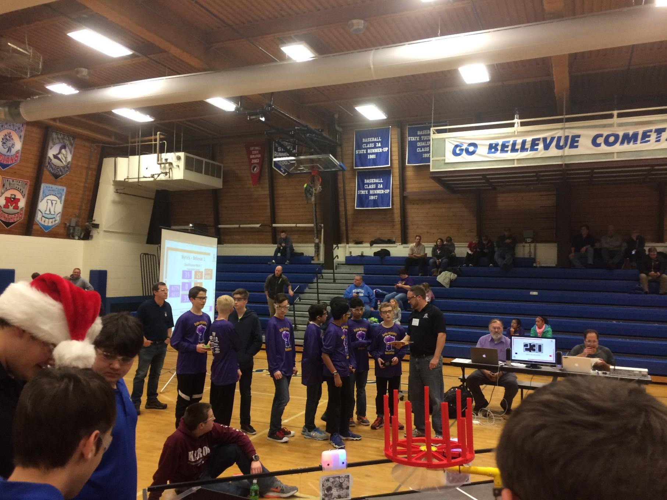

**Our Story**

Team #11142 RoboMinions Rebooted is a rookie FTC Team consisting of ten students in grades 6 through 8 and is a neighborhood team located in Bettendorf, IA. All middle schoolers, have participated in FLL for the past two to three years, and have moved onto FTC this year. This year’s challenge, Velocity Vertex, has pushed the Minions to explore more about science, technology, engineering, and mathematics (STEM).

This season, the RoboMinions started with a few training sessions with FTC Team 8813, the Winter Soldiers. The highly-experienced team of high schoolers showed the Minions the basic building skills they needed in order to make a functioning robot.

**Our FIRST Journey**

We have been involved in the FIRST programs for several years now. Many members have participated in Jr. FLL and almost all continued into FLL and now FTC. We participated in the World Class and Trash Trek seasons. We advanced to the State Competition twice and received two awards for Core Values and Project Research, while receiving the Champion’s Award twice at the regional competition.

We formed this team because our local junior high did not participate in FTC, and only participated in FLL. Through the help of sponsors, coaches, and mentors, we were able to use the ALCOA Learning Center for our team meetings, and buy the necessary items for our participation in the 2016-2017 season. We immersed ourselves in the world of FTC, and bonded during our work in our Programming, Design, and Outreach micro-teams. We will not stop in creating a better world of young ones partaking in STEM. We strive as such and seek sponsorship so we can bring our efforts to a global perspective. We are represented through QCESC, a nonprofit organization which inspires young students to partake in STEM. Only in its first year, we already mentored two other FLL teams and has put up an after-school coding class. One of our mentored FLL teams, Team 25580 “Furry Logic” is advancing to the State tournament. We are proud to work with a program of such determined people whom hold the same vision as them of a world run by young students in STEM.

As a rookie FTC team we are still adjusting to the different technology but are enjoying the new experience all the same! Even though we have ran into many issues with the new technology, such as pairing issues and unplanned restarts, we have managed to debug the problems so they do not happen in the future. The Minions are excited about this year’s challenge, FIRST Velocity Vortex, and also discovering more about the new Android platform.

What sets us apart is our great commitment and dedication toward FIRST. In fact we meet nearly every single day and began meeting and planning months before the season began and went straight to meeting once Kickoff had happened.

We leave no rock left unturned in their journey of achieving the most out of FIRST and STEM. One of the main strengths in the team is our ability to break off into specialty groups and concentrate to become an expert in that aspect. Be it robot building, programming, engineering notebook, we  know themselves better than anyone else and are able to instinctively know their strengths and through teamwork, are able to put together all their expertise into FTC.

Sponsors have also been no problem for these Minions. We have over ten sponsors, ranging from John Deere, Alcoa, PTC, ColoHub, R3 Services, Cobham, QCESC, Icon Charities, Mid-American Energy, Axiom 3D, Yash Technologies are proud to represent the RoboMinions.



We have created a timeline which highlights our main events this FTC year.

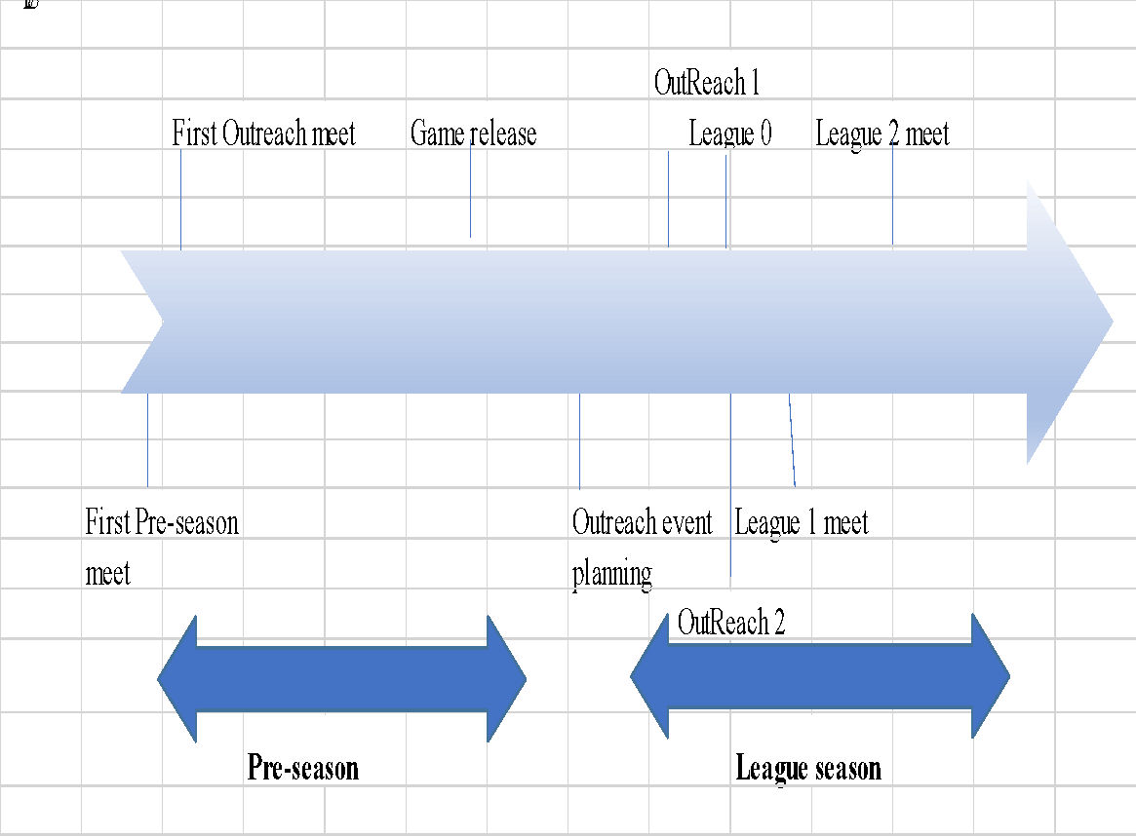

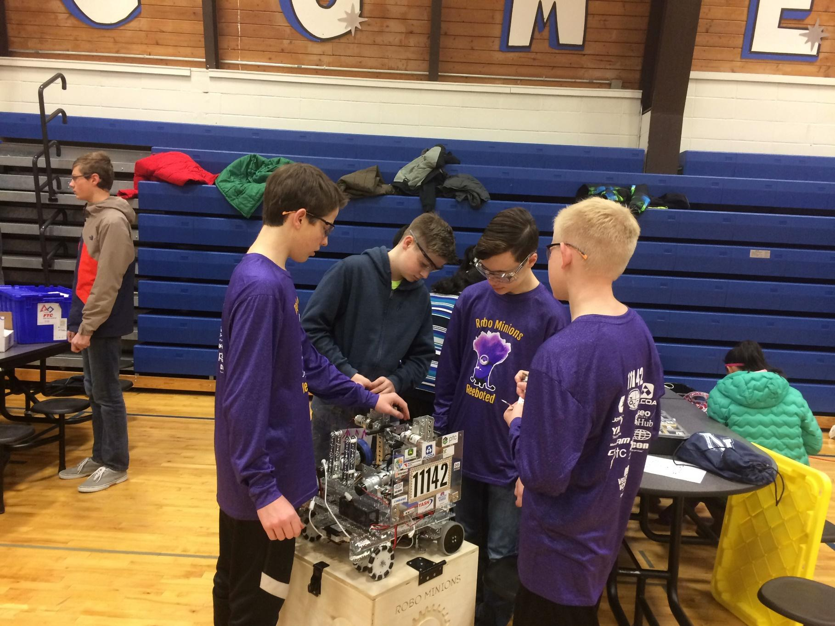

**Max Broussalian**

My name is Max Broussalian, I am 13 years old. I was born in Atlanta, Georgia then I moved to Switzerland followed by Seattle then to Nice, France and now in Iowa as an 8th grader in Pleasant Valley Junior High. School has been different for me, I am bilingual and meeting new people has always been a struggle. To adapt, I would play video games, minecraft and other strategy games. When I was about nine years old I thought to myself wouldn’t it be cool if I could be a computer designer / engineer, so being me I started to go on youtube 3 to 4 times a week and I would look up “How to \_\_\_\_” whether it was “How to make a game.” Or “How to code.” I would always be fascinated whatever it was. However each time I looked something up it always went wrong, the program or the video, or even a lack of tutorials; I was not done I really wanted to follow this passion so I took online courses about java, once I was done with one of them I would go to another and another and another but each time I felt like I wasn’t improving. When we moved back to America, I heard about “Robotics.” This was all very new to me, my mom explained it to me “It is a computer class sorta thing, you should give it a try.” So I tried, I was put on a waitlist for 2 years at PV Elementary. Finally, in 6th grade, I was cleared to try a semester. It was very fun I liked it but there was one thing about it that kept bugging me everyday, I thought it was too simple almost like a second grader could do what we were doing, until I heard of FTC Robotics. There was no real way of getting into that kind of club I thought to myself, So I waited about 2 more years, and in the middle of Summer it was brought up by a friend of mine (Kyle Sehlin) that I should join his robotics team FTC 11142 “The RoboMinions”, so with a bit of work I was in, and that's just a little 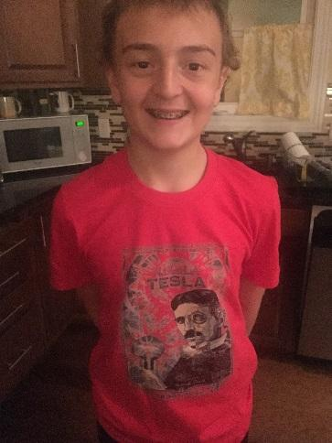

about to where I am today. I also play Saxophone and keyboard. I usually compose my own songs. In the future I would like to have a computer programming or NSA job as a career. I plan to attend the Def Con Hacking conference in Vegas next Summer with my dad.

**Tarun Vedula**

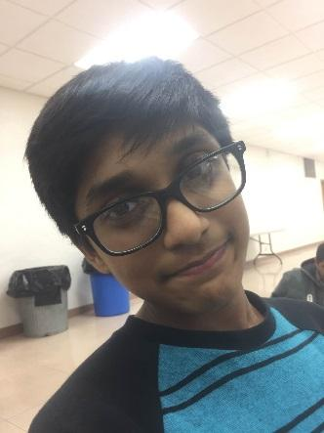

My name is Tarun Vedula and I’m 12 years old. I'm in seventh grade and attend Pleasant Valley Junior High. Some of my hobbies include playing the piano and practicing the oboe. I also like to play outside and go biking. When I grow up I want to be a aeronautical engineer at NASA. I think FTC will help me by teaching me how to communicate better. I have done FLL for 2 years and this is my first year of FTC. I joined FTC so that I improve my public speaking skills. I like to do robotics because it gives me a chance to work with my friends and have fun while learning things at the same time. My main focus in FTC is Outreach but I would also like to learn some stuff about programming.

**Vishnu Challa**

My name is Vishnu Challa and I am 12 years. I am a 7th grader at Pleasant Valley Junior High. I have always loved FIRST. I have participated in FLL for 2 years and this is my 1st year in FTC.The thing that is most exciting to me in FTC is Design and Programming, especially Programming.This because I want to be a computer engineer and Programming is a really big thing in that career. Things I like to do outside of FTC is play Minecraft. I also like to play outside of my house with my friends. Another I like to, that is relevant to Programming, is that me and my mom do python classes together, she's a software architect.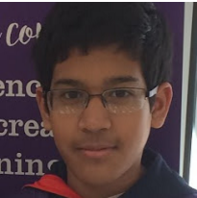

**Owen Devore**

I am Owen DeVore, I am 12 years old. I lives in davenport until I was 5 and then I moved to Bettendorf I am currently in 7th grade at Pleasant Valley Junior High. I want to become an engineer as my job. I enjoy reading and solving rubik's cubes. since I've always been interested in robots I thought I'd try FLL in 6th grade and I enjoyed it so I decided to step up and do FTC. Ezra's family found out about this team and asked if I wanted to join with Ezra.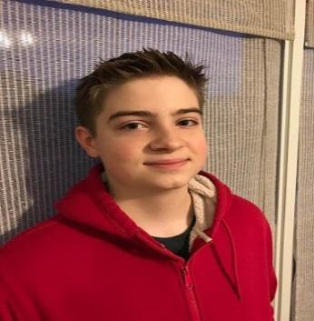

## 

**Ezra Lauritzson**

My name is Ezra Lauritzson. I'm in 7th grade at pleasant valley junior high. My hobbies consist of cubing, robotics, cello, Legos, karate, eating, games, and reading. (Reading is an extreme sport. I fell off my bed and had to get staples in my head. Ouch!) I don't have any FLL experience but I have had a lot of other robotics experience. I've done mindstorms at the library, at the summer camp, the after school robotics club in 6th grade (basic and advanced), and at my friend's house. I also read "Jin Sato's Lego Book of Mindstorms" which had a lot of info on C programming. I am on the design team for this FTC season and if I learn java by next season I want to be on the programming team. I also want to do FRC in high school and eventually get a job in robotics that I love.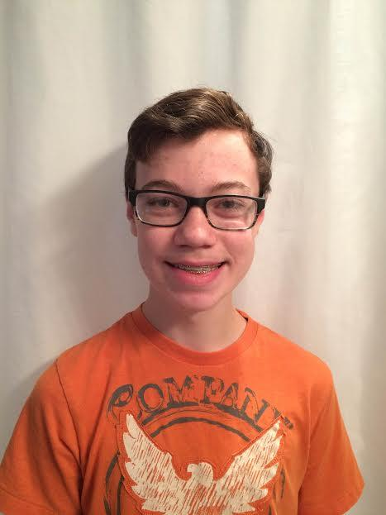

## 

**Uma Kasichainula**

My name is Uma Kasichainula. I’m in 8th grade, and I’m 13 years old. I play the violin, and I participate in the Quad City Youth Philharmonic Orchestra. I also take classical dance lessons. My favorite subject in school is science, and I hope to become a doctor. This is my first time doing FTC. I’ve done FLL for two seasons, once on the Hopewell Pancakes, and once on the RoboMinions. Since I hope to get a career in a STEM-based area, I believe FTC will help me to do this. I’m very excited to start the FTC season.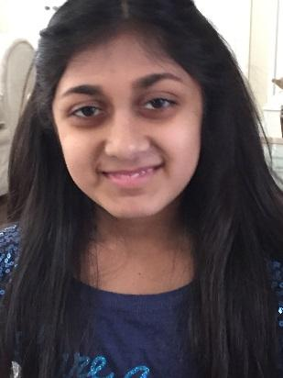

**Nikhil Ramaraju**

Nikhil Ramaraju is in 6th grade at Riverdale Heights in Bettendorf, Iowa. Prior to FTC, Nikhil had 2 years of FLL experience. His part in FTC is outreach and programming. He is looking forward to learning JAVA and learning the ropes with real life experiences as part of the outreach. He is involved in extracurricular activities including piano for more than 6 years and cello for the past 2 years as part of the Quad City Youth Symphony Orchestra. Nikhil enjoys being active by playing basketball, biking, and exploring in the woods. Finally, Nikhil loves to garden in his backyard and at his grandparents farm. 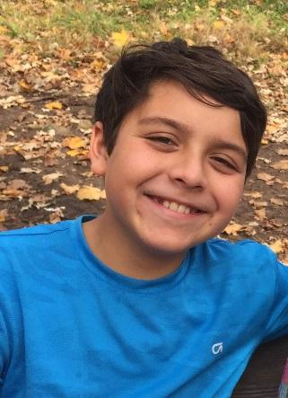

**Vinay Joshi**

My name is Vinay Joshi, I am 12 years old and in seventh grade at Pleasant Valley Junior High. I have participated in First Lego League for the past two years. This will be my first time doing FTC. My main focus within FTC is design and programming. Outside of FTC my hobbies include: reading, building Lego sets, programming, technology, tennis and playing video games. In my leisure time, I make videos. About once every month, I invite my friends over and we make comedy videos about anything from socks to annoying your siblings. I also play lots of ping-pong with my brother. I play almost every day and I think that I am pretty good at it. Sometimes I combine my hobbies of video-making and ping-pong by making slow motion videos of my brother and I playing ping-pong.   I also participate in music, I play percussion in band and viola in orchestra. When I grow up I want to be a software engineer. I believe that FTC will be beneficial for me because I will get to learn programming in Java.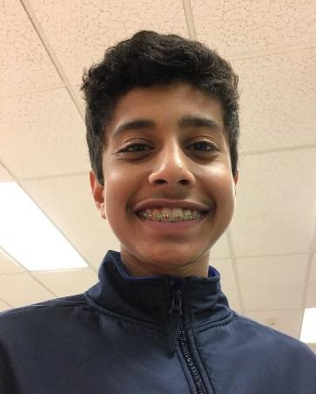

**Jake Gneiting**

I am Jake Gneiting I am 13 years old and I go to school at pvjh. I play the ufonium which is like a small tuba. I like to play outside, play with Legos and like to camp.When I am older I want to be a robotics engineer at John Deere. I am in the building and designing part for FTC. I have done FLL 1 year and I am doing another year of it as well as FTC and I think that FTC is going to help me get into the colleges that do robotics.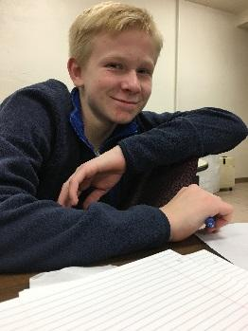

**Kyle Sehlin**

.

My name is Kyle Sehlin. I am fourteen years old and an eighth grader at Pleasant Valley Junior High. This is my first year in FTC but I have participated in FLL for two years. My main focus in FTC is robot design. I enjoy playing baseball for the Barnstormer Crush. I am a shortstop and second baseman for the Crush. When I grow up I want to be an automotive engineer. These FIRST experiences are helping me achieve my goal by teaching me basic engineering skills.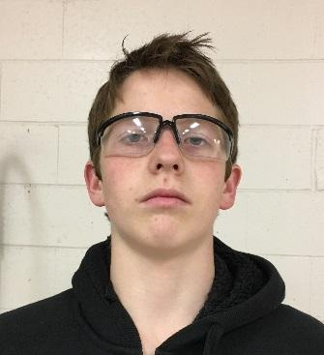

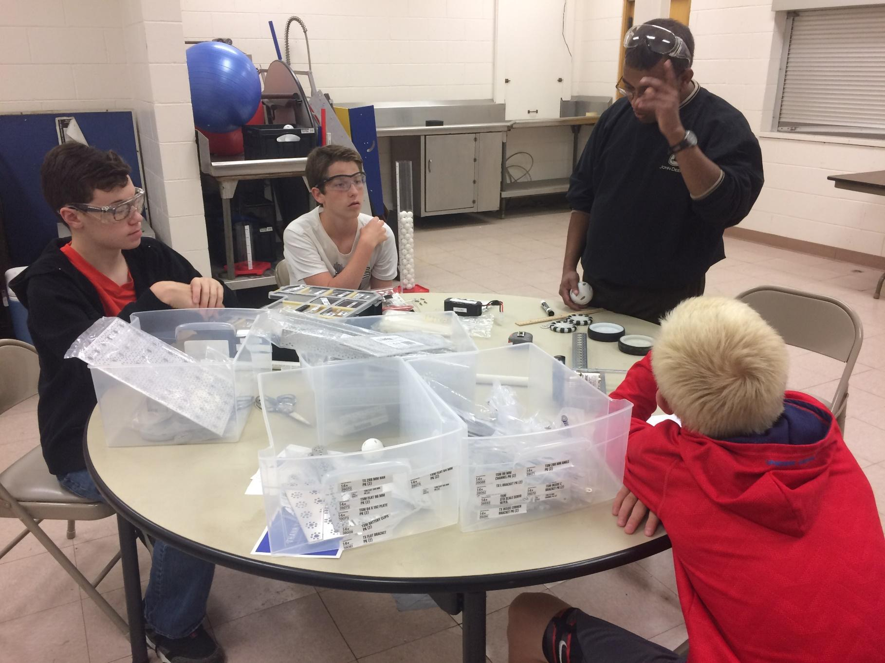

**Ram Vedula (Coach)**

Hello, my name is RamaGopal Vedula. I am a technology enthusiast and have been working for John Deere from past 14 years. I started FTC team 11142 this year in order to inspiring the next generations of girls and boys to become interested in STEM as future career. By the end of our season I hope the students learn aspects of Programming and Design. I have been volunteering for First programs for last seven years and have participated in all roles in FLL and FTC competitions. During 2014-15 season I founded and Coached the RoboMinions FLL team, who later went on to win the Regional Champion Award and participate in the State Competition. In my free time I enjoy maintaining my garden and watching sports. I am a Cricket enthusiast and daily follow the games going around the world. Throughout the year I volunteer for Friends of India, Quad Cities, and QC Hindu temple.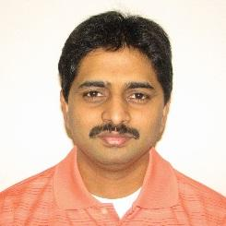

**Radhika Kasichainula (Coach)**

I work for John Deere as a project manager in IT. I am a mechanical engineer by education and got my graduate degree from University of Iowa (Go Hawks!). Before coming to the US. I studied Industrial Production engineering in India. Although, I stumbled into engineering, I found it be a very interesting field and an excellent academic path which gave me a lot of career opportunities for learning while having fun. I am also the proud mother of two girls who keep me busy and challenged. In my free time I enjoy watching movies, reading books, traveling, volunteering and spending time with family and friends. Volunteering for STEM and FIRST as a coach is something that I took up 3 years ago and it has been an excellent experience working with kids on Jr. FLL, FLL and now FTC teams. 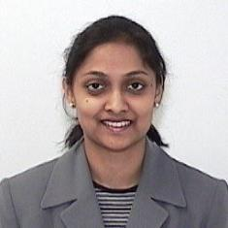

**Sumukh Bahulekar (Engineering Design Mentor)**

I like to solve problems. I am Mechanical engineer by education and profession. I work at John Deere as quality engineering supervisor and I am proud to be part of this great organization. My past experience is in mechanical design, project management and teaching. I also enjoy sports and specially enjoy playing cricket and table tennis. I am excited to be part of this team as I learn a lot during the process of building robot.

**Srilatha Challa (Android Programming Mentor)**

I work for John Deere as a Technology Architect. I hold a Master’s degree in Computer Science. I have two boys of age 12 and 10. For me, USFIRST experience started last year when my elder son participated in FLL. I got very excited during the FLL Regional Tournament and, that’s when the Robotics bug bit me hard. Today, I am a coach of a ROOKIE FLL team and Programming mentor of FTC team. When working with others, I am typically a quiet, analytical, loyal and behind the scenes worker-bee. In my free time I love listening to music, enjoy cooking, and spending time with family and friends

**Jackie Jordon (Outreach Mentor)**

Jackie is a lifelong advocate of empowering children to confidently pursue their dreams and challenge the status quo. She has spent the last 20 years of her professional life in the corporate sector with an emphasis in technology. Jackie is passionate about developing and recruiting talent. Over the course of her career, she has been a corporate IT recruiter at Augustana College and the University of Illinois while participating as a mentor to the Women in Computer Science. Over the last 7 years, Jackie has been a co-leader to a Girl Scout troop at Riverdale Heights in Bettendorf, IA. Jackie has been an FLL coach for the last 2 years for a team of 4th and 5th grade students. More recently, Jackie has been serving on the board of “Girls on The Run Quad Cities” and has volunteered as an FTC outreach mentor for the RoboMinions team. Jackie holds a bachelor’s degree in MIS and a minor in English from Loras College. She lives in Bettendorf, Iowa with her husband and 12 year old twins. 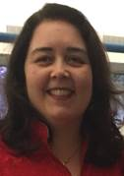



# Engineering Summaries:

**Pre-Season**

#### [Season kickoff](#_1v1yuxt) 20

#### [Meeting](#_19c6y18) 2# 23

[**Meeting**](#_28h4qwu) **3#** 25

#### [Meeting](#_i17xr6) 4# 27

#### [Meeting](#_320vgez) 5# 28

#### [Meeting](#_1egqt2p) 6# 33

#### [Meeting](#_1h65qms) 7# 37

#### 

**Season Kick Off**

**Meeting Date:** Fri, 06/24/2016, 5:00 PM - 6:00 PM

**Personnel Present:** Vishnu, Uma, Tarun, Kyle, Jake

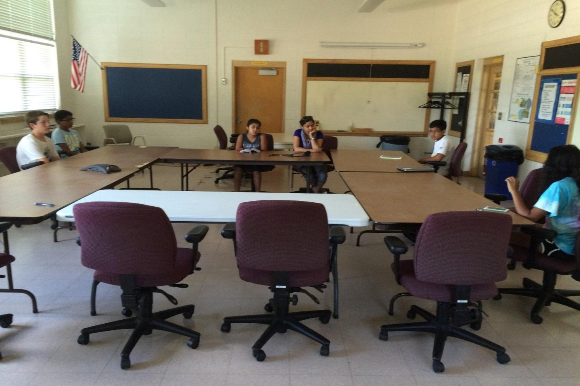

**Tasks This Meeting:**

* Overview of FTC program from Team # 8813
* Recruit more members
* Work on funding and fundraisers

**Reflections:**

We kicked off the season with an Overview from our senior Team (#8813) member Ramya Banda.

* Ramya Banda from Team # 8813 gave an overview of following:
* Overview of FTC
* Engineering Notebook
* Business Plan
* Outreach Activities
* Fundraising
* Robot Design/Programming

At the meeting we discussed the vague plan for this year, like roles and responsibility- ties. Each team member will need to spend at least an hour each day and we plan to divide the team into smaller sub-teams. Everyone will get a chance to try everything but they may belong to a sub team such as ’programming’ or ’design’, etc, based on their skills and interests. We also planned ideas for fundraisers and outreach events. We already have one sponsor, John Deere and we need to reach out for more.

There is a lot to do but now we have a good idea where to start! Since we are a rookie team this year we started off by researching the main components of the FTC tournament.

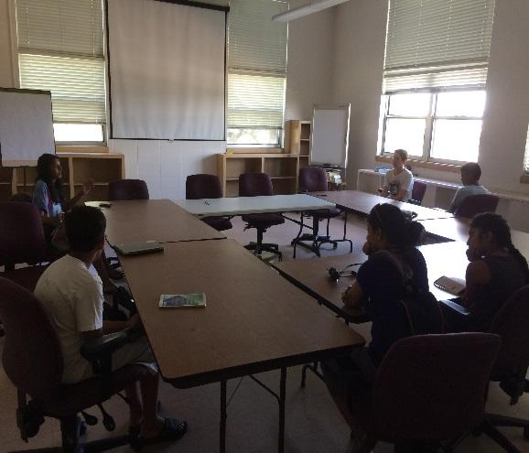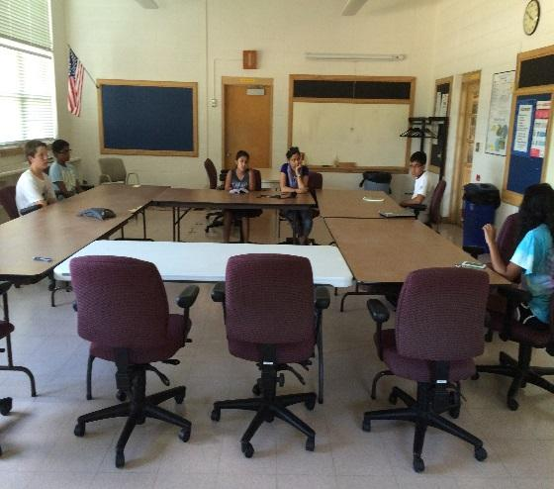

**Submitted By Uma**

**Meeting 2**

**Meeting Date:** Fri, 07/08/2016, 6:00 PM - 7:00 PM

**Personnel Present:** Vishnu, Uma, Tarun, Kyle

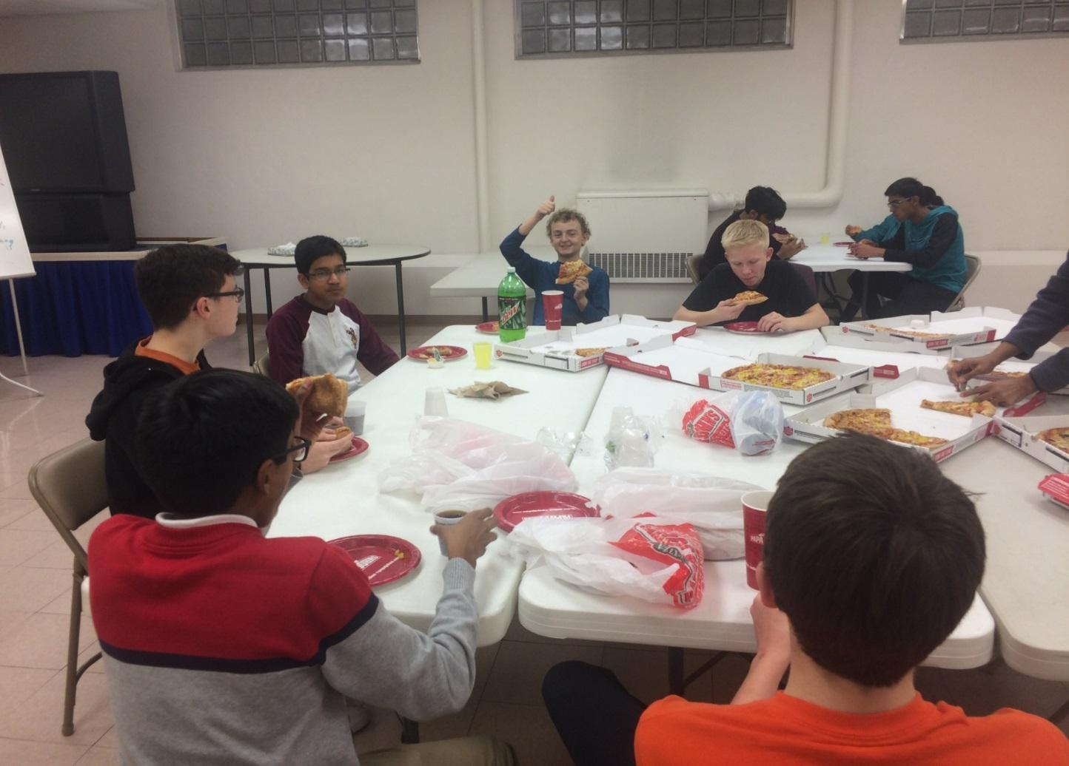

**Tasks This Meeting:**

*Team Details:*

* Team Registration has been completed
* Team #11142
* Team Name = RoboMinions
* Team Communication Discussion.
* Created a timeline of what to complete before school starts.

*Fundraising:*

* Where to start our fundraising
* Goal for fundraising is $1,500 before August 23 (when school starts)
* Team Name Changes (If any)
* Communication (GroupMe, WhatsApp, Twitter, etc.)
* Individual-Bios(Due July 1)
* Order FTC parts online

*Next Week:*

* Budget Discussion and Fundraising Ideas
* Outreach Activities
* Templates for Business Plan and Engineering Notebook
* Team Member Roles

**Reflections:**

Our coach informed that the team has registered and John Deere Grant has been approved and parts order has been placed. Our Team number is #11142 and he put the team name same as our FLL team RoboMinions 2. Since we are doing FTC he taught to upgrade Minions to one more version 2.0. Then he informed we can change the team name if needed and gave two weeks’ time to discuss the name change.

Also we discussed on the communication how to communicate with the team members as we used email during FLL. The problem with email is not everyone checks their email every day. This was a to-do by next week to come up with options. The next topic we talked is about fundraising. Funds play an important role in FTC and we decided to start the fundraising immediately and put a goal of $1500/- before school start on August 23. Lastly we talked about the Engineering note book importance and how we should document our meetings.

**Submitted By Tarun**

**Meeting 3#**

**Meeting Date**: Fri, 07/15/2016, 5:00 PM -6:00 PM

**Personnel Present:** Vishnu, Uma, Tarun, Kyle, Vinay, Ezra, Owen 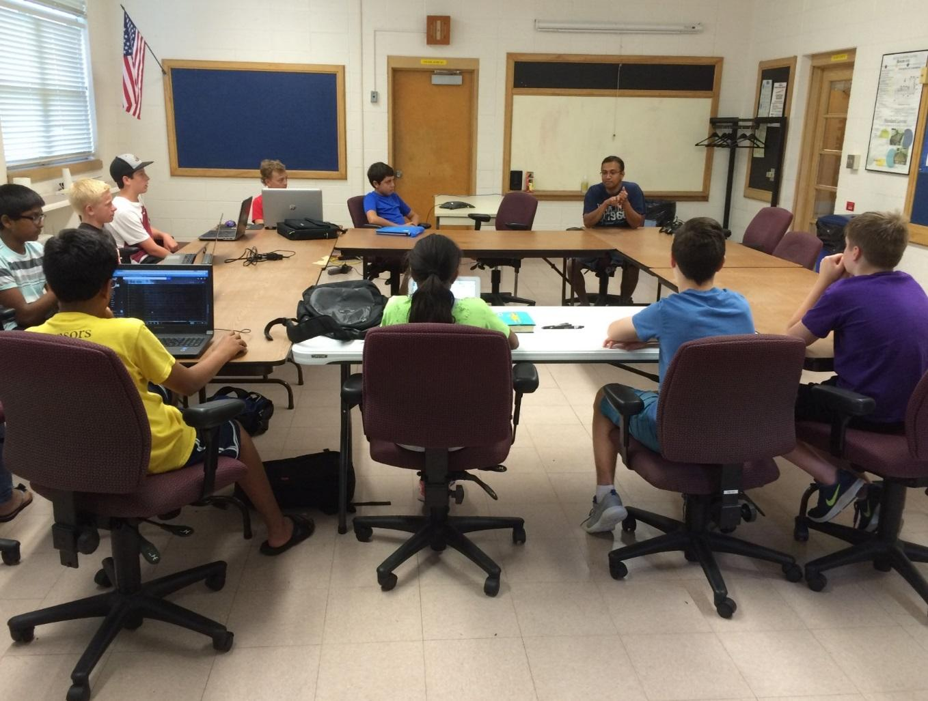

**Tasks This Meeting:**

* Meet the team
* The team discuss about Funds and how to do fund raising Brainstormed ideas on how to raise $1500.
* Finish Bios by next meeting
* Sponsorship and volunteer match-ups

**Reflections:**

This Two new people join the team ( Ezra and Owen).This is Ezra’s first time participating in FIRST activities. Owen has had previous experience with FLL in a neighborhood team

The coach, Ram, gives both new members a brief intro to FTC. Tarun, Kyle, Uma, Vinay,

and Vishnu all discuss the tasks from last meeting. Team discussed on communication among team members. (Apps vs Email). We decided to use Google hangout to communicate as everyone has email and some people do not have cell phones.

Where all of our money will go:

$1,488 grant from John Deere

We spent $1,364

$580- Tetrix kit

$316- Electronics set

$318- Control set

$275- Registration

We have $124 left.

Next week we will be meeting our Design Mentor.

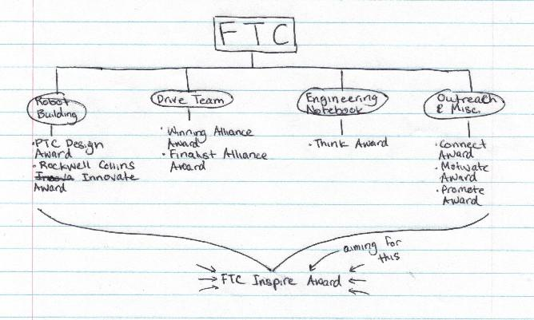

**Submitted By Vishnu**

**Meeting 4 #**

**Meeting Date:** Fri, 07/222016, 5:00 PM -6:00 PM

**Personnel Present:** Vishnu, Uma, Tarun, Kyle, Vinay, Ezra, Owen, Nikhil, Max

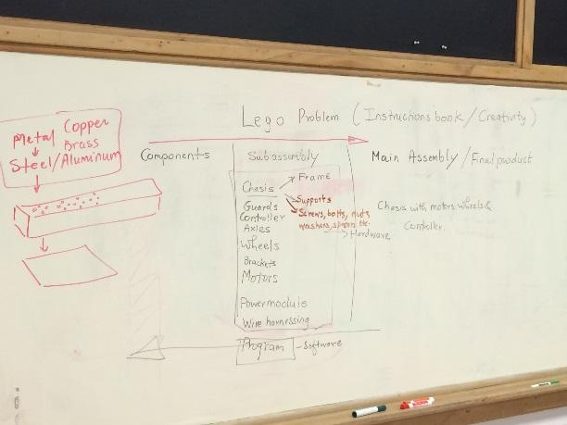

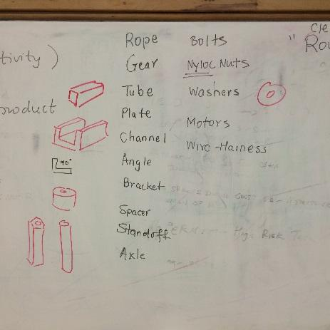

**Tasks This Meeting:**

* Max and Nikhil joined the team.
* Fund raising ideas.
* Sumukh Bahulekar design mentor gave an overview of
* Parts, PTC Creo.

**Reflections:**

This Two new people join the team (Max and Nikhil).We had Mr. Sumukh come and teach us about Robot Design and PTC Creo Parametric. Components and Sub-Assembly for FTC Robot. Used the FTC Robot of Team #8813 Winter Soldiers

Learned some Engineering Vocabulary.

Gear, Rope, Tube, Plate, Channel, Angle, Bracket, Spacer, Standoff, Axle, Bolts, Nyloc Nuts, Washers, Motors, Wire-Harness, Pulley, Lexan

Discussed the importance of Creo Parametric.

**Submitted By Ezra**

**Meeting 5 #**

**Meeting Date:** Fri, 07/29/2016, 5:00 PM -6:00 PM

**Personnel Present:** Vishnu, Uma, Tarun, Kyle, Vinay, Ezra, Owen, Nikhil, Max

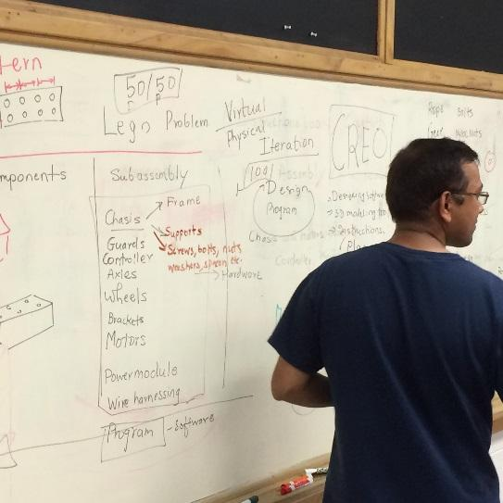 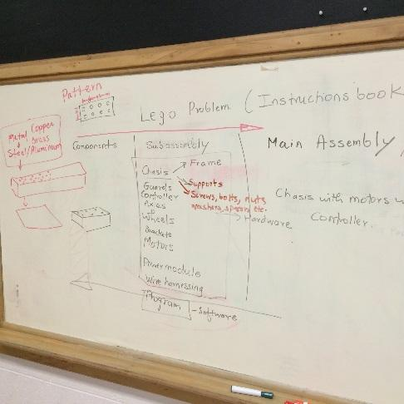

**Tasks This Meeting:**

* PTC Creo hands on
* Business sponsorship document review.

**Reflections:**

Our design mentor Sumukh showed us how to create Creo models hands on. He has shown us the dimensions on Creo and all the view models. He explained what a constraints it and how to fully constraint a model. All the team members downloaded Creo from PTC website and started working on sample. Lot of the team members felt that it’s very difficult as there are several views and the model keeps shrinking the size when we move the mouse here and there. Our Coach had sent some youtube videos so that we can watch and learn Creo models.

During this meeting we reviewed the initial Sponsorship document which we want to send to all the sponsors and corrected some wording. Out next goal is to start sending this document to all the potential sponsors and meet them personally to explain about STEM and FTC.

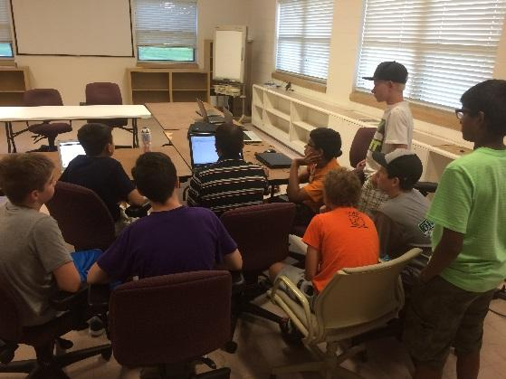 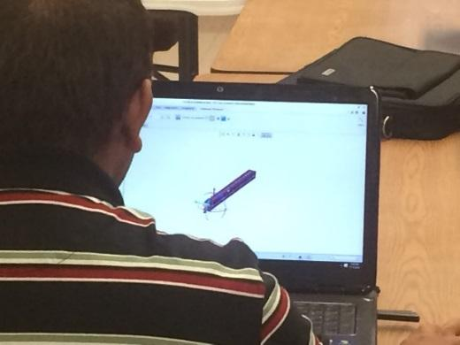

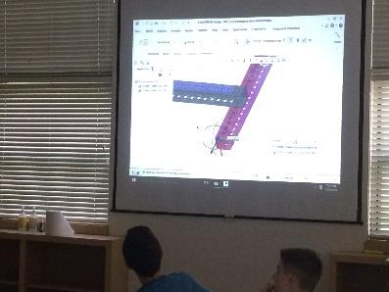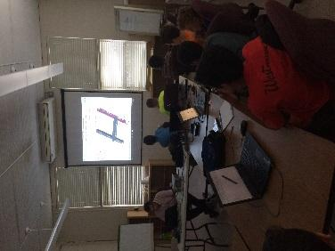

**Sponsorship Letter**

Who are we?

We are a group of 10 students from the Pleasant Valley school district, who are excited to be a part of a new FTC team. FTC stands for FIRST Tech Challenge. FIRST Tech Challenge is a competition started by FIRST, an organization dedicated to engaging kids in hands-on learning, while inspiring a love of Science, Engineering, Technology, and Mathematics, or STEM. This is our first year in FTC, and we are learning the ropes of the FIRST Tech Challenge. In order to participate in the FTC competition, our team needs funding from sponsors. We believe that your company would make a great partner, and would benefit from sponsoring our team during the 2016-2017 season.

Why should you sponsor us?

You will support STEM learning and help teach kids about professional skills needed in the workforce.

FTC competitions consist of building a robot, known as the Robot Game, and communicating the importance of programming and FIRST competitions to the public, known as the Outreach.

The organization also intends to teach skills that children will need when they start working. These include abilities like:

Self-confidence

Communication

Leadership

The money you provide us with will be used to buy necessary items for our team, including, but not limited to:

Tools

Robot parts

T-shirts

Souvenirs

You will get free marketing!

All sponsors will be mentioned on our web page, no matter the amount of money you contribute

Advertisements are also available on our robot, pit banner, and t-shirts

In summary, your sponsorship will fund a love of learning and STEM, while encouraging young talent, and helping the community.

Sponsorship Levels

|  |  |  |
| --- | --- | --- |
|  |  |  |
| Bob_minions_2015.png | $100-250 (Bronze) | Thank you letter at season end  Ad on webpage |
| Unknown | $250 - $500 (Silver) | Ad on our webpage  Thank you letter at season end  Medium-sized advertisement on our team t-shirt |
| gru.jpg | $500 + (Gold) | Ad on our webpage  Large advertisement on our team t-shirt  On our robot  On banner in our pits at competitions  Thank you letter at season end |

**Estimated Budget**

|  |  |  |  |
| --- | --- | --- | --- |
| Item | Budget Amount | Category | Rationale/Explanation |
| Registration | 275.00 | Registration | FTC registration fee (required). |
| Kit of Parts: Competition Set | 600.00 | Robot Supplies | Rookie teams will need to start with either a TETRIX or MATRIX kit. |
| Kit of Parts: Control & Communication Set 2 | 300.00 | Robot Supplies | For 2016, teams will need to purchase materials for the New FTC Technology, primarily phones and adapters for events. |
|  |  |  |  |
|  |  |  |  |
| Kit of Parts: Electronics Modules & Sensors Set | 400.00 | Robot Supplies | Teams can choose to add modules, sensors, or other supplies to their kit. |
| Tools | 200.00 | Robot Supplies | Rookie teams will likely need to invest in purchasing some basic, essential tools. |
| Mat & Fence | 1000.00 | Game Setup | Mats and fence round the mat for the game setup. |
| Misc. Parts & Supplies | 400.00 | Robot Supplies | Needs arise for parts, etc, so budget accordingly so you have the money. |
| Team T-Shirts | 150.00 | Team Supplies | To promote the team and show spirit. |
| Team Buttons | 60.00 | Team Supplies | To promote the team and raise funds. |
| Pit Display | 50.00 | Team Supplies | To promote the team at events. |
| Printing | 100.00 | Team Supplies | The team will likely incur printing costs (paper, ink), so plan for it in the budget. |
| Qualifying Tournament Registration | 75.00 | Registration | Event registration fees vary by region. |
| Gas | 100.00 | Travel | Getting the team and the robot to the event often takes a bus. |
| Food | 200.00 | Travel | Feed the team at meetings and/or events. |
| Sub-Total | 3710.00 |  | Projected total expenses for the season. Actual Costs may be lower/higher, but it’s best to plan high. |

**Sponsorship Information**

(Please print or type so we can accurately include your information)

Business Name: \_\_\_\_\_\_\_\_\_\_\_\_\_\_\_\_\_\_\_\_\_\_\_\_\_\_\_\_\_\_\_\_\_\_\_\_\_\_\_\_\_\_\_\_\_\_\_\_\_\_\_\_\_\_\_\_

Contact Person: \_\_\_\_\_\_\_\_\_\_\_\_\_\_\_\_\_\_\_\_\_\_\_\_\_\_\_\_\_\_\_\_\_\_\_\_\_\_\_\_\_\_\_\_\_\_\_\_\_\_\_\_\_\_\_\_

Address: \_\_\_\_\_\_\_\_\_\_\_\_\_\_\_\_\_\_\_\_\_\_\_\_\_\_\_\_\_\_\_\_\_\_\_\_\_\_\_\_\_\_\_\_\_\_\_\_\_\_\_\_\_\_\_\_\_\_\_\_\_\_

City: \_\_\_\_\_\_\_\_\_\_\_\_\_\_\_\_\_\_\_\_\_\_\_\_\_\_\_\_ State: \_\_\_\_\_\_\_\_\_\_ Zip Code: \_\_\_\_\_\_\_\_\_\_\_\_\_

Phone: (\_\_\_\_\_\_) \_\_\_\_\_\_\_\_\_\_\_\_\_\_\_\_\_\_\_\_\_\_\_ Email: \_\_\_\_\_\_\_\_\_\_\_\_\_\_\_\_\_\_\_\_\_\_\_\_

Business Website: \_\_\_\_\_\_\_\_\_\_\_\_\_\_\_\_\_\_\_\_\_\_\_\_\_\_\_\_\_\_\_\_\_\_\_\_\_\_\_\_\_\_\_\_\_\_\_\_\_\_\_\_\_\_\_

Please make checks payable to: QCESC(Quad City Science & Engineering Council)

(in memo write Robot Minions 2.0)

Give checks to your student contact, or mail to:

QCESC

Attn: RoboMinions

PO BOX 1166

Bettendorf, IA 52722

QCESC,which is a registered 501(c)(3) non-profit, charitable organization.All donations are tax-deductible.

Student Contact: \_\_\_\_\_\_\_\_\_\_\_\_\_\_\_\_\_\_\_\_\_\_\_\_\_\_\_\_\_\_\_\_\_\_\_\_\_\_\_\_\_\_\_\_\_\_\_\_\_\_\_\_\_\_\_\_\_\_

Amount Donated: $\_\_\_\_\_\_\_\_\_\_\_\_\_\_\_\_\_\_\_ Check # \_\_\_\_\_\_\_\_\_\_\_\_\_ Cash \_\_\_\_\_\_\_\_\_\_\_

**Thank you for your support!**

**Submitted By Kyle**

**Electrical Aspects**

#### 45.1 Electrical Wiring

We are connecting the 12 volt battery directly to the Core Power Distribution Module via Tamia. This module then distributes the power to the other modules with Anderson power pole connectors and a micro USB. Each controller/module can connect to multiple things. For example the Core Motor Controller can connect with up to two motors while the Core Servo Controller has access to maximum six servos. We have found that it’s the best practice to plug in one of the modules to the Core Power Distribution Module at port zero. Also connecting the Core Servo Module at port one. After multiple tests of the Electrical Wiring and the configuration system we have confirmed that with a low battery the phone does not detect all the modules, so it’s best to keep a good level of charge.

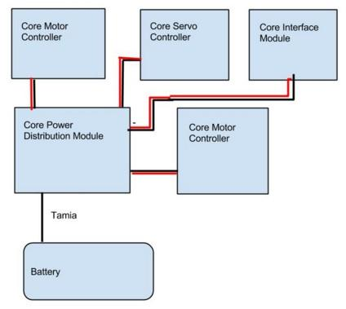

A simplified diagram of the modules connected.

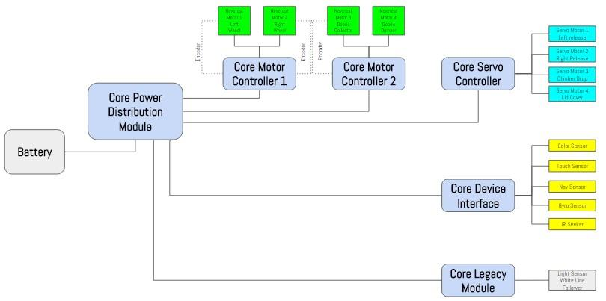

A more detailed diagram of the modules and other input and output functional parts.

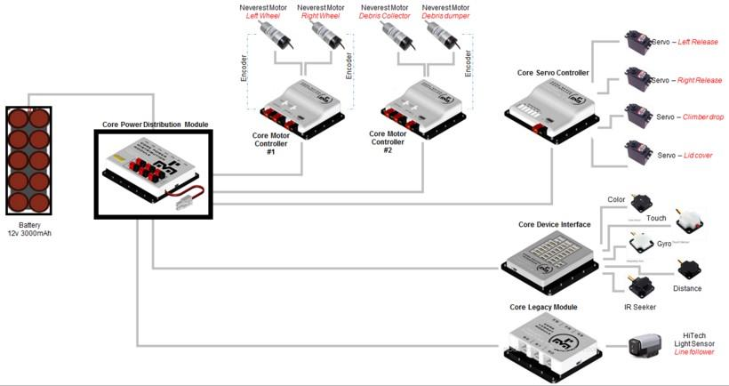

*Connectors*

Tamiya Connectors are a type of DC power connector which are usually used on radio-controlled model vehicle battery packs and chargers. They are also commonly used on airsoft guns. The wiring has the positive red wire going to the terminal with a square profile, and the negative black wire runs to the half circle, half square terminal. This applies for both genders of the connectors and the female sockets are and the male housing while the male pins are in the female housing. The male pins are usually on the side of the battery. The two sizes of the Tamiya Connectors are regular and mini. The outside dimensions for female connectors are:

Regular: 14mm x 7mm x 28mm (about 17/32" x 9/32" x 1 3/32")

Mini: 10mm x 6mm x 22mm (about 3/8" x 7/32" x 7/8")

Locking mechanism does not come undone easily

Connector physically isolates the negative and positive wires so they are safe to use in damp conditions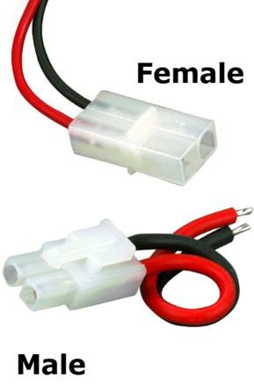

#### Encoder Wiring

We are using the AndyMark NeverRest Motor which comes with an encoder. In TETRIX motors, we connect external encoders and the following holds good. Tetrix cable has a guide slot which help us to connect the cable in the right way. The wiring follows with M+ on the top, M- in the middle, and lastly GRD on the bottom.

The motor we are using is a NeverRest motor. There is an encoder mounted to the back side of this motor. It is seven pulse per revolution (ppr), making it stronger than other motors. Encoders allow us to set a target speed, and the motor controller will apply whatever power necessary (within its safety limits) to achieve the desired speed.



2Wikipedia, "Tamiya Connector," 2015

3AA Portable Power Corporation, "Connector/Adapter: Standard Male and Female Dean Connector with 14 AWG Wire," 2016

An encoder connected to a DC motor.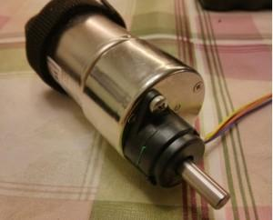

[4](#_415t9al)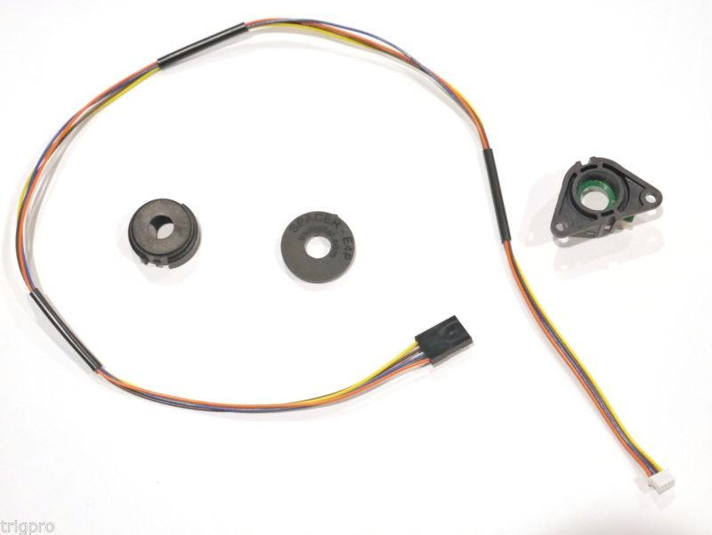

These are the parts of an encoder (shown above). We connect all of these parts to are motor and

then it will tell us how fast are motor is going. This can be helpful to tell us information from one format or code to another, to help us understand it better and compare the different motors.

*Problem*

The main issue we have with the two types of encoders (AndyMark and TETRIX) is that TETRIX encoders come with terminals with a protrusion which indicates the orientation when connecting the encoder to the motor. With the AndyMark, the primary one we are using, there is no protrusion, so we do not know how to connect the TETRIX encoders.

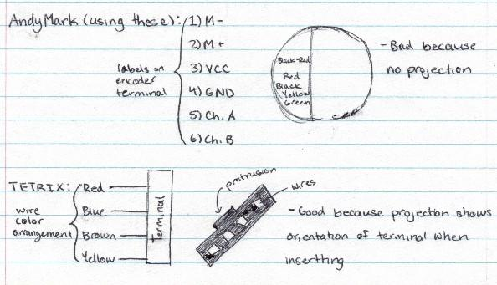

As shown by the sketch, the TETRIX encoder terminal wire colors follow as red-blue- brown-yellow, however this is not the case with AndyMark, where the standard is redblack- red-black-yellow-green. Also, for the AndyMark, the terminal wires have a specific sequence for which wire connects to which input setting. Using this drawing, it is easier to understand to knowing how to connect the TETRIX motor encoders onto the AndyMark DC motors.

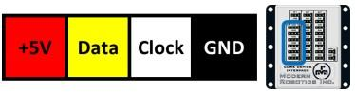

[7](#_2gb3jie)

Lastly, a housing used connect the LED pin to the CDI module is to be made. Using a two connector housing, the LED pin is connected through the blue wire to the housing, using the housing to connect the LED pin to the signal pin of a digital port.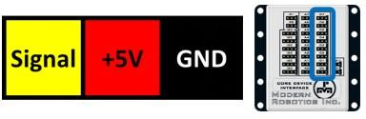

#### USB Connectivity

*Overview of the USB*

The USB is also known as the Universal Serial Bus. The purpose of it is serve a method of communication, connection, and electrical supply between two electrical devices. Two main examples can be given by USBs that connect computer peripherals ( keyboards, point- ing devices, digital cameras, printers, portable media players, disk drives, and network adapters) and electronic devices. The USB has replaced many of the earlier interfaces, like the serial and parallel ports, along with separating power chargers for portable devices. Each end of a USB cable is a different kind of connector, a Type-A and Type-B to be exact. The reason for this is because it prevents electrical overload and damage to equipment, for only the Type-A socket provides power.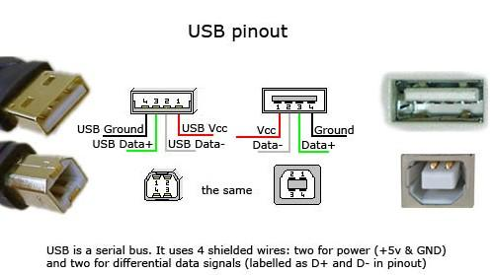

*USB Connections*

Physical USB connections are an obvious issue and contributor to loss of communication between electrical constituents of the robot. This may occur due to risky and jerky actions performed by the robot. It may also happen even when the robot is just slowly moving because a loose USB is vulnerable to be pulled out. To solve this issue, it is highly recom- mended to properly and securely fasten all modules and devices to the frame of the robot and make certain that all USB cables are secured tightly so they do not move during the running of the robot and risk unplugging. The two tabs of the male end of USBs make a clicking noise when they are inserted correctly, thus we have to make sure that we follow through with all USB cable connection protocols.

*Battery Voltage*

Battery voltage is a crucial aspect of USB functionality. If the voltage is too high or too low in regards to the standard of twelve volts, it is expected that the USB module disconnection issues will arise. Battery power is also an issue, but it must drop a fair amount to show any changes.

*Scanning Issues*

Complications when scanning the robot for configuration are also possible. This can occur when the Core Power Distribution Module and the Robot Controller is unable to detect oneor more of the USB modules on the Power Module’s USB bus. Power cycling the robot, closing/re-installing the application, restarting the phone, and disconnecting the USB cable all seem to not work. This problem can be attributed to the error that happens when the USB microchips within the Core Power Distribution Module wait indefinitely to receive a reset signal as they are powered one, resulting n where one or more devices are not able to be detected on the USB bus. There is still more research that is to be made towards Modern Robotics and the reliability of their Power Module.

*Modern Robotics Core Device Discovery*

The Core Device Discovery utility enables retrieval of module information and serial numbers, test connectivity and most functions of each module. The Core Distribution Module is comprised of four LEDs which all are supposed to be lit up after connection to a host device. If not, that indicates an error status.

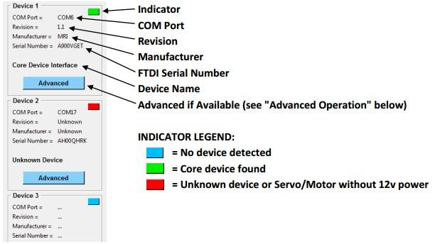

*Core Power Distribution Module*

The Core Power Distribution Module is equipped with four LEDs as status indicators. Under normal operation, all four LED’s should be illuminated after the module is con- nected to a host phone or computer. 12V indicates that the 12v supply is connected and the power switch is on. 5V indicates that the 5v power supply is operating and supplying 5v to the USB ports. 3.3V indicates that the 3.3 volt supply to the internal electronics are operating. USB Enabled indicates that a host device is connected to the USB input port.

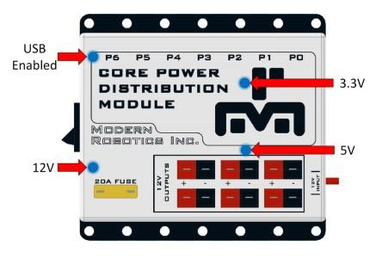

*Core Motor Controller*

Motors can be controlled in three operation modes and their encoder values displayed. The mode can be switched using the three buttons labeled Constant Power, Constant Speed, and Run to Position. The button will appear white when selected indicating the current mode enabled. Motor values can range from a power of -100 to 100 and encoder values can range from -2147483648 to 2147483647.

* Pressing key or “Update Values” will update controller with the user input
* Pressing key will set the power of both motors to 0
* Pressing “Reset Encoders” will set motor power and encoder values to 0
* Pressing the or arrows on the keyboard will adjust the values +/-5

*Core Servo Controller*

Servos can be enabled or disabled using the selection buttons in the bottom right. The button will appear white when selected indicating the current mode enabled. Servo values can range from 0 - 255 (1.5uS to 2.5uS). Also, it is important to note that most servos range from (1.75uS to 2.25uS) and extending the range to the mechanical limits can cause damage to the servo over time. It is recommended to find the limits of each servo by increasing and decreasing the value until the servo "hums" indicating it has hit a mechanical limit and not exceeding this range in the design.

* Pressing key or “Update Values” will update controller with the user input
* Pressing the or arrows on the keyboard will adjust the values +/-5

*Core Device Interface*

The Core Device Interface has multiple inputs and outputs to be used with Modern Robotics Inc. Core sensors as well as user created sensors and devices. These functions include on board indicator LEDs, Analog input and outputs, Digital input and outputs, I2C communication, and PWM outputs. Also note that the PWM outputs are for sensor design only and not to be used directly with servos as the power circuitry cannot support the current needed for servo operation.

**Meeting 6#**

**Meeting Date:** Sat, 08/06/2016

**Personnel Present:** Max, Kyle, Jake, Owen, Ezra, Uma, Vinay, Vishnu



**Tasks This Meeting:**

* Go over the basic components of a FTC robot
* Learn FTC Robot Wiring
* Introduce Android Software Programming
* Parts from Tetrix

**Reflections:**

Today our programming mentors Srilatha Challa from John Deere gave an overview of basic components of FTC robot. She had given an overview of a Java program and explained how to write a basic Java program. She also showed us how to connect Core components. Core power module, Controllers and Servo. What modules to use for connecting motors, servos. She told us she will get in more detail during the season.

*Basic Components of a FTC Robot*

Core Power Distribution Module

Core Motor Controller

Android Phone

Robot Controller

Battery

DC Motor Controller

Sensor Controller

Legacy Controller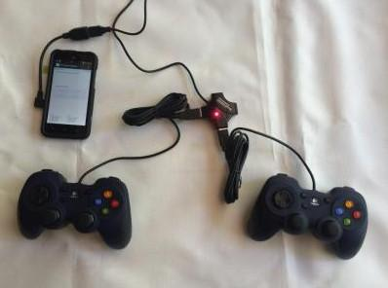

*Core Power Distribution Module*

This is what is connected directly to the 12 Volt Battery Pack. This module is what sends power to all the different modules. It is the most important part because without it, nothing else will get power. It also has a 20A fuse which means that it can control the power it gets. This is more of a safety aspect so that no one gets shocked.

*Core Motor Controller*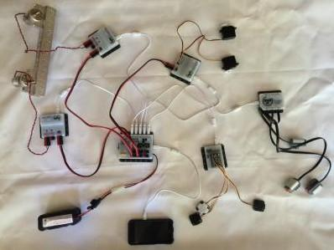

This module is what gives power to the DC motors. These are what give power to things such as wheels or arm lifts. Two motors can be connected to one of these modules. We have been given two Core motor controllers, which means we connect four motors total. But there is no limit to amount of motors so we can use as many as needed.

*Core Servo Controller*

This module gives power to the servos. The servos are basically smaller DC motors and they can be used for tasks with less energy required. An example is turning a pipe to raise a flag, like in the Block Party FTC challenge. You can connect six servos to this module.

*Core Device Interface*

This module supplies the sensors. It has 26 slots for things like touch sensors, color sensors and IR sensors. There is a certain way you need to place the sensors, each row is for a different types 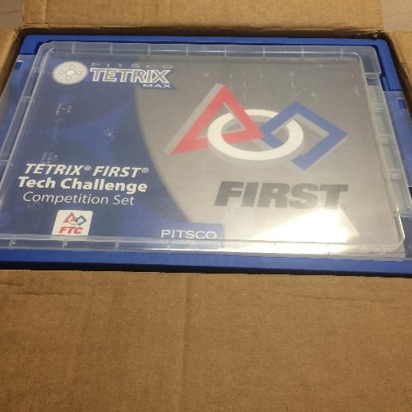

***New Android Programming and Platform***

Key components: robot, programming

New Android platform

Programming is now on Java

One Android phone on robot, one in Driver Station

Three programming options: Android App Development with Java, MIT App Inventor, simple movement download app. We decided to use Android App Development with Java as the programming option for our team. We also received the parts from Tetrix and we started looking and identifying the parts which we learnt in our initial session.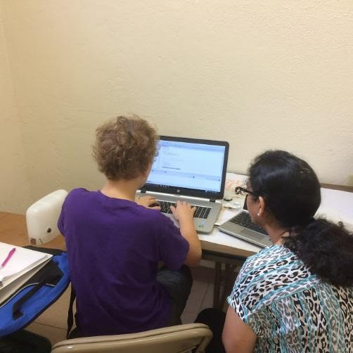

**Meeting 7#**

**Meeting Date:** Sat, 08/13/2016

**Personnel Present:** Max, Kyle, Jake, Owen, Ezra, Uma, Vinay, Vishnu

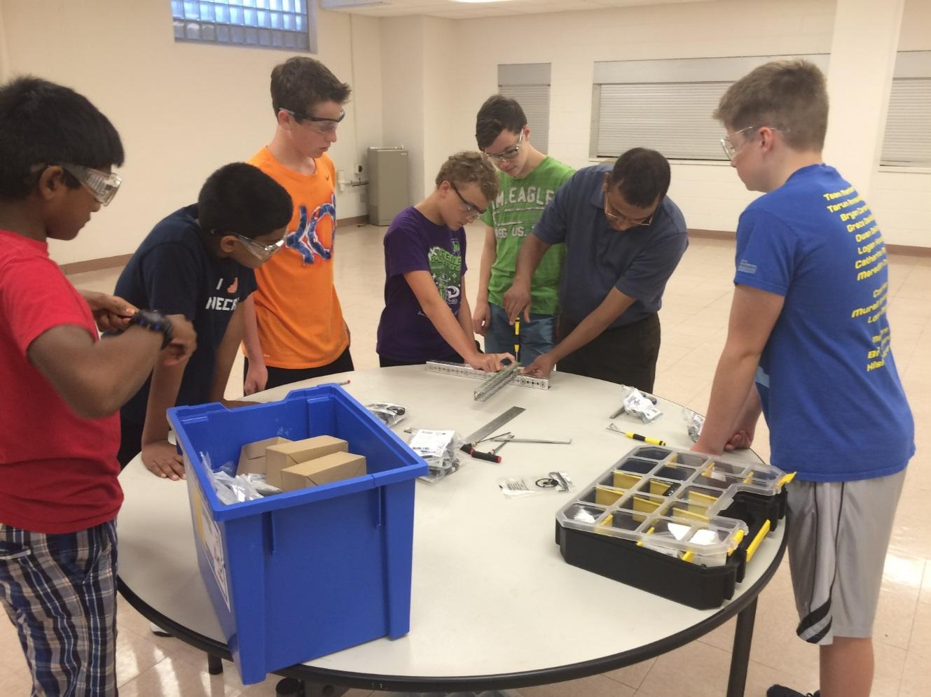

Tasks This Meeting:

Design Process

Putting parts together and testing

Programming team creating program

**Reflections:**

Today we started the meeting with going through the design process which we are going to follow this season. We brainstormed some design ideas and decided to use a simple version which is based as Of NASA Design process. We called the process as Minion Process. We used this process and started creating rough drawing each memberof he design team created a drawing and then we sat together and discussed the best approach. We finalized on one design and asked Vishnu create a Creo Model. Vishnu started creating the model while Max started working on the program. The rest of us started working on assembling the parts together.

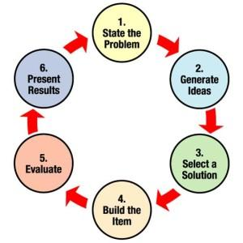

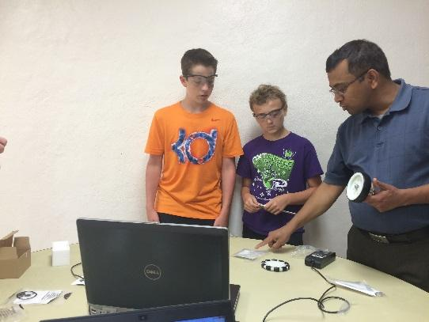

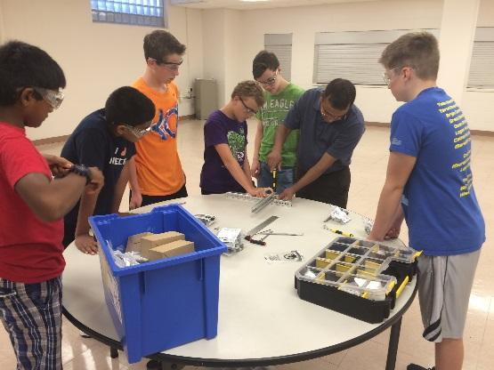

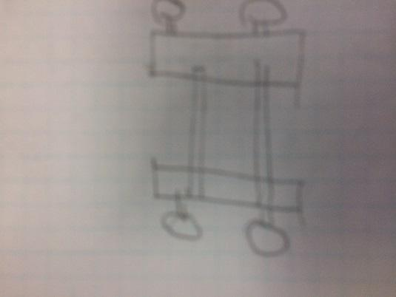

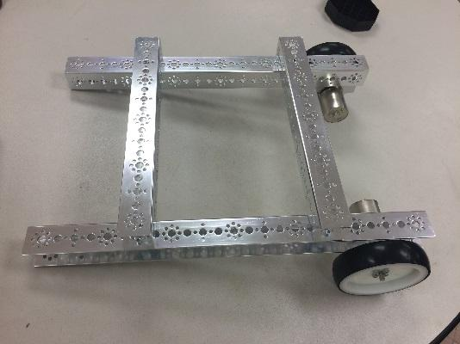

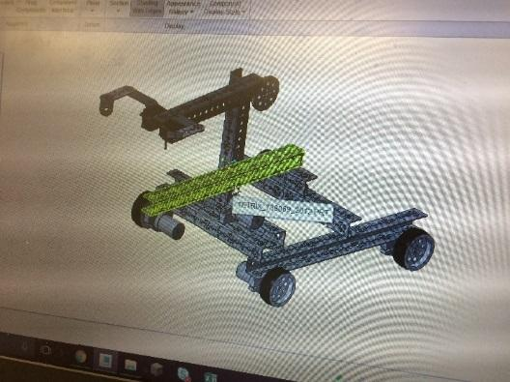

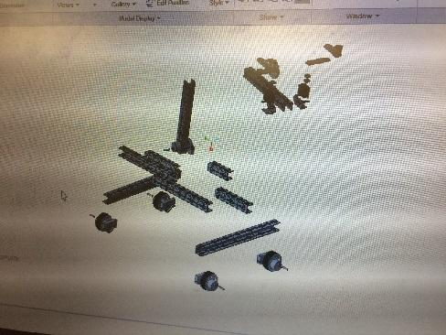

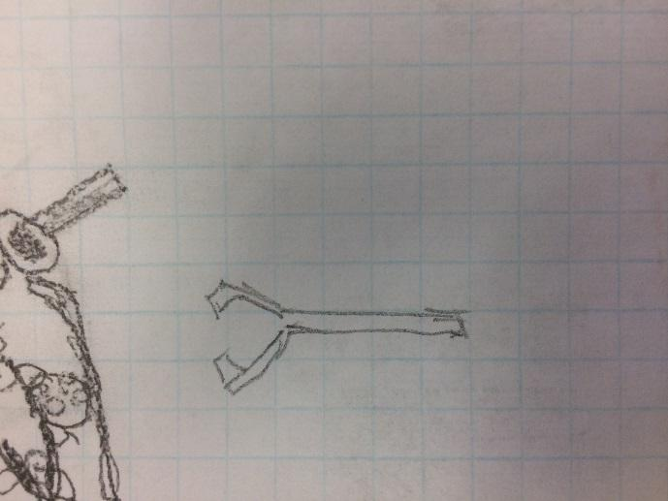

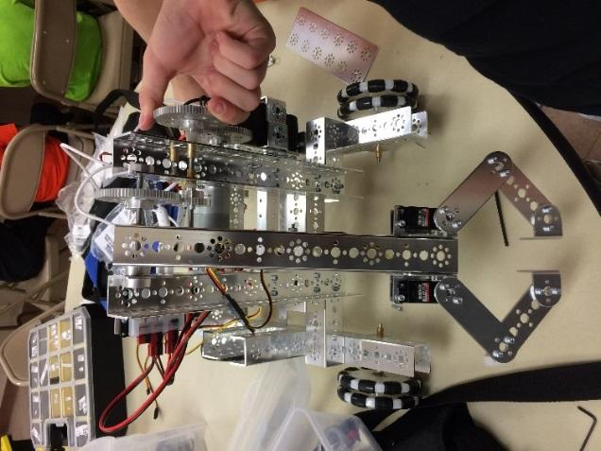

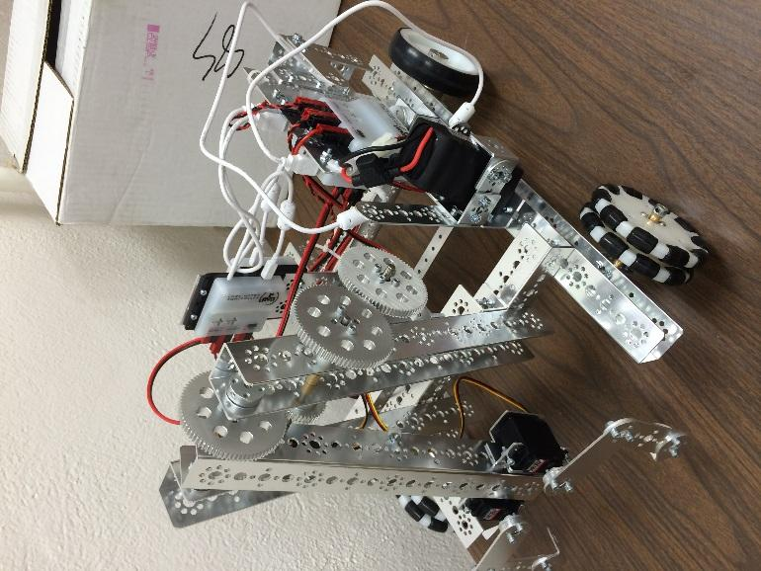

**Submitted By Owen**



# Engineering Summaries:

**Early Season**

#### [Kick Off](#_1f7o1he) 45

#### [Brainstorm](#_3z7bk57) ideas 48

#### [Prototype Ideas](#_2eclud0) 51

#### [Outreach kickoff](#_2eclud0) 52

#### [Design Team](#_thw4kt) Review 55

#### [Ball Picker](#_3dhjn8m) 58

#### [Catapult](#_4cmhg48) 59

#### [Outreach Details](#_2rrrqc1) 61

#### [Things to do before scrimmage](#_4bvk7pj) 62

#### [Preparing for Scrimmage](#_16x20ju) 63

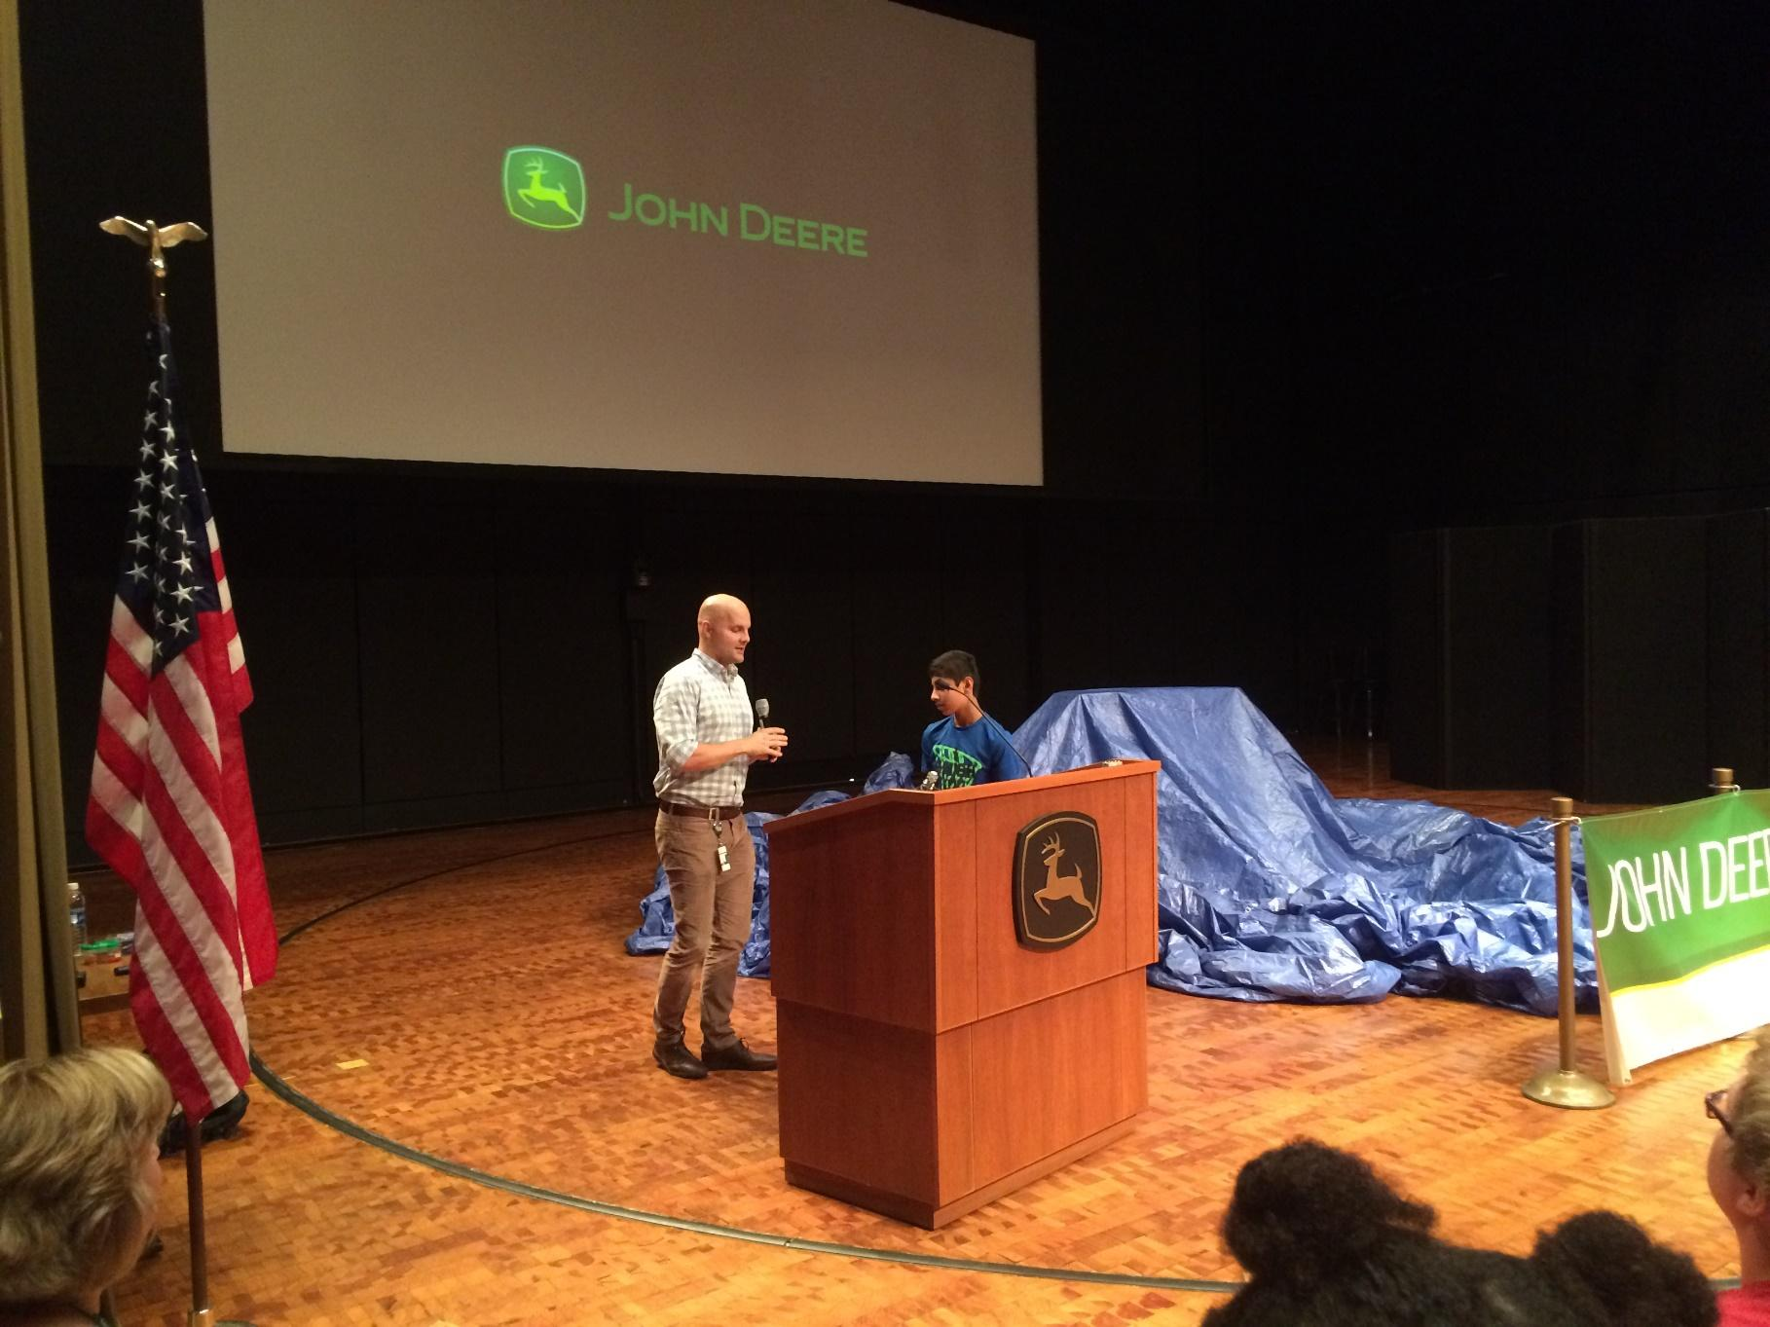

**Meeting Date:**Sat, 09/10/2016

**Personnel Present:**Everyone!

**Tasks This Meeting:**

* + Team members attend breakout sessions
  + Gather more information on programming, Design
  + First view of 2016 Competition

**Reflections:**

This year the kickoff event was organized by John Deere at their Head Quarters. We signed up for the event and made sure all the team members were present at the John Deere world Wide Head Quarters. The kick off event is well organized. There was food and some tables setup where prior FTC team bought their robots and answered all different questions. There were two breakout sessions. We made sure all the session are attended by the team members.

**Breakout Session 1**

Available for session 1 are:

* + - 3D Printing
    - Programming/Teleop
    - Judging
    - Interactive Resource Stations

**Networking Fair/Interactive Resource Stations**

**Breakout Session 2**

Available for session 2 are:

* Game Strategy/Design Process
* Programming/Autonomous
* Team Formation for Success

**Game Reveal and Conclusion**

Everyone had fun at the kickoff. We all participated in the activities, and got more ideas for the season. After seeing the game reveal, we immediately started talking about ideas. The Programming team went to both programming sessions. The Design team went to Game Strategy/Design Process and 3D Printing. The coaches and Outreach team attended Team Formation for Success and Judging We took a couple of pictures of our team and of what we did at the kickoff.

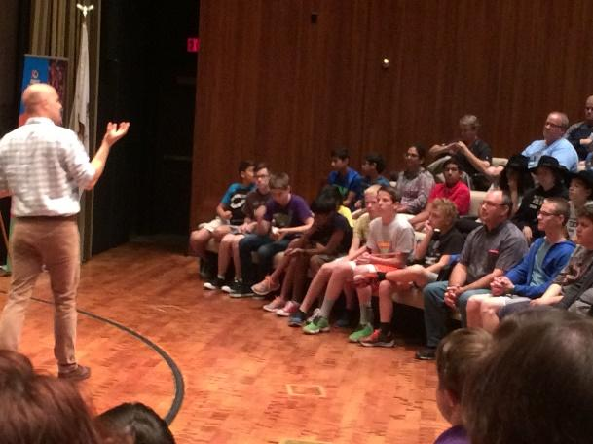

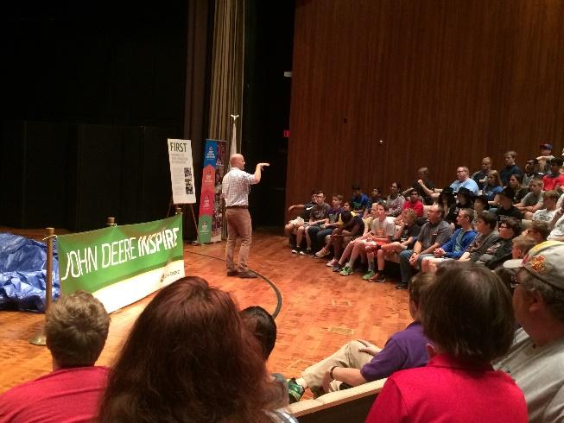

Submitted By Uma

**Brainstorm Ideas**

**Meeting Date:**Sun, 09/18/2016

**Personnel Present:**Present = Vishnu, Kyle, and Ezra. Absent = Jake, Owen

**Tasks This Meeting:**

**.**

* How to pick up ball?
* How to throw ball that is picked up?
* Design of 3 different attachments (Catcher, Catapult, Shooter) plus Chassis

**Reflections:**

Exchanged ideas for the design

Will create model of attachments (3-D) next meeting.

We drew out robot concept idea after an intense brainstorming conversation with Coach Ram. First, we drew a basic Chassis similar to that what we build during pre-season. Then drew out the following designs for ball attachments.

***Ball Attachments:***

*Ball Catcher*; using plastic tubing to catch ball and pull to inside of robot.

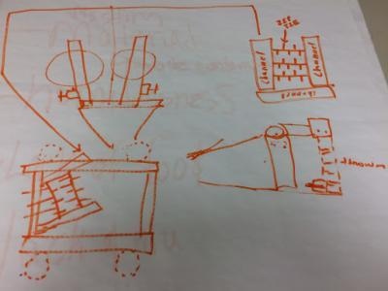

*Ball Catapult*; from ball catcher, ball goes through chute and lands in cup which is launched.

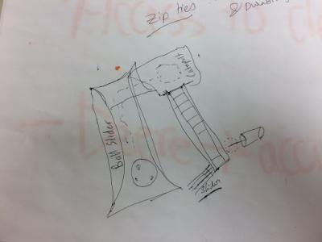

*Ball Shooter,*from ball catcher, ball goes through a chute in which placed between 2 tires which rotate which will cause friction to launch ball.

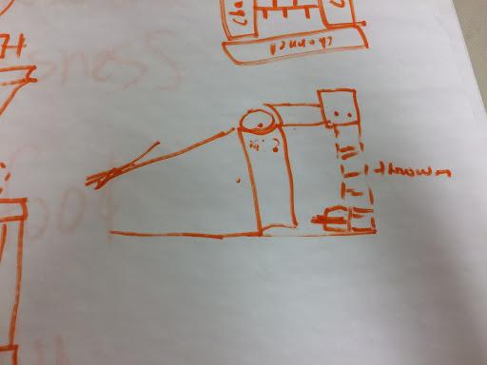

We informed our coach the material needed for building our robot. (Wheels, Channels, Motors, Aluminum sheets for building ball bucket)

**Submitted By Kyle**

**Prototype Idea**

**Meeting Date:**Mon, 09/19/2016

**Personnel Present:**Present: Ezra Owen Kyle Vishnu Absent: Jake

**Tasks This Meeting:**

* Create prototype to simulate ideas.

**Reflections:**

Prototype looks realistic. We used Amazon boxes, sticks to build a prototype of the robot. While building the prototype, we have several ideas as how to put the catapult. Owen Suggested to put the catapult in a position so that it can come directly into catapult when the ball grabber rotates. We discussed our idea with our coach and we used the programming Chassis and compared our idea. We changed and built a bucket in slant position so that the ball can rollover to the catapult.  We concluded the meeting as we are not sure where to put the catapult. To the end or to the side. We also discussed shooting positions and come up with idea that catapult should have the mechanism to rotate while throwing.

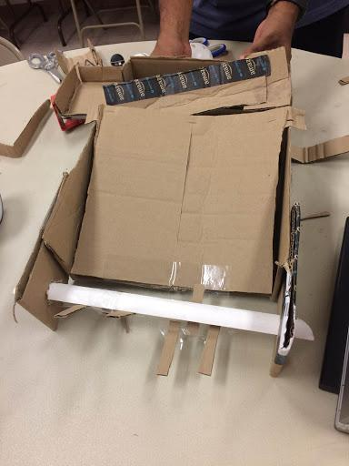

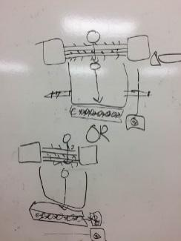

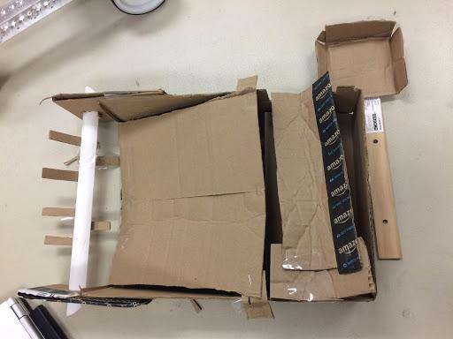 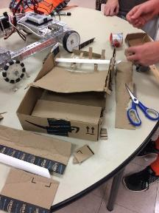

**Submitted By Ezra**

**Outreach Kick Off**

**Meeting Date:**Sat, 09/24/2016

**Personnel Present:** Present: Owen, Ezra, Max, Kyle, Nikhil, Vinay, Tarun, Uma and Vishnu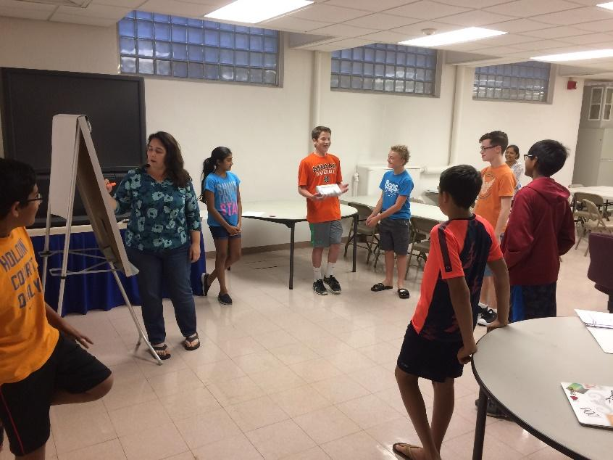

**Tasks This Meeting:**

* Discuss sharing ideas on Outreach.
* Start Building Robot.
* Create new Google Hangout Group for Outreach.
* Programming team cannot test as phones died.

**Reflections:**

More ideas will come if the phones need to be charged before leaving.

Outreach: Each one of us shared three ideas based on the list which we came last week. The person who shared the most ideas got "Krabby Patties".

|  |  |  |
| --- | --- | --- |
| **Name** | **Problem / Idea** | **Score** |
| Nikhil | War zones have refugees that need medical supplies, food and water | |
|  | 95% of tap water has chromium in the water which is harmful to our health, Superbugs in water | 6 |
|  | Use unmanned vehicles to deliver food to war zones | 2 |
| Jake | Veterans  need supplies, support | 2 |
|  | Global warming - Bring awareness, talk to car companies - switch to electric or be more echo friendly | 1 |
| Max |  | |
|  | Veterans are mistreated, povertly, lack of job, food.  Need community support | 2 |
|  | Lack of clean water - chromium and lead.  Government needs more oversight | |
| Vinay | Lack of education - this can help address issues like lack of food, homelessness | |
|  | Equal distribution of wealth.  Most people in the world live on under $10 per day | |
|  | Distractions on the road - texting, Pokémon go - causing too many traffic accidents | |
| Ezra | Lack of access to clean water, use tax money to fix our infrastructure |  |
|  | Use less antibiotics (Animals) | 2 |
|  | Use less antibiotics (Humans) |  |
|  | Human deaths fighting ISIS - use more robots |  |
| Owen | Global warming factory reductions - do temperature comparisons from 10 years ago using more current technology | |
| Kyle | Lack of education in war zones.  Help with homelessness |  |
|  | Vets - don't have the resources when they come back to get a job, food | 2 |

Max has taken lead to create a new hangout group for Outreach ideas.

 Programming team cannot do any programming as the phones weren’t charged today.

Design team started building the Robot. New material zip ties, spindle and try needed for next meeting.

Outreach homework: Research couple of hours on the topic and come prepared for the meeting.

**Submitted By Owen**

**Design Team Review**

**Meeting Date:**Wed, 09/28/2016

**Personnel Present:**Present: Kyle, Ezra, Jake Absent: Vishnu, Owen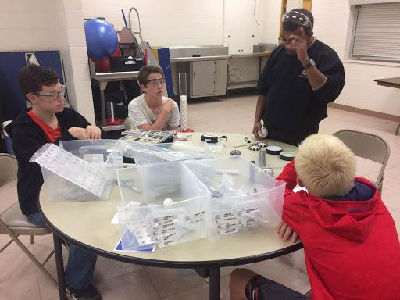

**Tasks This Meeting:**

* Robot Design Ideas
* Decisions on the Ball Thrower

**Reflections:**

Discussion and asking questions will lead to more ideas. Design team met with Mentor Sumukh to discuss the overall robot and material needs. Goal of the meeting is to decide on Wheels and how to launch Balls.

**4 Wheel Drive**: Reason for having 4 Wheel drive is if in case one motor fails the other motors will work without stalling the robot.

**Ball Grabber:**We will use an axle and cover with a pipe with zip ties and mount in front of the chassis for the ball Grabber.

Another idea for ball grabber is to use PVC pipe and instead of zip ties use rubber tubes.

**Ball Launcher:** We discussed two ideas one is catapult and the other is similar to ball throw launcher.

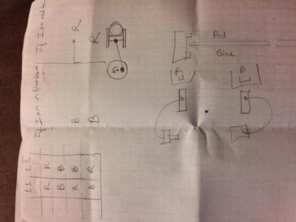

**Ball Throw:**Use 3D print or lighter wheels and rotate in opposite directions with sufficient speed to simulate the ball thrower. This ball thrower will be attached immediately after the ball grabber. We also discussed of putting a tube along the ball thrower so that we can the ball in the middle of the basket from different areas of the field.

**Beacons**: We discussed the attachments for the beacons. We want to build two attachments and check onside for the color. It its true then move the pad on the attachment to press the button otherwise the other attachment on the opposite side is pressed.

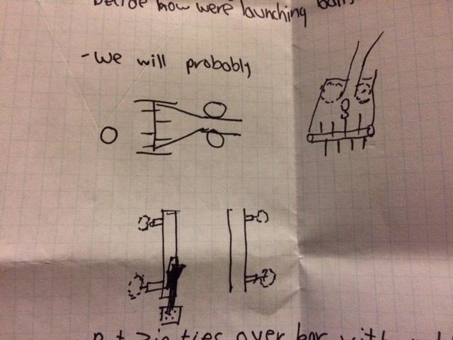

Material Needed: Andy mark Motors, Tube, Zip ties, all wheel drive wheels for the chassis (Four-wheel drive).

**Submitted By Jake**

**Ball Picker**

**Meeting Date:**Tue, 10/25/2016

**Personnel Present:**Kyle, and Ezra

**Tasks This Meeting:**

* Build a ball puller
* Test to see if the puller works

**Reflections:**

We were able to complete the puller and we successfully tested it. It was able to pick up the particles. To build it we attached a motor to channel and attached an axle to it. Then we tied zip-ties to the axle and turned on the motor. This successfully worked because when we feed it balls it would pull the balls into the chassis. Vishnu designed a PTC Creo model for this.

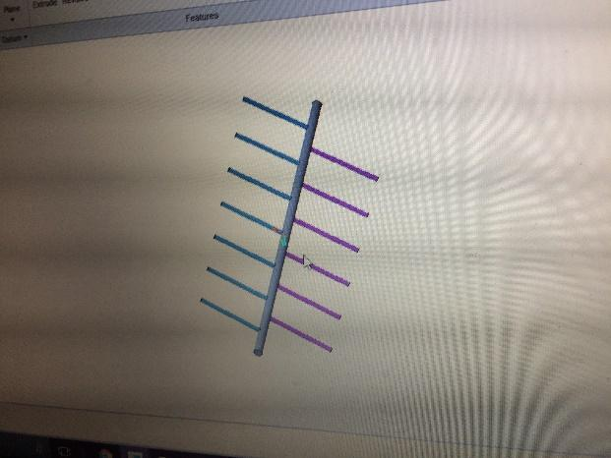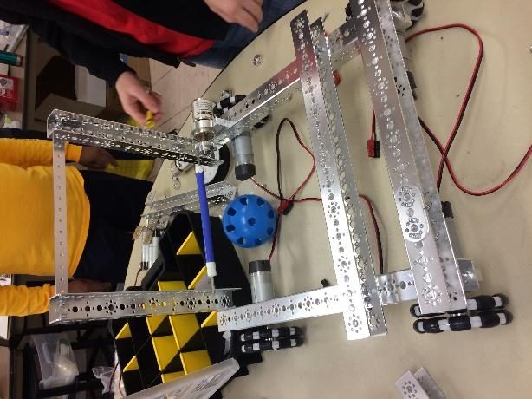

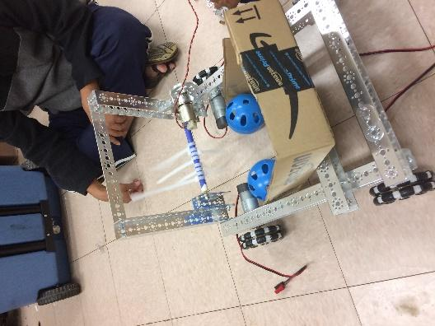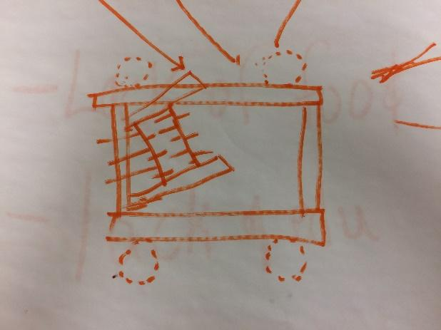

**Submitted By Kyle**

**Catapult**

**Meeting Date:**Wed, 11/09/2016

**Personnel Present:**Ezra Owen Kyle Jake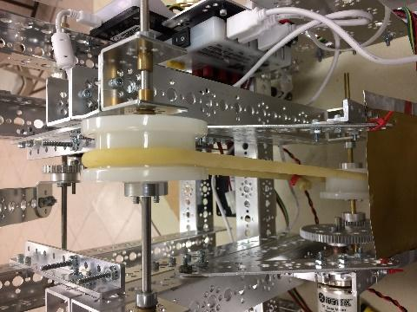

**Tasks This Meeting:**

We all put finishing touches on the catapult and tested it

**Reflections:**

This feature helped us get points in our first tournament although later we scrapped it due to not being able to pick up balls.at this meeting we tested and our catapult and we deemed it successful. we used this feature in the autonomous period of the game. We had it preloaded because we could not pick up balls.

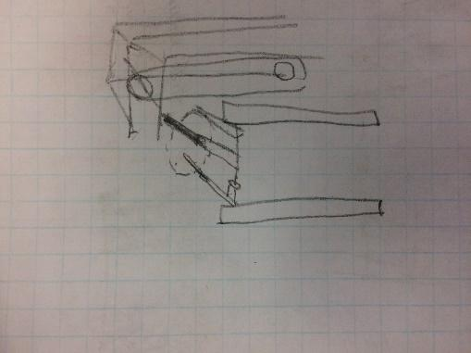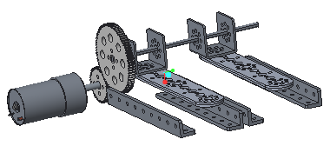

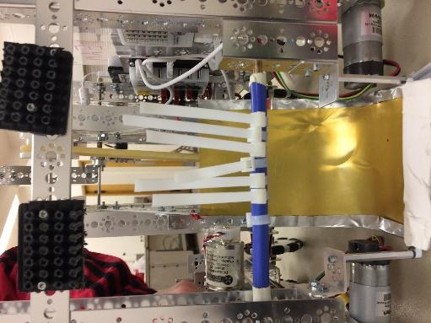

**Submitted By Jake**

**Outreach Details**

**Meeting Date:** Sat, 10/01/2016

**Personnel Present:**Vinay, Uma, Kyle, Max, Tarun,Vishnu, Srilatha, Ram

**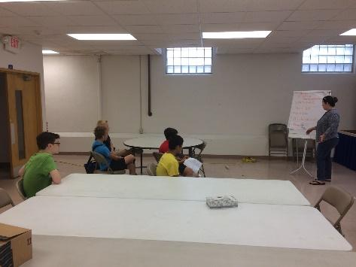**

**Tasks This Meeting:**

Research Outreach activities

* Clean water
* Refugee Education
* Veteran Help
* Implementing STEM Activities in the classroom
* Narrow down Outreach activities

**Reflections:**We researched our Outreach Activities, and our teammates are going to be researching their own personal preferences. We didn't get to narrowing down as yet.

**Submitted By Vinay**

**Things to do Before Scrimmage**

**Meeting Date:** Sat, 10/12/2016

**Personnel Present**: Vinay, Uma, Kyle, Max, Tarun, Vishnu,

**Tasks This Meeting:**

* Create a list of Items to be taken for Scrimmage
* Complete Hardware & Field Inspection Check list

**Reflections:** We prepared a list of thing and packed everything in boxes to be taken to the scrimmage. The list was prepared by Tarun and verified by Vishnu to make sure we are not missing anything.

Phones

Extra cable

Power Supply

Battery and Charges

Roaster Sheet with Hardware and Field inspection sheet

Tool box

Extra Motors, Gears and some Parts used on Robot

We planned to start at 10:30am on Sunday and informed everyone to be at our Lab by 10:00 so that we can load everything and head out.

**Submitted By Tarun**

**Preparing for Scrimmage**

**Meeting Date:** Sat, 10/13/2016

**Personnel Present:** Kyle, Max, Tarun, Vishnu, Jake, Owen, Max

**Tasks This Meeting:**

* Check the Robot Size and Dimensions
* Setup the Pit area
* Start lining up for Hardware inspection
* Tarun and Max go for Scouting with other teams

**Reflections:**Our team was excited to see our new Minion Box which is exactly 18\*18\*18. It has wheels and the robot can be easily carried without lifting. If the robot fits in the box then we are sure our robot is less than the dimensions. We loaded the robot and the boxes and headed to our first Scrimmage at Dubuque. We forgot to put the Flag holder before so we quickly installed the flag holder.

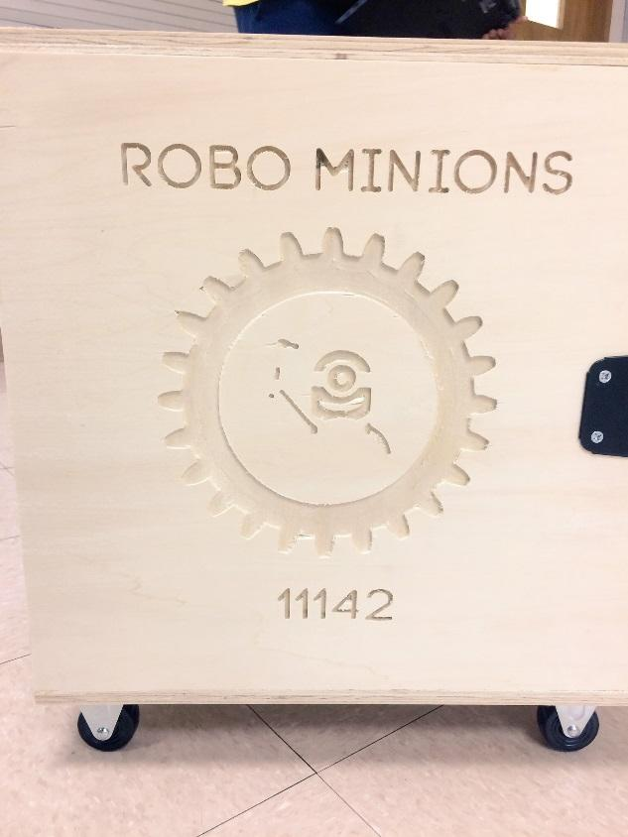 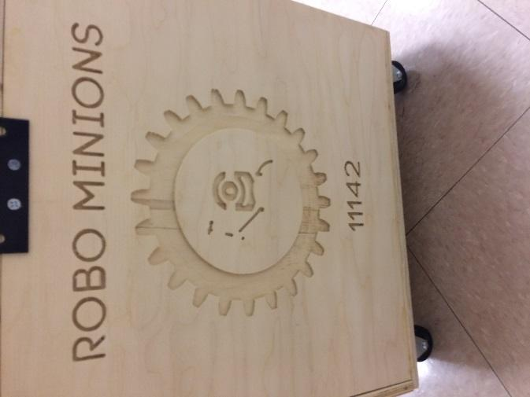

**Submitted By Kyle**



# Engineering Summaries:

**League Season**

[**Scrimmage One**](#_3qwpj7n) **66**

[**Bane Bot Motors**](#_261ztfg) **68**

[**Color Sensor testing**](#_l7a3n9) **70**

[**Field and perimeter Setup**](#_356xmb2) **71**

[**Ball Shooter**](#_1kc7wiv) **72**

[**Beacon Pusher**](#_44bvf6o) **73**

[**Ball lift**](#_2jh5peh) **75**

[**Second Scrimmage**](#_ymfzma) **76**

[**Scrimmage Analysis**](#_3im3ia3) **78**

[**Beacon Pusher Changes**](#_1xrdshw) **79**

[**Third Scrimmage**](#_4hr1b5p) **81**

[**Scrimmage Analysis**](#_vgdtq7) **84**

[**Ball Shooter & Macanum Wheels**](#_2wwbldi)…………… **85**

**First Scrimmage - Dubuque**

**Meeting Date:**Sun, 11/13/2016

**Personnel Present:** Everyone

**Tasks This Meeting:**

* Go through Scrimmage process
* How to call FTA in case of Issues
* How to do Scouting with other teams
* Check list of what to take to the scrimmage
* Maintain Gracious Professionalism by helping other teams

**Reflections:**

We are excited as this is our first tournament. We spent lot of hours the day before fixing our Autonomous. Last minute we removed some of the sensors which we didn’t use but forgot to change our configuration. When the meet started the first match we got lot of errors as we didn’t remove the sensor from the configuration. First game was not a good one. We went to our pit and immediately fixed our config and made sure it works. The next game onward we consistently shoot a ball in autonomous and dislodged the cap ball and parked in the center field. We had put a small beacon pusher 3D print in front of our robot which we used for pushing beacons. We used that for pushing beacons during our Teleop period. We are able to shoot the ball in the corner vertex in one of the games.

We used our new travel Minion box which got everyone’s attention. Lot of teams came and took pictures of our box. They asked us how we built it.

We learnt Several things during our first scrimmage. We were very happy with our results from the first scrimmage.

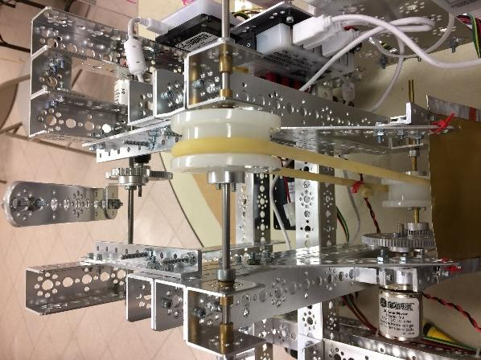 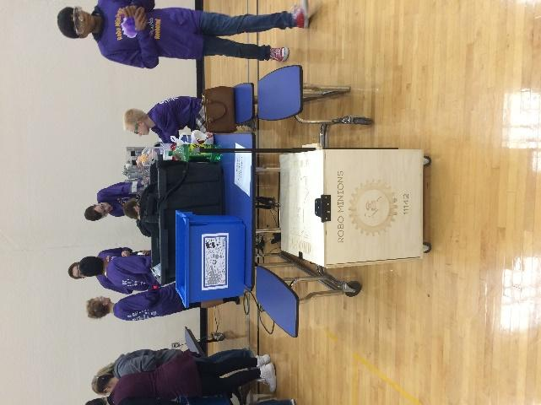

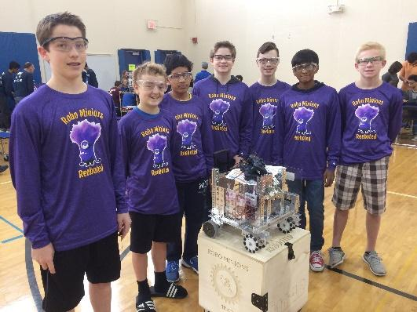 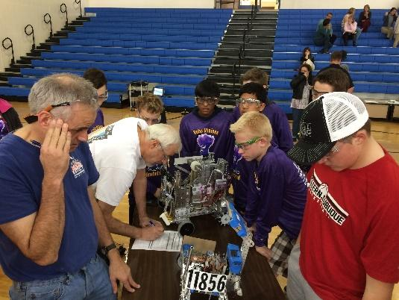

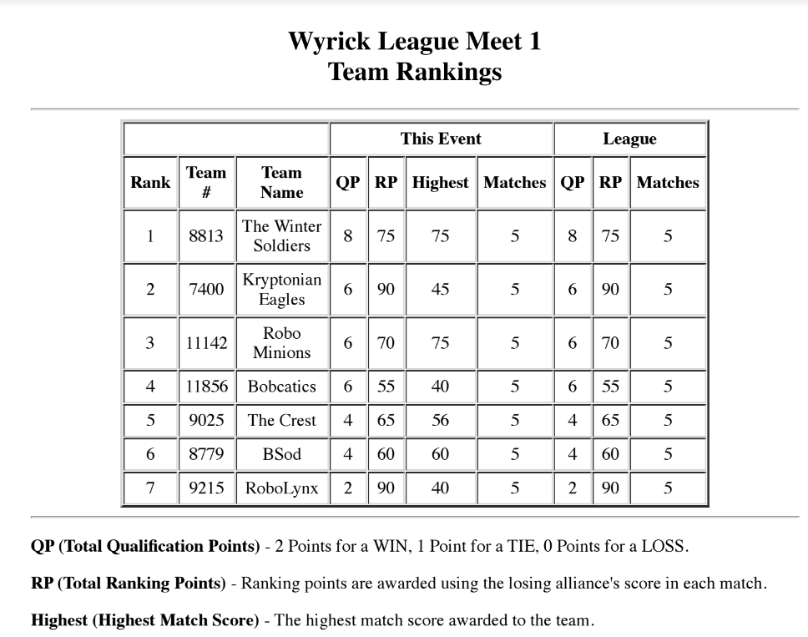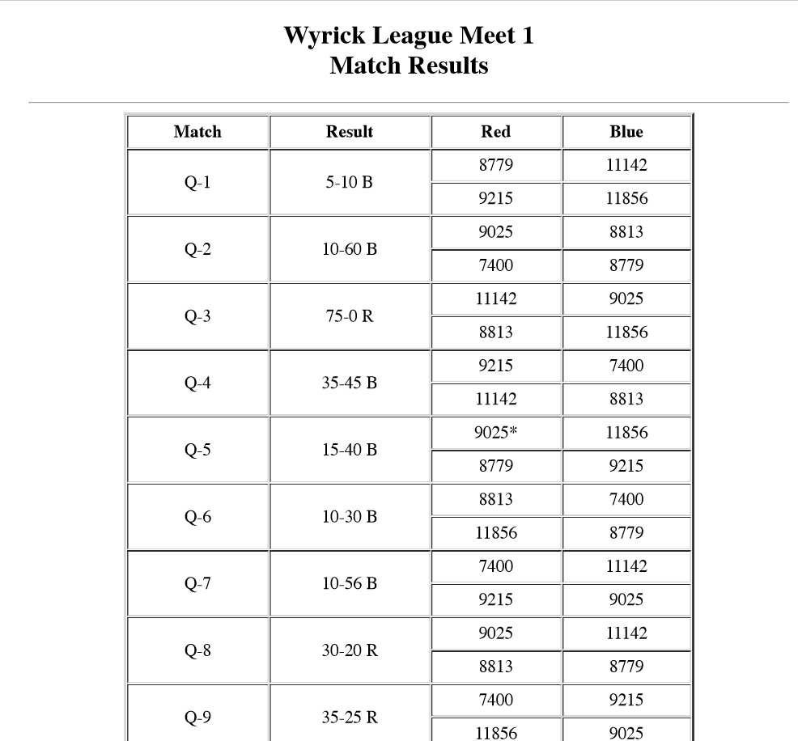

**Submitted By Tarun**

**Bane Bot Motors**

**Meeting Date:** Wed,12/7/2016

**Personnel Present:** Kyle, Ezra, Owen, Jake

**Tasks This Meeting:**

* + - Use Bean bot motors to shoot the ball
    - Install wheels to the Bean bot motors
    - Test the ball throwing mechanism

**Reflections:**

Today we received the Bean bot motors from Andy mark. We saw several teams using Bane bot motors with wheels to shoot the balls. We checked the youtube videos on how to install the Bane bot motors and install the wheels using the key and the other mechanism. The installation is pretty simple and we are very much satisfied with our test of the motors. The speed is very accurate and it results in shooting the ball nicely.

#### C:\Users\ftcte\AppData\Local\Microsoft\Windows\INetCacheContent.Word\IMG_2565.jpg

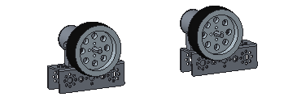

**Submitted by Kyle**

**Color Sensor Testing**

**Meeting Date:**Wed, 10/26/2016

**Personnel Present:**Vishnu, Max, Kyle, Ezra

**Tasks This Meeting:**

* Learn how Color Sensor works
* Create a program and test Color Sensor

**Reflections:**Today we started learning about color sensor. How the color sensor needs to be connected. Color sensor uses 4 pins not three like other sensors. We also leant that there is a flash mode which can be enabled or disable programmatically. Using flash mode will help while testing in night times but during ordinary light there is no need to use flash light. We decided to disable the flash led. Then we created a program where if it sensors red the phone back ground will turn red and vice versa. We were very much satisfied with our results and decided to use color sensors for beacon push during autonomous.

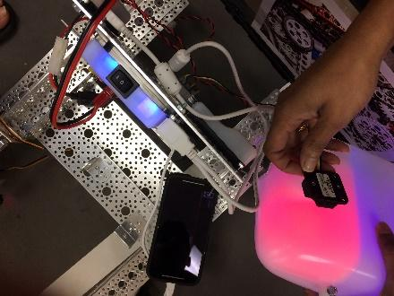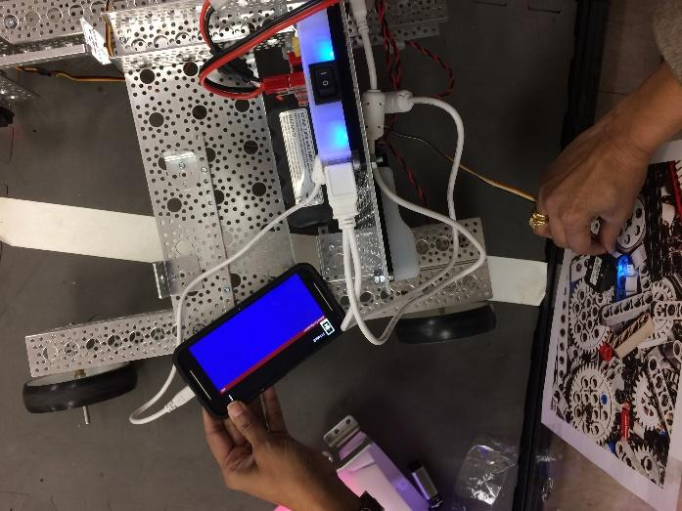

Submitted By Max



**Setting up the Field & Perimeter Fence**

**Meeting Date:**Wed, 09/21/2016

**Personnel Present:**Tarun, Vishnu, Kyle & FTC team 8813

**Tasks This Meeting:**

* Setup the Game Field as per instructions
* Setup the Perimeter Fence

**Reflections:**

Today we got the Setup field and the Perimeter fence. It took a month for these parts to come after we ordered them. We want to make sure we setup field correctly so that there are no issues when we go to scrimmages. We had some questions and we posted in our twitter to Andy Mark and they immediately replied with links on how to setup the corner vertex. Also, we ordered the Perimeter fence which came during the same time. FTC team 8813 who uses the same space helped in setting up both the field and the perimeter fence.

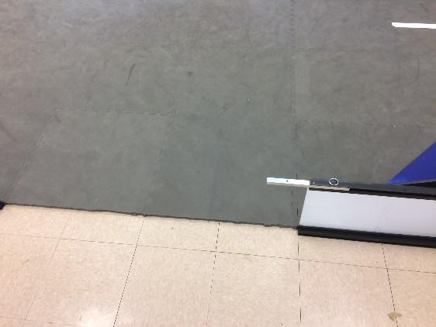 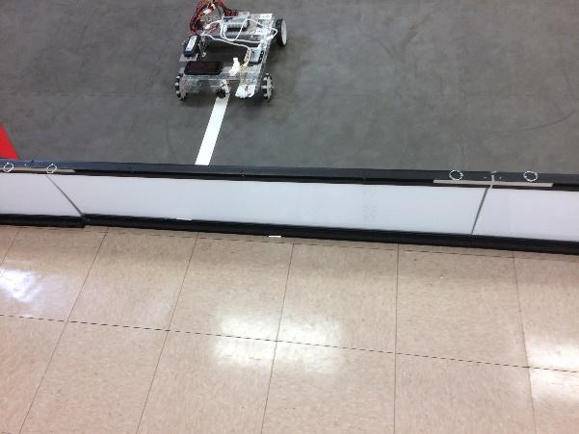

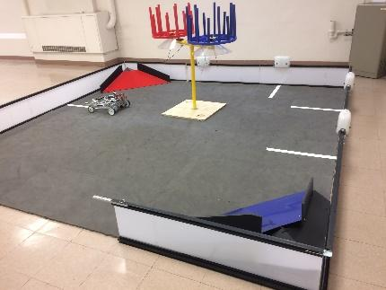

Submitted By Tarun

**Ball Shooter**

**Meeting Date:**Sun, 10/09/2016

**Personnel Present:**Vishnu, Ezra, Kyle, Jake

**Tasks This Meeting:**

* Draw ideas of ball Shooter
* Develop prototype
* Design in Creo

**Reflections:**

In today’s meeting, we brainstormed ideas for ball shooter and Developed a prototype. Our Creo Designer designed the prototype. We build the ball shooter system and tested. What we found was the ball shooter worked well though it has lot of dependencies on the Gears. During our test, we found every second trail the gears were slipping and the battery was draining rapidly. At the end of this meeting we decided to focus on a different mechanism for ball shooter without gears but just using motors.

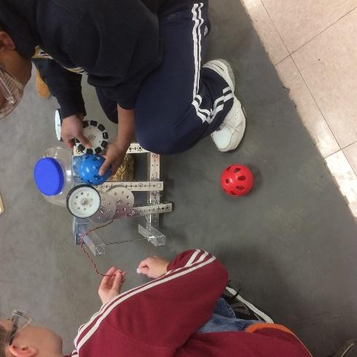 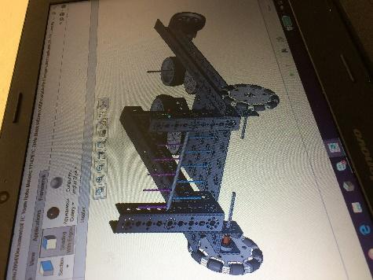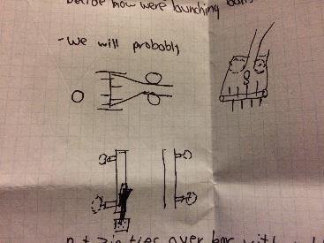

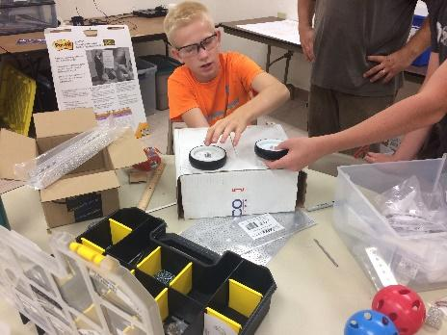

#### Submitted By Vishnu

**Beacon Pusher**

**Meeting Date:**Sat, 12/10/2016

**Personnel Present:**Vishnu, Ezra, Kyle, Jake

**Tasks This Meeting:**

* Design Mechanism for Beacon Pusher
* Use Servo to push the pusher forward or backwards
* Design a 3D part for the Pusher

**Reflections:**

In today’s meeting, we brainstormed ideas for beacon pusher and developed a prototype. Our Creo Designer designed the prototype. We liked the model and printed the beacon pusher on the 3D print. At the same time Ezra and Kyle worked on creating an attachment for the beacon pusher. We used the rack and pinion track and wheel to create the attachment. We designed the attachment in such a way that the beacon can be pushed forward by setting the Servo to 1. We found some issues where the track comes out of the attachment. To fix that we put a tight screw to the end to stop from jumping out of the track. We got the 3D printed part and attached to the end using the angle bracket. We tested the pusher and it works perfectly fine all the time.

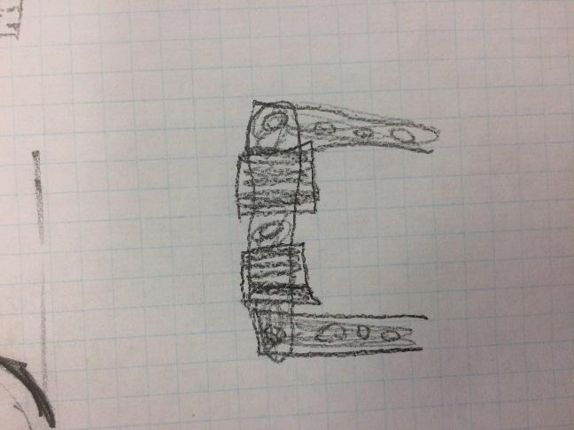 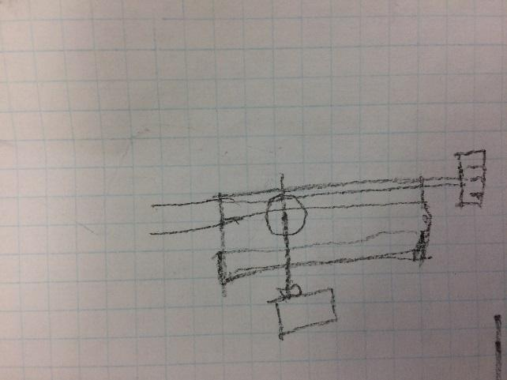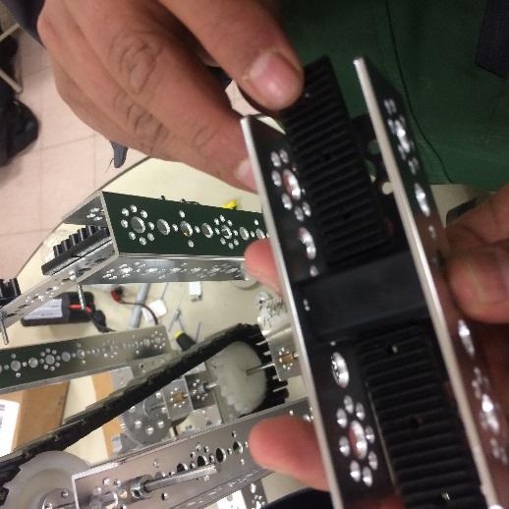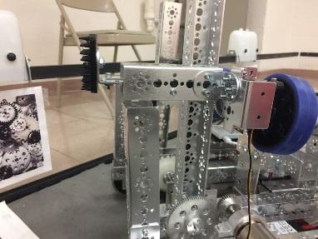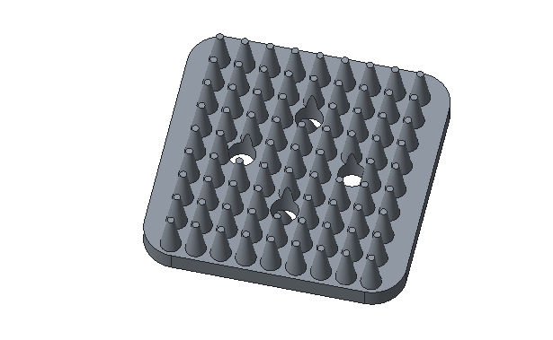

Submitted By Kyle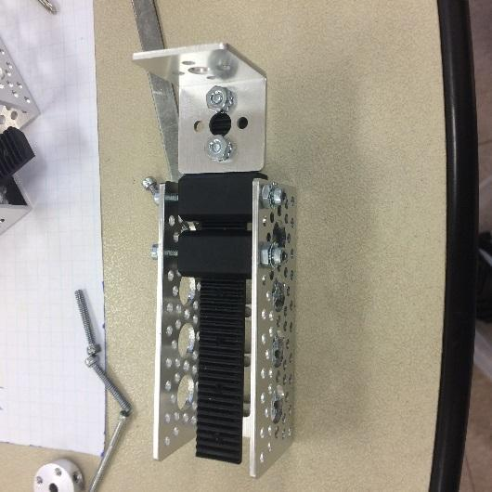

**Ball Lift**

**Meeting Date:**Sun, 12/04/2016

**Personnel Present:**Vishnu, Ezra, Kyle, Jake, Max, Owen

**Tasks This Meeting:**

* Design Mechanism to push the ball between wheels
* Use Beltway mechanism to grab the ball
* Use plastic square pieces to put in belt to provide the lift mechanism

**Reflections:**

In today’s meeting, we decided to use belt to grab balls and the square plastic pieces will help to push the ball between the ball shooter. We connected the belt using two hollow spiral modules connected by an axle. One end of the axle has a motor connected. We tested couple of balls and it went well. We use the plates to provide guide for the ball to roll. We had some difficulty at the join of two plates as there is more room between the belt and the plates. It was taking long time for the ball to go through the shooter. We decided to bend the plates and added zip ties to push the ball faster. It worked fine and we assembled the piece into the robot.

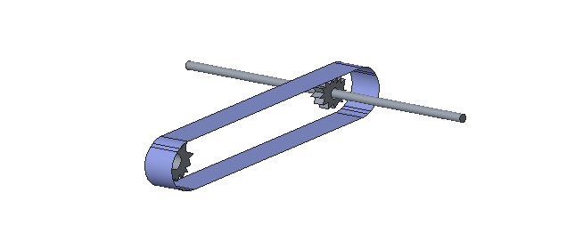 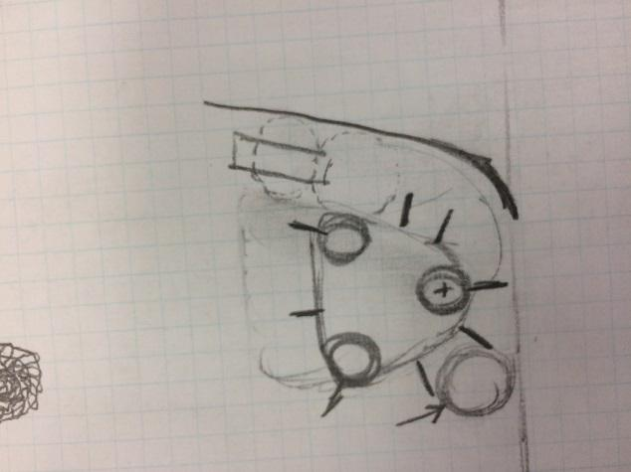

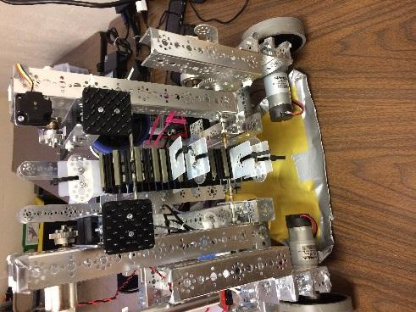 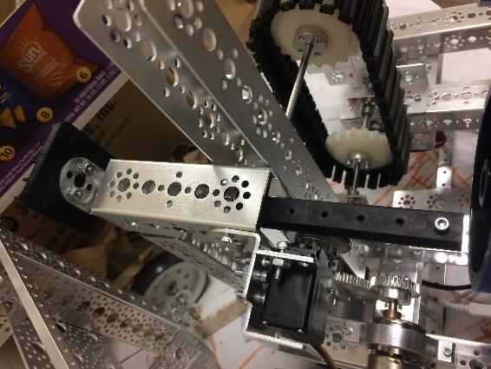

#### Submitted By Ezra

**Second Scrimmage - Bellevue High School, Bellevue**

**Meeting Date:**Sat, 12/17/2016

**Personnel Present:** Everyone

**Tasks This Meeting:**

* Go through Scrimmage process
* How to do Scouting with other teams
* Maintain Gracious Professionalism by helping other teams

**Reflections:**

We had several issues with our Robot. Weather was also a factory. There was a winter storm and we are not sure whether the scrimmage will be on or called off. Our fixes to the robot took lot of time and we din’t give programming team enough time to program. We spent lot of hours on Friday fixing the program and robot. Our Autonomous was not that perfect and our ball grabber was also not working properly. We did spend some time on Saturday morning on programming and took the robot as we got a call that scrimmage was on and they are playing only one tournament instead of dual which was announced earlier. We reached the venue and quickly went for Hardware and field inspection. We did okay in the first round and the problems started for us. Our Chain broke second game and we were forced to skip ball shooting. In the third, fourth, fifth we had issues with robot stopping all of a sudden and started throwing several errors. (Warnings). Overall not a good scrimmage but the positives from the meet are we came to know more what’s causing the warnings, our beacon pusher was flawless. 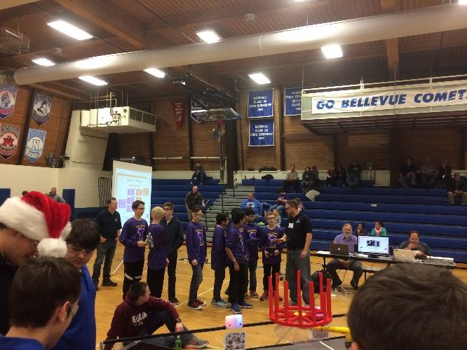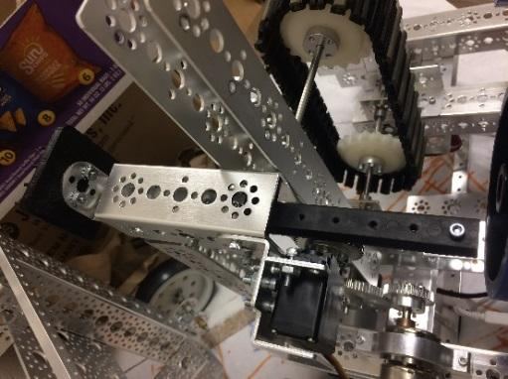

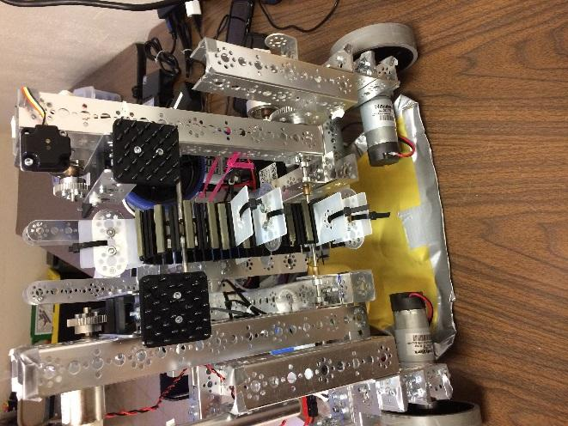

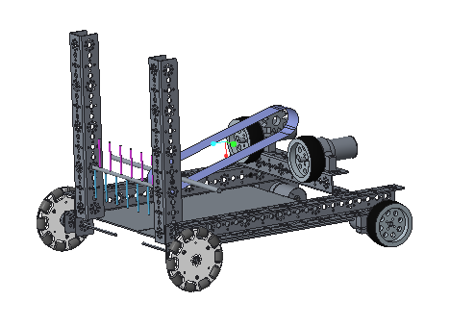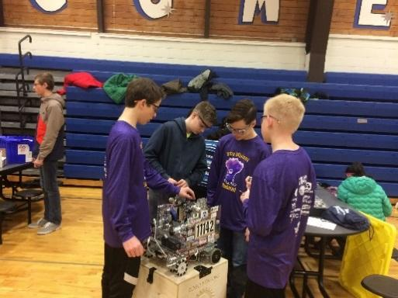

#### Submited by Tarun

**Discuss Scrimmage Issues**

**Meeting Date:**Sun, 12/18/2016

**Personnel Present:**Vishnu, Ezra, Kyle, Jake, Max, Owen

**Tasks This Meeting:**

* What went wrong?
* Why the wheels are not spinning?
* Problems with ball grabber.

**Reflections:**

In today’s meeting, we brainstormed the following:

Q) What went wrong & why?

Inside the BaneBot motors the gear slipped causing one of the wheel to stop running.

Solution: Try BaneBot wheels and ask Andy mark for a replacement motor.

Q).Warning Error and Robot stop?

Solution: One of the team on the twitter suggested to use 3D printed parts which will hold the connector to Modern robotics devices. This will help in fixing the loose contacts and staying the connections alive.

Q). Ball Grabber Issues:

The distance between the ball and the belt at some points are so tight the chain will break due to friction of ball getting stuck and motor running continuously.

Fixes:

1). Put the belt at an inclined angle. Instead of shooting up make sure to put the wheels at the corner instead of top.

2). Finally move the beacons to the side so that there is lot of space for the ball thrower and the belt to be set at inclined angle.

Submitted by Vishnu

**Beacon Pusher & Ball Grabber Changes**

**Meeting Date:**Sun, 12/24/2016

**Personnel Present:** Ezra, Owen, Nikhil

**Tasks This Meeting:**

* Move beacon pusher to the side
* Move the belt at an angle
* Replace wheels with BaneBot wheel for more Grip.

**Reflections:**

In today’s meeting, we

started taking all parts of the robot and started moving the beacon pushers to the side. We printed bigger squares for the beacon pusher. We inclined the wheel at an angle so that there is more space for the ball to flow through. And we moved the wheels for ball shooter to the end of the robot. We took more caution and make sure there is enough room between the belt and the attachment so that ball can roll over smoothly. We made sure to build a channel and put some foam in places where the distance between the ball and belt is more. This has provided an nice way for the ball to move through the channel.

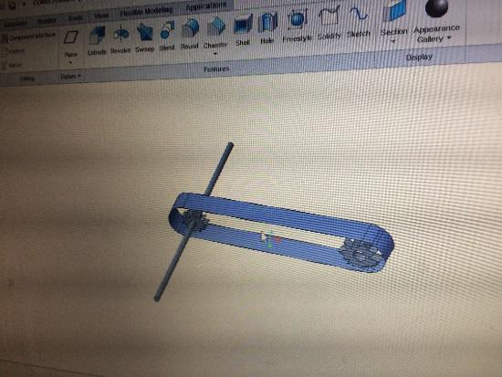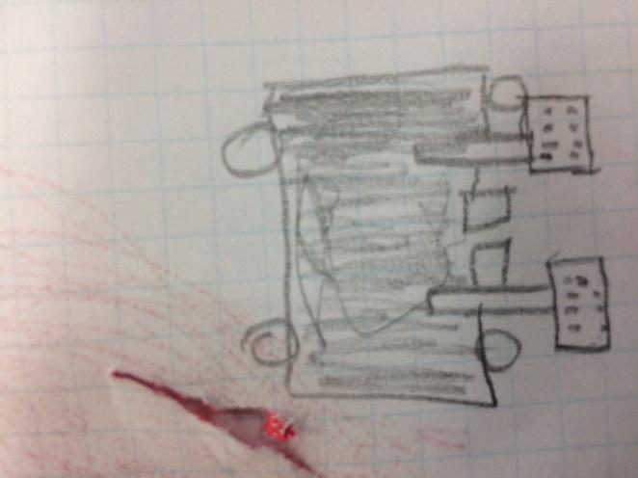

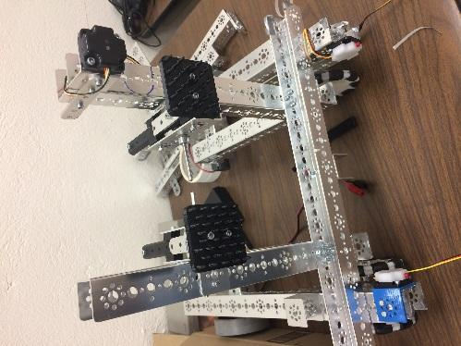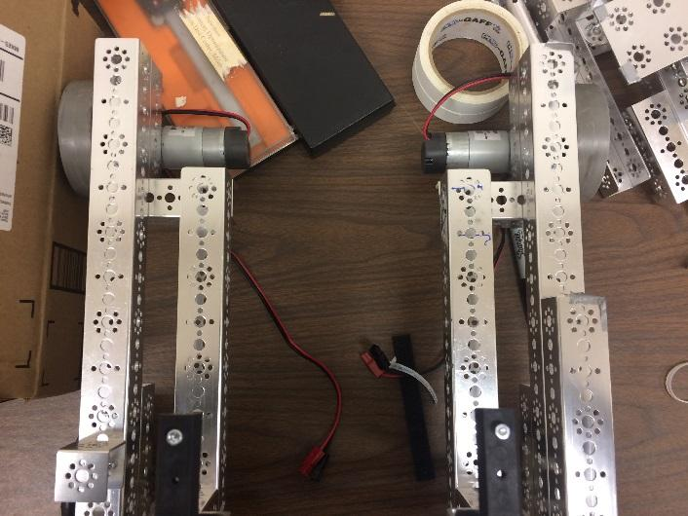

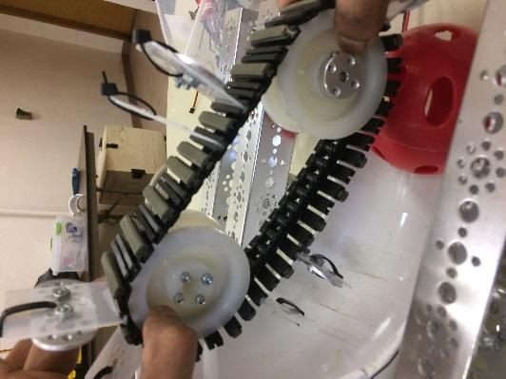 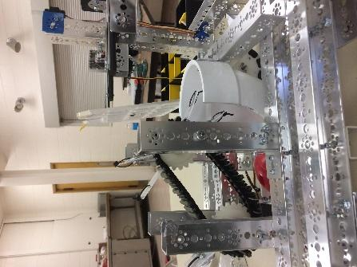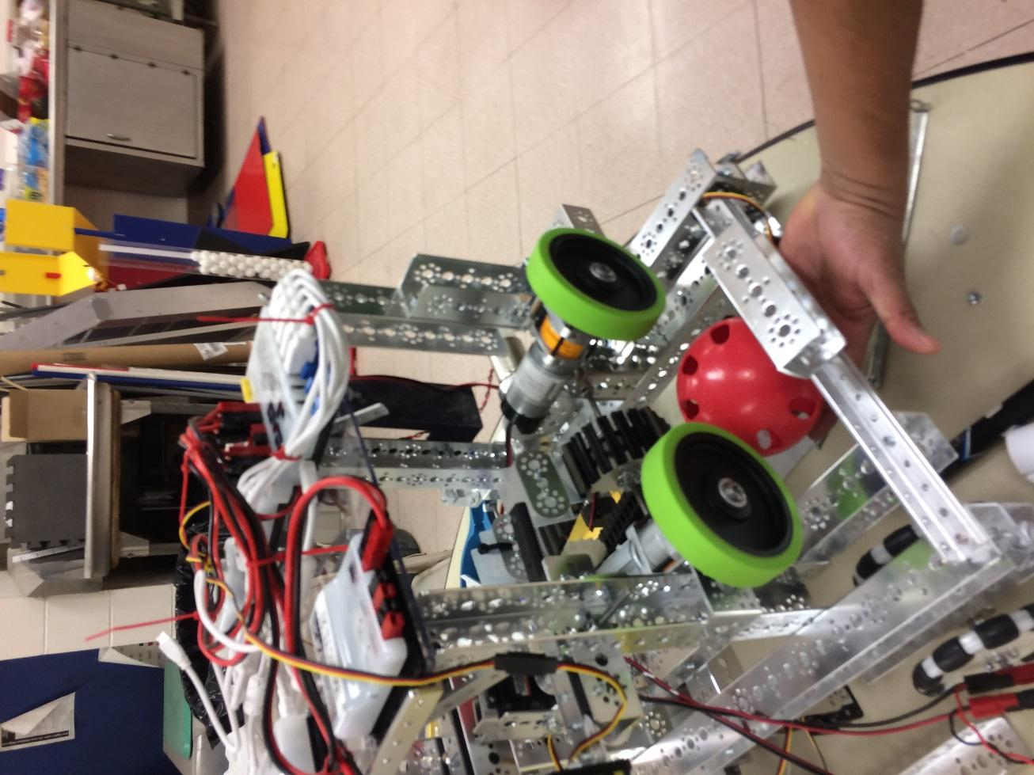

#### Submitted by Nikhil

**Third Scrimmage - ARCONIC Learning Center, Bettendorf, IA**

**Meeting Date:**Sat, 1/7/2017

**Personnel Present:** Everyone

**Tasks This Meeting:**

* Go through Scrimmage process
* How to do Scouting with other teams
* Maintain Gracious Professionalism by helping other teams

**Reflections:**

We are joint host for this scrimmage and it’s a dual meet. So lot of games and we want to make sure we put a good show at our home ground. We made sure all our issues are fixed programming team was given enough time. Our Robot is much better this time. In the final moment we decided not to go for ball grabbing during our tele-op mode. We went for beacon push in autonomous and we didn’t have much success but we are able to dislodge the cap ball and park along with shooting balls in center vortex. Though we didn’t had good luck we consistently scored 50 points every round. Our beacons to the side had some advantage and disadvantages. We are not able to move freely due to two wheel drive. We already decided in the match we are going to go with Macanum wheels. Since it’s a dual meet we made sure to check on wheel and make sure to fix them every round if needed. Some of our team member helped at the concession stand in pit area. Overall it’s a good scrimmage lot of positives to take from this dual scrimmage.

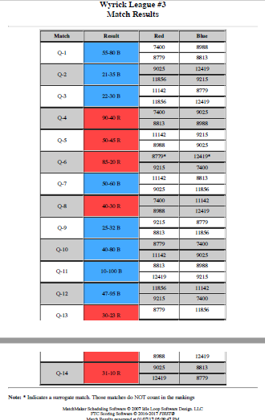

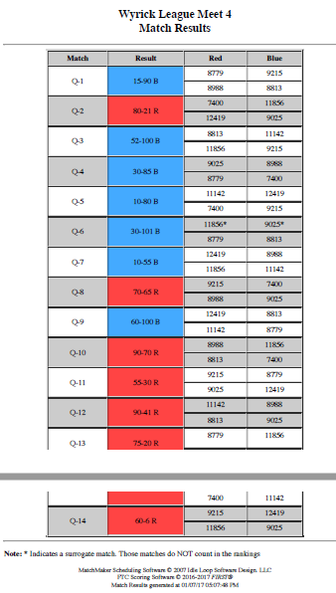

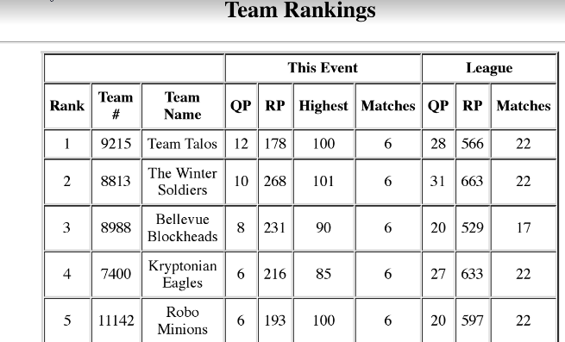

 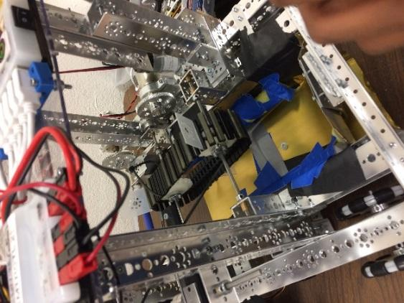

Sub u

**Submitted by Ezra**

**Discuss Scrimmage Issues**

**Meeting Date:**Sun, 1/8/2017

**Personnel Present:**Vishnu, Ezra, Kyle, Jake, Max, Owen

**Tasks This Meeting:**

* What went wrong?
* Why the wheels are not spinning?
* Problems with ball grabber.

**Reflections:**

In today’s meeting, we brainstormed the following:

Q) What went wrong & Why?

Inside the banebot motors the gear slipped again causing one of the wheel to stop running.

Solution: Go back to the ball shooter from Scrimmage one for consistency.

Q).Ball Grabber not used?

Solution: Team wants to skip chasing ball. Remove the functionality.

Q). Movement of wheels to press beacons.

Install Macanum wheels for faster movement.

Fixes:

1). Install ball shooter similar to Scrimmage one.

2). Remove ball shooter.

3). Aim for 100 points in Autonomous.

**Ball shooter and Removal of Ball Grabber**

**Meeting Date:**Sat, 1/14/2016

**Personnel Present:** Ezra, Owen, Nikhil, Max, Vishnu, Tarun

**Tasks This Meeting:**

* Remove Ball Shooter
* Rebuilt the ball shooter
* Install Macanum wheels

**Reflections:**

In today’s meeting, we started taking all parts of the robot and started moving the ball shooter out. We installed the ball shooter easily. We provided enough support to the chassis. We installed Macanum wheels but not sure if they are correctly installed or not. We called Brandon Richards from Combustible Lemons he did a face time and told that our install was right but asked to check some mechanical issues.

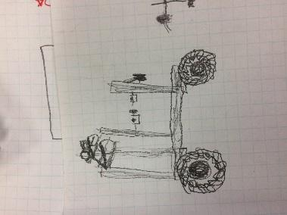 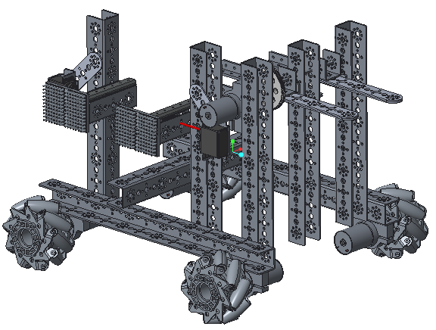

**Submitted by Ezra**



# Team Summaries:

**Pre-Season**

#### [Engineering Note book](#_34g0dwd) 94

#### [3D printer](#_1c1lvlb) overview 98

#### [Android](#_3w19e94) Programming 100

#### [Core Components-](#_2b6jogx) 101

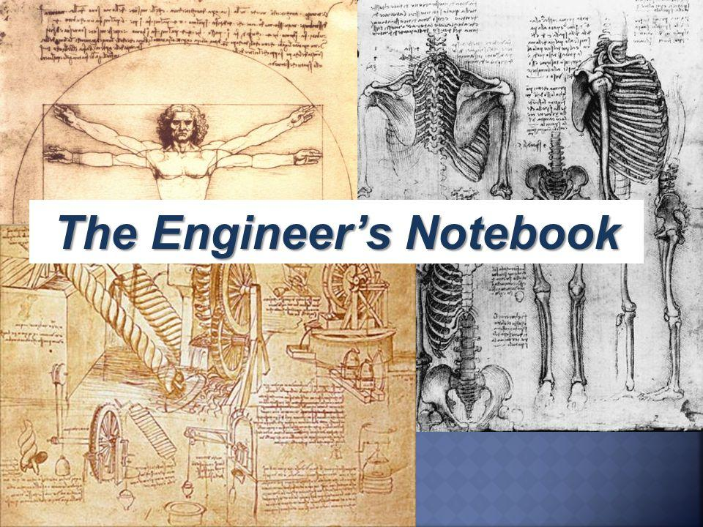

**Engineering Notebook**

**Meeting Date:** Fri, 08/26/2016,

**Personnel Present:** Uma, Nikhil, Tarun

**Tasks This Meeting:**

What format should we use to document Engineering Notebook?

Everyone in the team needs to be familiar with how to document meeting in the engineering notebook.

**Reflections:**

Engineering note book plays a key role in FTC as it is a journal of what we have done in every meeting throughout the season. We considered FTC resources and downloaded some sample engineering note books to understand the format. Initially we started the preseason by printing some sheets and documenting our meeting in the sheets. After seeing the sample we did some online research and we found this team who is giving a free site to document the engineering note book. We taught of writing engineering notebook by hand but our writing is so bad we can’t ready what we have written. So, we decided to find more details on the online engineering notebook. we sent an email and we immediately received an email with our account created. We logged into our account and it was so easy to document the work and add photos etc. We decided to use this as our engineering notebook. There is no issue with writing by hand or drawing as we can upload pictures to our meeting notes.

|  |  |  |  |  |
| --- | --- | --- | --- | --- |
| |  | | --- | | FTC Team Engineering Logs | |  |  |  |
|  | | |

Thank you for your request for a new engineering log.  
  
We have received the following information from the form that you submitted:  
  
  
Team Name: RoboMinions Rebooted  
Team Number: FTC1114  
Location: bettendorf, IA  
Organization: QCESC  
Coach/Mentor: RoboMinions Rebooted  
Contact e-mail: [ftcteam11142@gmail.com](mailto:ftcteam11142@gmail.com)  
Contact Phone: [3097960879](about:blank)  
   
  
Hello RoboMinions Rebooted,

Thanks for your interest in using the FTC online engineering notebook.

An FTC team group is now set up for you to use. You can access your notebook once you've logged in via a menu option at the top or on the left (on the site). Additionally, you can access it directly at:  
[http://ftcengineering.org/FTC](http://ftcengineering.org/FTC7045)11142

Other teams have found that it generally works best for each person that might be editing or entering log entries to have their own unique user ID. Assuming that you wish to do so as well, during the registration process a user can type in an Access Code and be automatically assigned to your team. This Access Code is personal for each team, and team members from any one team cannot see anything about any other team's logs.  
   
Enjoy, have a great season, and if you have any questions please feel free to ask!  
  
Sophia Shaw

FTC6002

Admin

The logs are maintained by **TERA NOVA ROBOTICS, FTC TEAM 6002.**

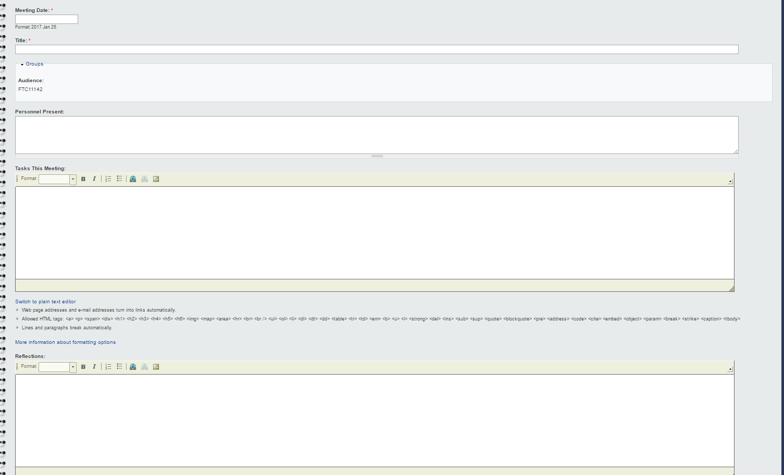

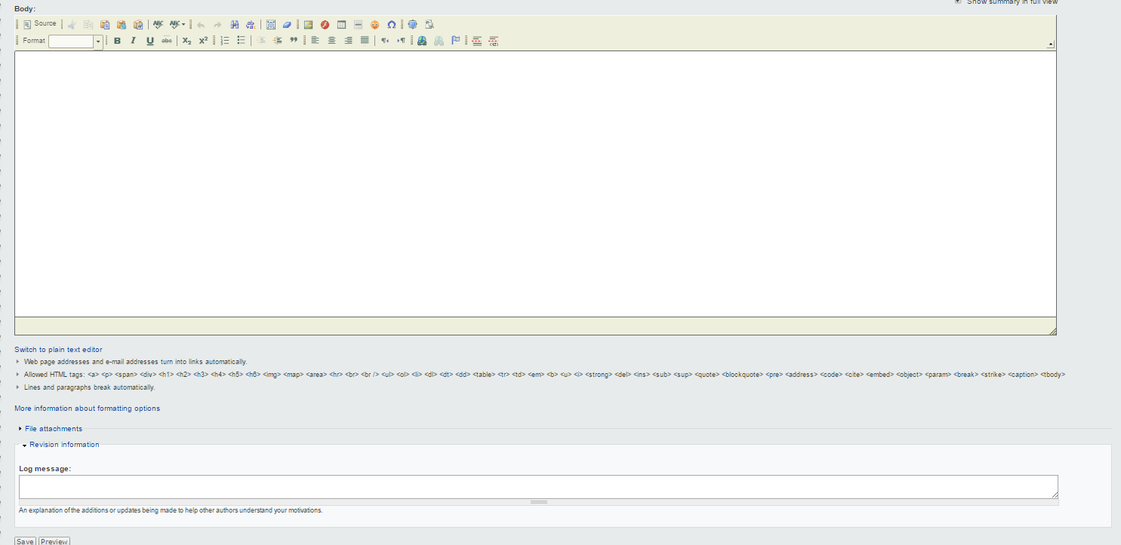

**Submitted By Tarun**

**3-D printer session**

**Meeting Date:**Fri, 11/11/2016

**Personnel Present:**Vishnu, Jake, Kyle, Ezra

**Tasks This Meeting:**

* Learn how to 3-D print a part
* Research on how to convert Creo files to STL files
* 3-D Print Material

**Reflections:**

FRC team 648 QC Elite taught us how to 3-D print a part. We learned that to 3-D print a part we need to use an STL file. We didn't know how to create an STL file, so we did some research on how to convert a Creo file to a STL file.  We figured out in Creo we can export a Creo file as an STL file and can use for 3D printing. We used Cura Software to print our 3D parts. The STL file is converted to a gcode which will be used to Print Parts. We have designed some parts in Creo and then created a STL file. We opened the STL file in Cura and verified how the layers gets printed etc. Once everything looks good. We need to make sure that the part should be flat on the printer. Then we save the file to the SD Card which saves the Gcode.

3D Printer Instructions:

Start the 3D printer, Select the Prepare button and use option Preheat ABS1. This will preheat both the base and the Nozzle. The ideal temperature is Nozzle heated to 240 and base heated upto 120. We figured out before we print any part the Glass (base) should be coated with Glue. This will help in the 3D printed part not sticking to the glass and can be taken out easily. Once the heat is reached we insert the SD card in the slot and select Print from SD and select the gcode name of the file we want to print. When the print starts the 3D printer will go across and clear any filament to the nozzle by brushing it against the brush at the end. Then it select the four coordinates and comes to the center and starts printing.

We did several 3D printings of our parts. The beacon Pusher, The battery holder, Phone Holder, Holder for stacking Electronic components, and ODS censor attachment.

Our 3D printer was from AXIOM WOLF. We had issues with the printer, the nozzle broke once and we sent it for repair. They asked about our FTC program and did the repair for free. Axiom wolf is willing to be a sponsor for our team next year. We are glad that we got a 3D printer company as one of the sponsor.

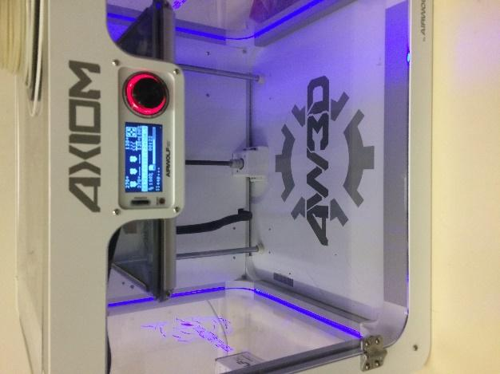 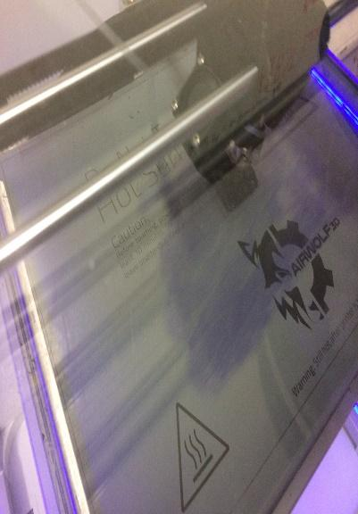 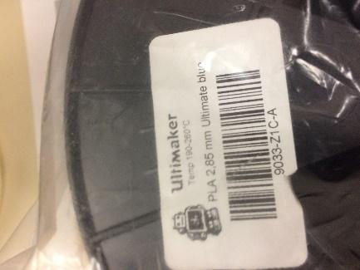

#### Submitted By Vishnu



*Basic Components of a FTC Robot*

Core Power Distribution Module

Core Motor Controller





Android Phone

Robot Controller

Battery

DC Motor Controller

Sensor Controller

Legacy Controller

*Core Power Distribution Module*

This is what is connected directly to the 12 Volt Battery Pack. This module is what sends power to all the different modules. It is the most important part because without it, nothing else will get power. It also has a 20A fuse which means that it can control the power it gets. This is more of a safety aspect so that no one gets shocked.

*Core Motor Controller*

This module is what gives power to the DC motors. These are what give power to things such as wheels or arm lifts. Two motors can be connected to one of these modules. We have been given two Core motor controllers, which means we connect four motors total. But their is no limit to amount of motors so we can use as many as needed.

*Core Servo Controller*

This module gives power to the servos. The servos are basically smaller DC motors and they can be used for tasks with less energy required. An example is turning a pipe to raise a flag, like in the Block Party FTC challenge. You can connect six servos to this module.

*Core Device Interface*

This module supplies the sensors. It has 26 slots for things like touch sensors, color sensors and IR sensors. There is a certain way you need to place the sensors, each row is for a different type. **Submitted By Vishnu.**



# Team Summaries: Early

**Season**

[**PTC Thingworx - IOT**](#_xvir7l) **104**

#### [Outreach Guest Talk](#_qbtyoq) 107

#### FLL Mentoring 109



**Meeting Date:** Fri, 10/14/2016

**Personnel Present:** Max, Uma

**Tasks This Meeting:**

* What is IOT?.
* What is the feature for IOT?
* PTC Thing Worx application

**Reflections:**

IOT stands for Internet of things. The Internet of Things (IoT) is a system of interrelated computing devices, mechanical and digital machines, objects, animals or people that are provided with unique identifiers and the ability to transfer data over a network without requiring human-to-human or human-to-computer interaction. PTC has their own IOT platform called ThingWorx. ThingWorx is the only enterprise-ready technology platform that enables innovators to rapidly develop and deploy smart, connected solutions for the

Internet of Things.

**Why You Should Be Using an IoT Platform**.

Building a complete system for IoT solutions can be a huge undertaking for even the most resourceful companies. It requires a lot of expert know-how, time, and capital – and in the end, companies end up plagued by long IT project cycles and low return on investment.

Ready-built IoT platforms simplify the development of IoT applications. The IoT platform easily connects devices and sensors and enables connections to related information systems and operational assets, delivering more comprehensive business value than a do-it-yourself platform.

As more well-established enterprises are following the lead of the startups into the IoT, s calability is also critical. Ready-built IoT platforms can scale to meet the needs of any company and easily accommodate continual growth and change

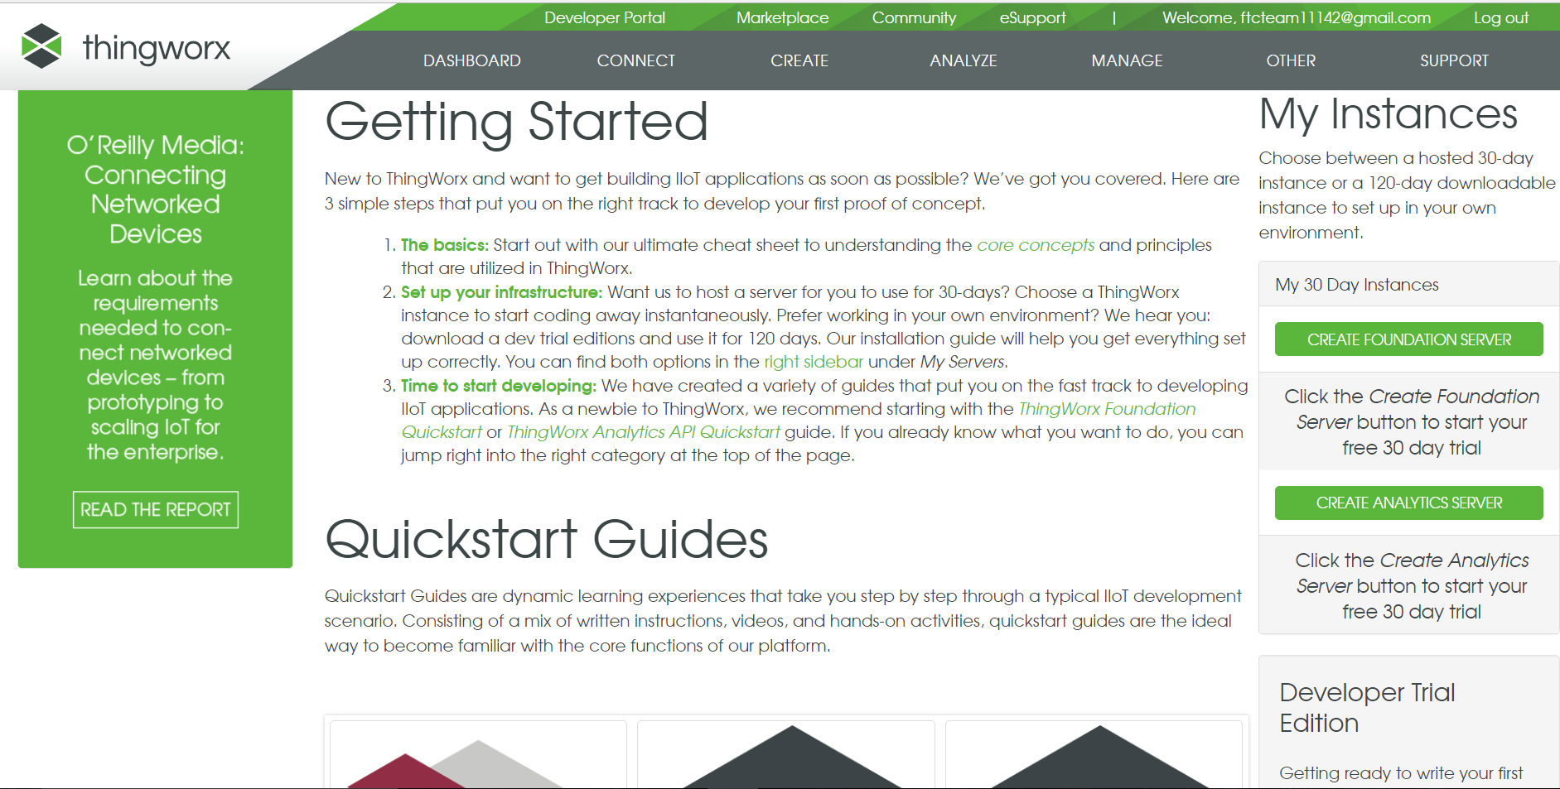

We created a 30 day foundation server and followed the example given in PTC Education. We are amazed to see the results.

Android Smartphones and Thingworx

Collect and Display Data from Your Phone Sensors

In this tutorial you will use the sensors on your Android phone, send data to your ThingWorx hosted instance and then display the data in a pre-built ThingWorx Mashup. The purpose of this project is to let you quickly connect a sensor or set of sensors to a ThingWorx Mash Up and then display that data. This project also removes the need to deal will electronics or programming. Later you can make modifications such as adding additional sensors, modifying the mash up, creating

an alert or using the phone and its sensors to make something smart and connected. [*Tutorial Instructions*](http://www.thingworx.com/wp-content/uploads/academic-program_getting-started-android-smartphones.pdf)  (.PDF)

Getting Started with Android Smartphones Project Files:

This archive contains an Android Studio project that reads data about your Phone’s Type, IMEI, GPS Location, CPU Usage, Accelerometer data (whether the phone was shaken or not), Available RAM and Total RAM to your ThingWorx hosted instance and sends them to a Thingworx Server using REST calls. [***Download Project Files***](http://www.thingworx.com/wp-content/uploads/ProjectFilesGettingStartedWithAndroidAndThingWorx.rar) (.RAR)

This archive contains an xml file that once imported in the ThingWorx Composer will give you access to the pre-built mashup. [***Download Entities File***](http://www.thingworx.com/wp-content/uploads/EntitiesGettingStartedWithAndroidPhone.zip) (.ZIP)

This archive contains the .apk file that you need to install on your phone. [***Download APK Files***](http://www.thingworx.com/wp-content/uploads/APKGettingStartedWithThingWorx.zip) (.ZIP)

We followed these guidelines and here are the results:

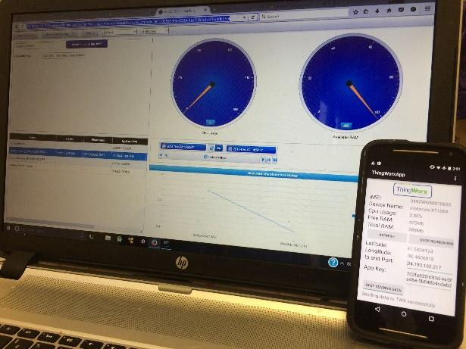 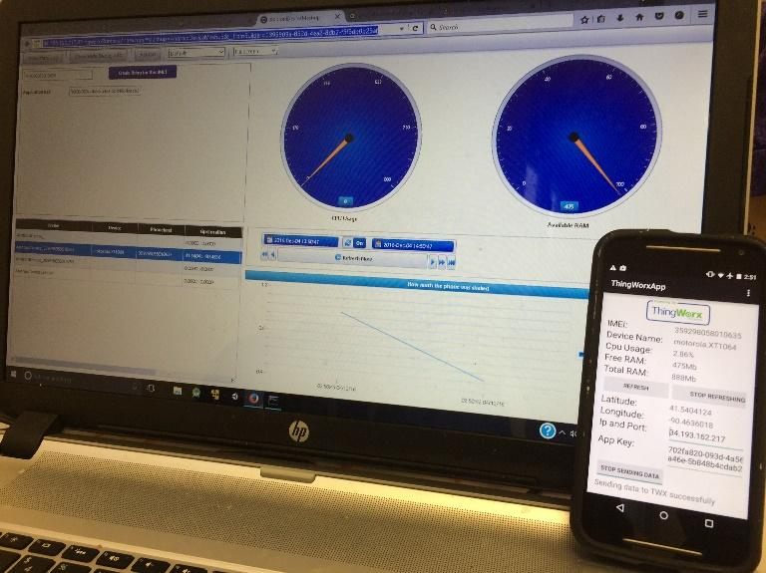

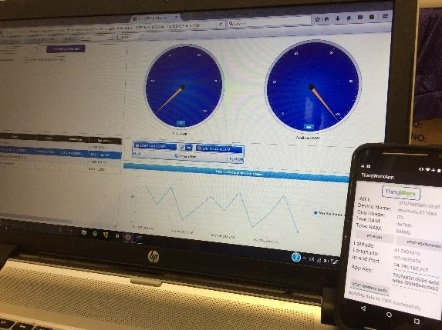

**Submitted by Max**

**Outreach Guest Speaker**

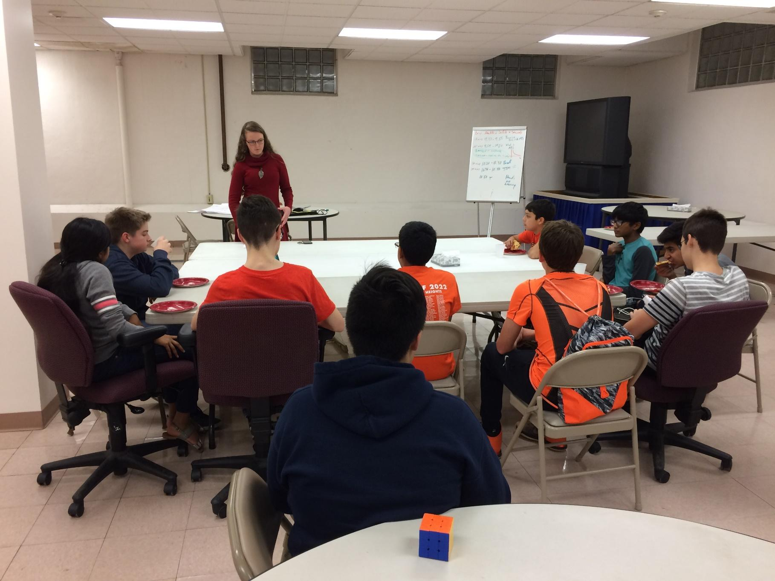

**Meeting Date:** Fri, 10/14/2016

**Personnel Present:** Vinay, Ezra, Owen, Kyle, Max, Tarun, Nikhil, Uma, Vishnu, Jake

**Tasks This Meeting:**

* What Outreach will count for FTC.
* Do any projects we do count?
* Rachel Ekert special guest.

**Reflections:**

It was a really great opportunity to get young kids involved in STEM. We were able to bring FIRST into so many lives and inspire kids and parents to get started! Today we met with so many kids that would soon become FIRST participants. Our Special guest today was Rachel Eckert a team member from FTC

Davenport Central School. We had several questions as what will count as Outreach and what does not. Our initial community events coats for Kids etc will these count for FTC outreach? Rachell answered all our questions about Outreach and other topics. She was very patient and we gained lot of insights on what will work for our outreach and what doesn’t. We came to know for FTC the outreach should be related to STEM activities and promoting STEM in the community. We had nice Pizza dinner after the meeting. We thanked Rachel for taking time to talk to our team.

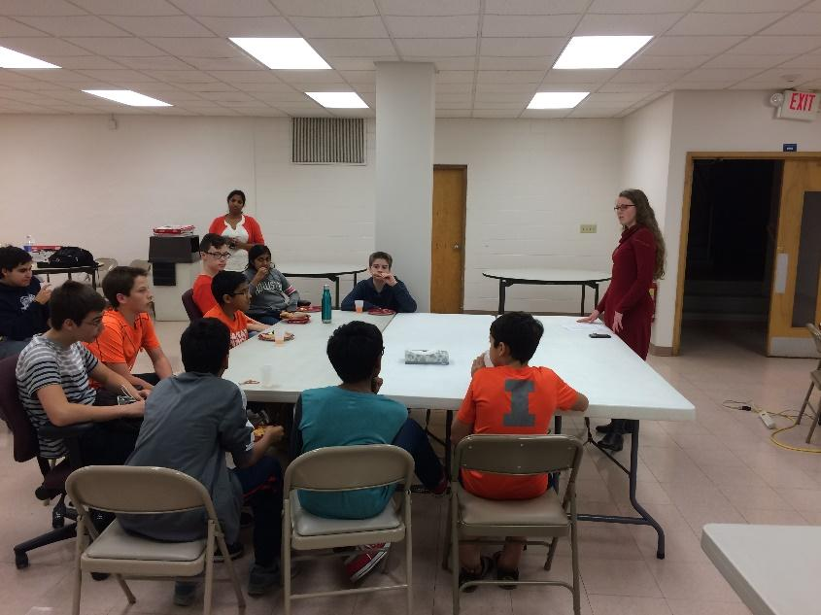

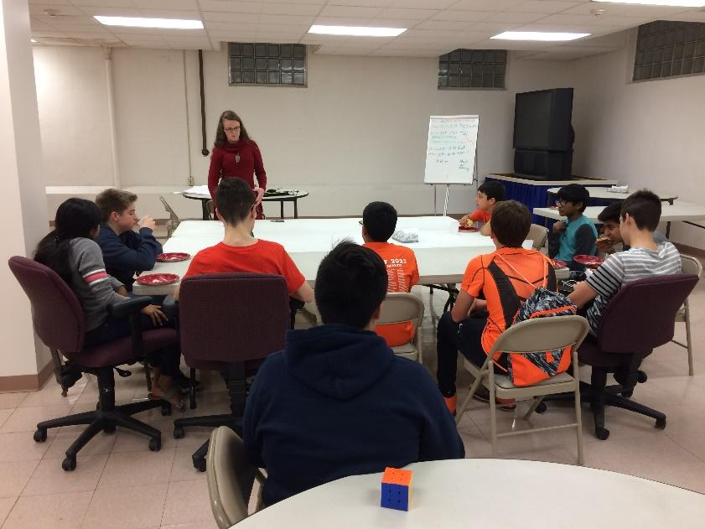

**Submitted By Uma**

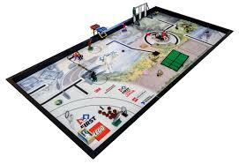

**Furry Logic & MARS team FLL Mentoring**

**Meeting Date:** Fri, 11/24/2017

**Personnel Present:** Uma, Vishnu

**Tasks This Meeting:**

* Lead successful Core Values activities
* Demonstrate good FLL and FTC Core Values

**Reflections:**

Vishnu helped Furry Logic & Mars teams to mentored them in programming. We taught them about strategy and planning their 2 1/2 minutes to get as many points as possible.

We also led Furry Logic in two Core Values exercises. The first one required them to organize themselves in a line by order of birthdays, first time without talking, and second time with talking. When we reflected, we discussed the importance of communication in a team and why it's important. The second activity involved them making themselves into a human knot and untangling themselves, using all their Core Values. After that, we discussed the qualities of good

collaborators. They had some insightful things to say. It was a fantastic experience!

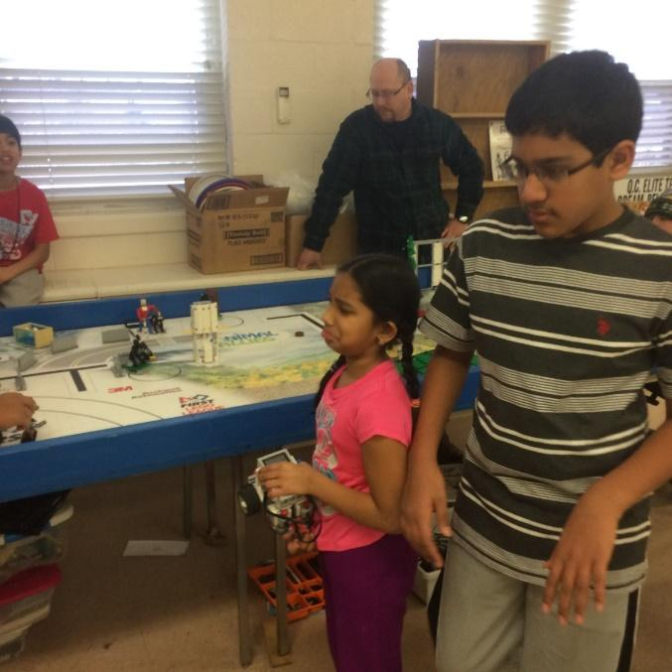

Screenshot of snippet of code.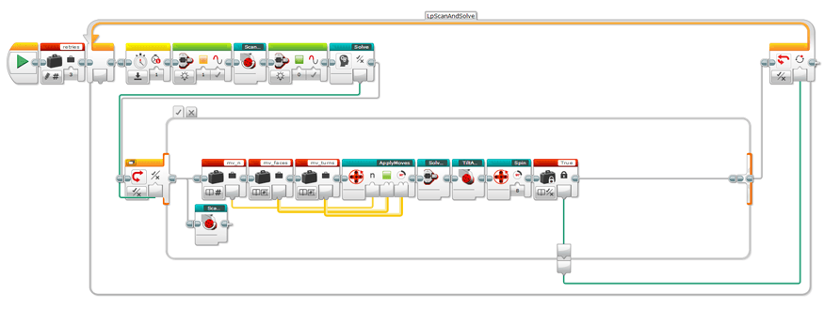

**Submitted By Vishnu**





# Team Summaries: League

**Season**

[**Girls on the run**](#_2w5ecyt) **114**

[**FLL**](#_3vac5uf) **Scrimmage** **118**

[**FLL Regionals Volunteering @Putnam**](#_pkwqa1) ……**121**

**Bake Sale** …….......................................................... **123**.

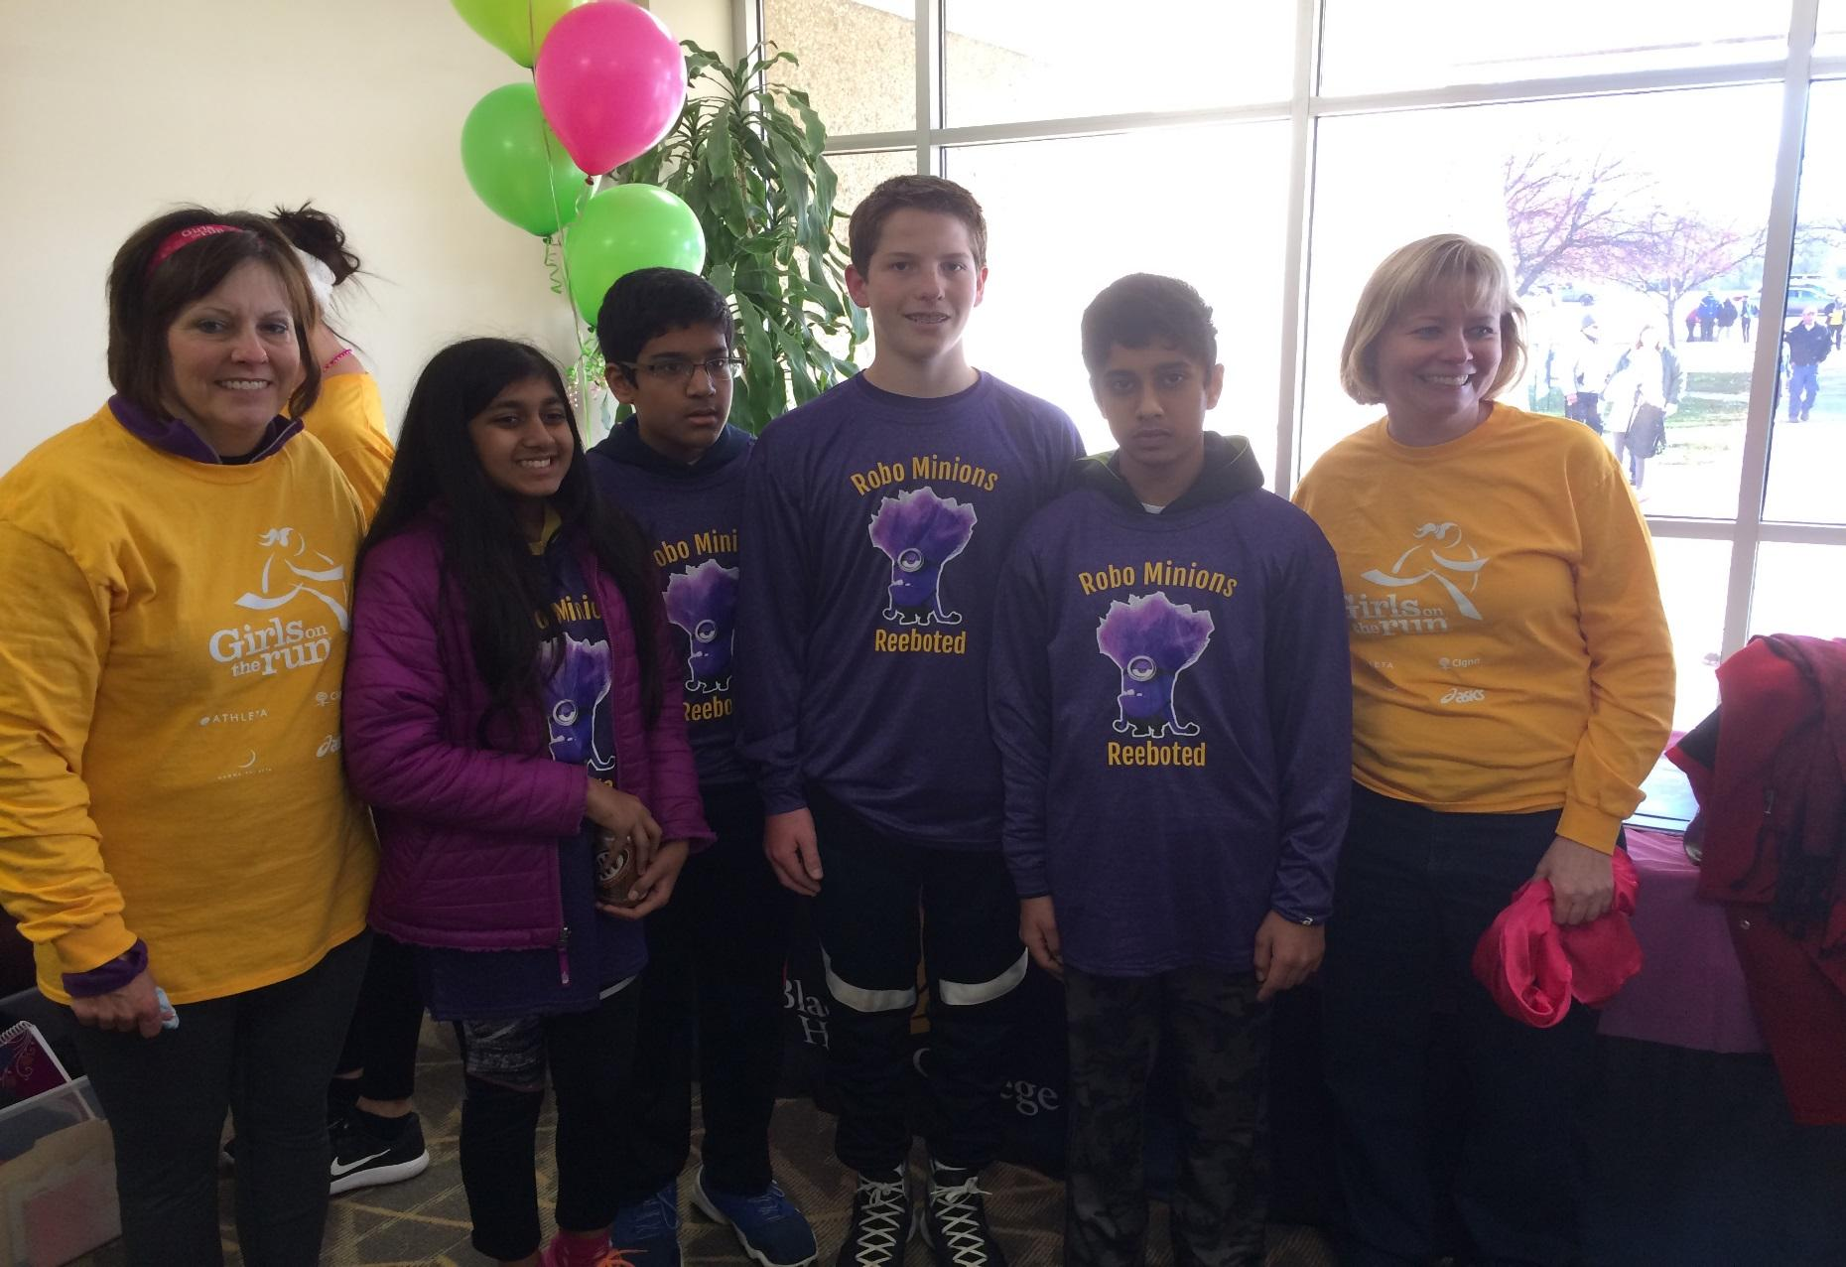



**Girls on the Run**

**Meeting Date**: Sat, 11/12/2016

**Personnel Present**: Kyle, Vinay, Vishnu, and Uma

**Tasks This Meeting**:

* Help out at the Girls on the Run race event
* Have a good time volunteering
* Demonstrate FTC Core Values in everything we do

**Reflections:**

We had a lot of fun volunteering. We helped out a lot of people and demonstrated our Core Values.  During the volunteering event we learnt Running can be used to inspire and motivate girls, encourage lifelong health and fitness, and build confidence through accomplishment. We arrived in the morning. Kyle was made a race official, and Vishnu, Vinay, and I helped direct people to the registration tables. When the race was winding down, we helped direct some of the girls enrolled in GOTR to the refreshments.

Girls on the Run® is a 501(c)3 non-profit organization dedicated to creating a world where every girl knows and activates her limitless potential and is free to boldly pursue her dreams.

Meeting twice a week in small teams, we teach life skills through dynamic, interactive lessons and running games. The curriculum is taught by certified Girls on the Run coaches and includes three parts: understanding ourselves, valuing relationships and teamwork and understanding how we connect with and shape the world at large.

Running is used to inspire and motivate girls, encourage lifelong health and fitness, and build confidence through accomplishment. Important social, psychological, and physical skills and abilities are developed and reinforced throughout the program. At each season's conclusion, the girls and their running buddies complete a 5k running event which gives them a tangible sense of achievement as well as a framework for setting and achieving life goals. The result—making the seemingly impossible, possible, and teaching girls that they can.

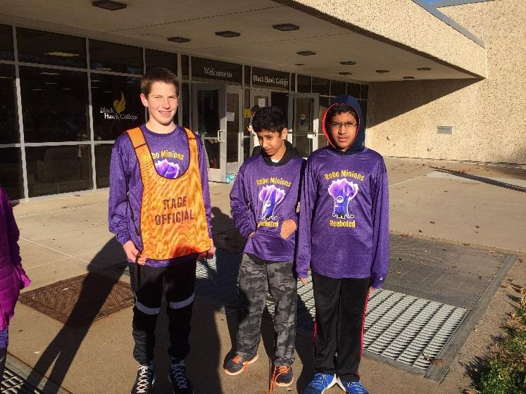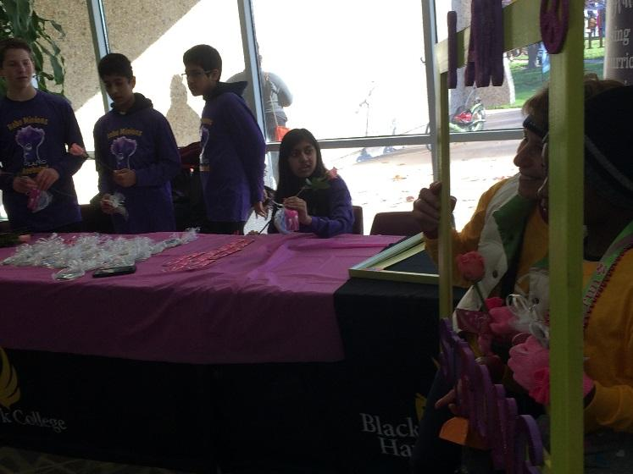

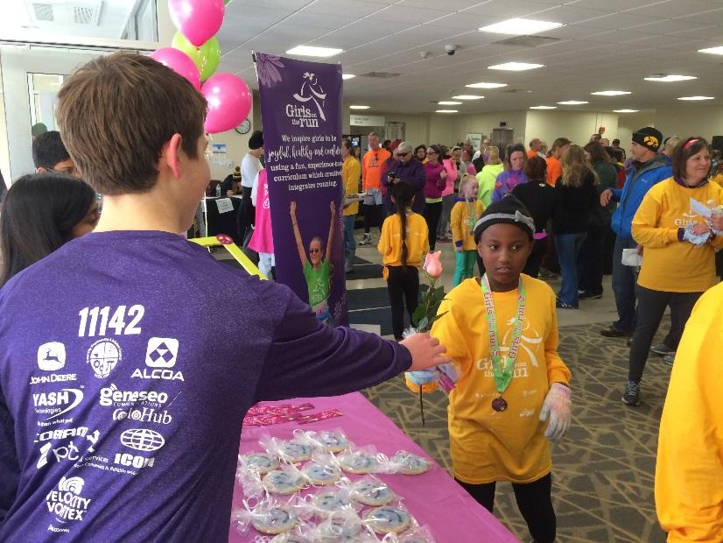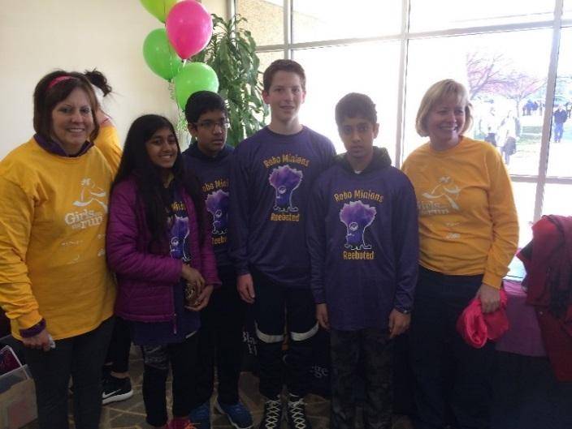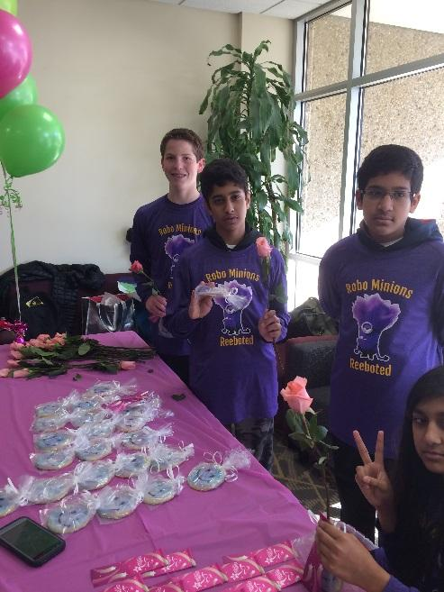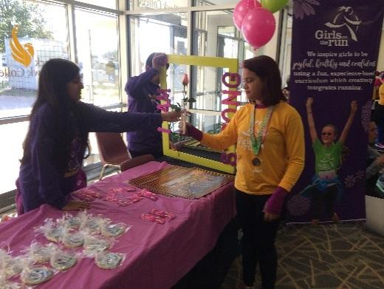

**Submitted By Uma**

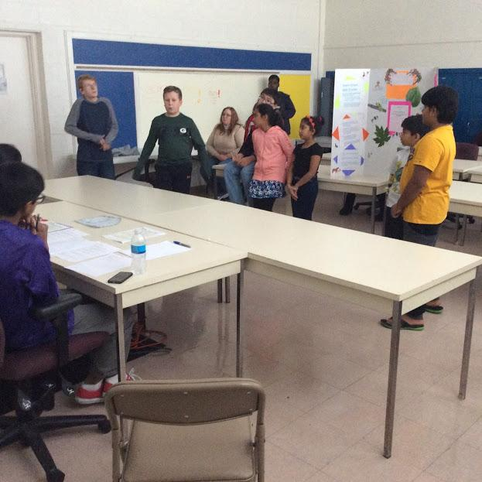

**Meeting Date: S**un, 11/20/2016

**Personnel Present:** Vinay, Max, Vishnu, Tarun, Ezra, Owen, Jake, Kyle, Nikhil, and Uma

**Tasks This Meeting:**

Have a successful scrimmage event

Help teams to identify their strengths & Weakness

Demonstrate excellent Core Values

Preparing FLL teams for Regionals

Overview of FTC and demo of our Robot

**Reflections:**

We feel like we had a successful event. It went off without a hitch, and we didn't face any

problems in the interviews. After we had all the interviews, the judges deliberations went well, and we were all able to agree. During the FTC demonstration, we got to show off our robot, and allow the kids to control it. In the end, we feel proud of what we did.

Before this scrimmage, we created schedules for each of the teams. We gathered some Core Values questions, some Project questions, and some Robot Design questions for our judges to ask. We also printed out the rubrics for each of the interviews and the scoring guide for the Robot Game. We also set up the rooms for each of our interviews.

For the Robot Game, we needed to get two Robot Game tables. We borrowed one table from the team, and decided that we would have only one table. We arranged to have some concessions and created some pit areas.

During the scrimmage, we had no problems, and were able to successfully run the tournament.

Here is our advertisement:

Sunday, November 20

2:00pm – 5:00pm

  FLL Scrimmage !

FTC team RoboMinions Rebooted (11142) will host a drop-in First Lego League Scrimmage using the 2016-2017 competition field and the new missions for the 2016-17 theme “Animal Allies”. FLL team will bring their current robot with programs and a programming laptop and their Mind storm supplies to practice/compete in scoring points from the missions. Referees will be scoring the missions to help assist the team in understanding the scoring.

Activities will be similar to FLL regional tournament where the team can try out their robot and programs and then go back to a workstation and modify their robots and programs to improve their performance. There will be interviews for Robot Design, Core values and the project so that the teams can get some experience during FLL interviews.

The Scrimmage will be in Alcoa Learning center from 2:00 PM until 5:00 PM. To plan the event better please send us an email to [ftcteam11142@gmail.com](mailto:ftcteam11142@gmail.com)  if you are interested in participating.

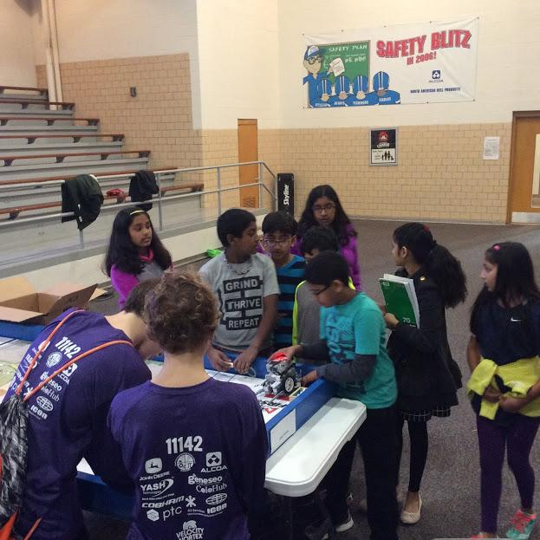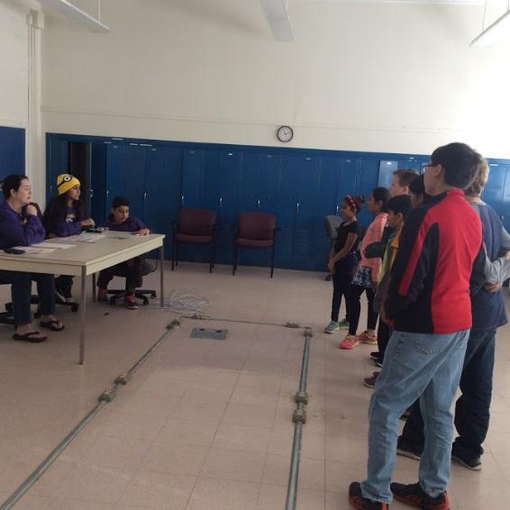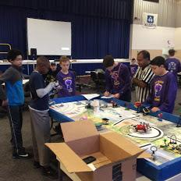 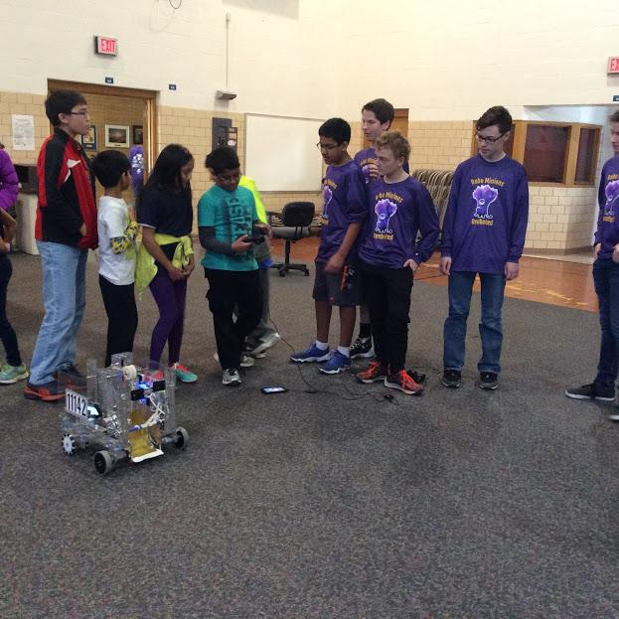

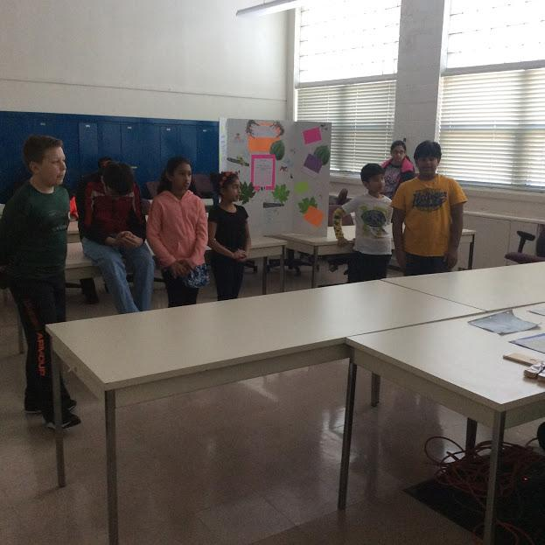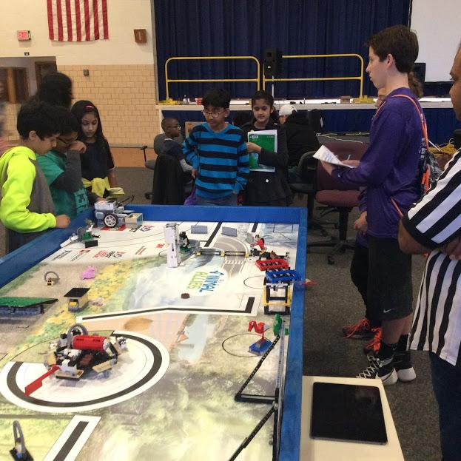

**Submitted by: Tarun**

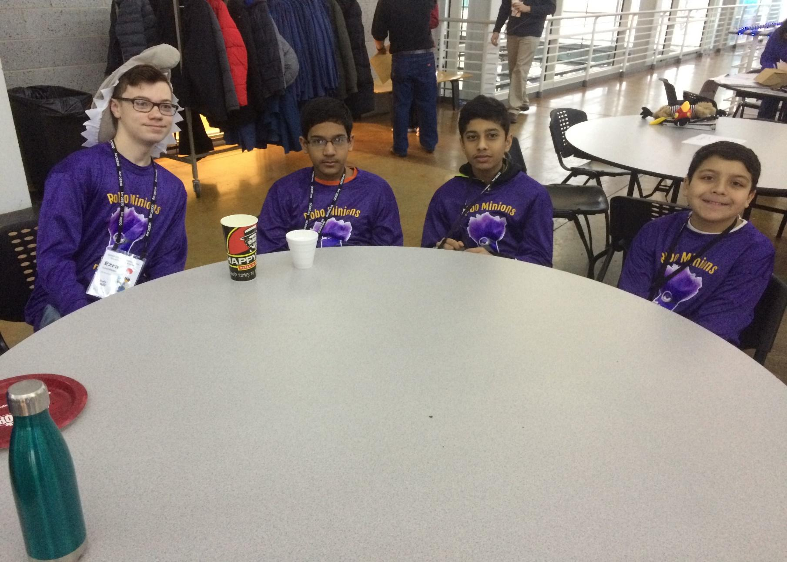

**Meeting Date:** Sun, 12/11/2016

**Personnel Present:** Nikhil, Uma, Ezra, Owen, and Vishnu

**Tasks This Meeting:**

* Help out the FLL teams
* Help the officials hold a successful tournament
* Demonstrate FTC and FLL Core Values

**Reflections:**

We helped out a lot at the tournament. Uma and Vishnu sat at the timer station all day, timing each Robot Game set. Ezra helped carry important messages to the FLL teams at their pits. Nikhil and Owen helped around everywhere, carrying messages, helping teams, and more. We feel like we demonstrated good Core Values. At the end of the tournament, we got to high-five the award-receiving teams. It was a great experience, and we feel so happy we got to help out. Ezra was a pit runner.

Vishnu and Uma manned the timer and music

Owen and Nikhil were floaters

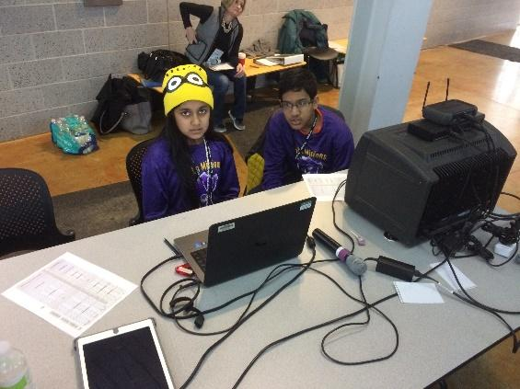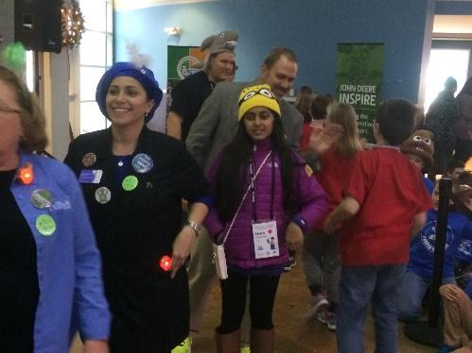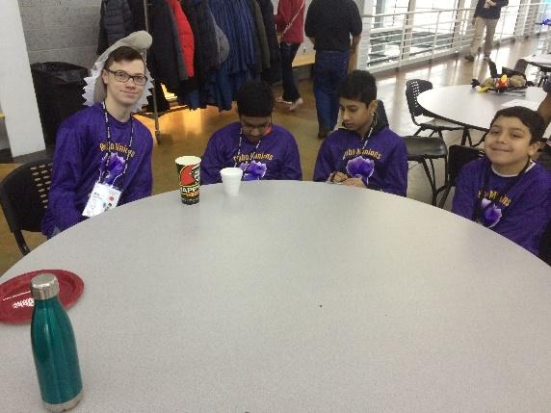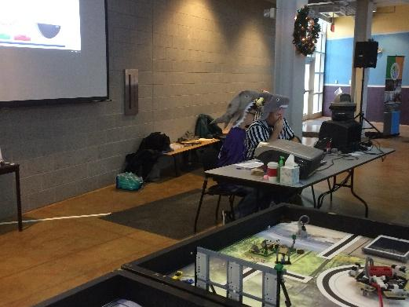

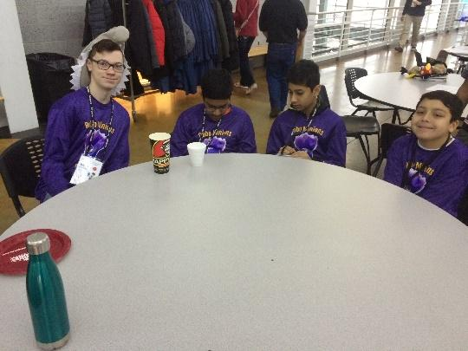

**Submitted By Ezra**



**Meeting Date**: Sat, 1/08/2017

**Personnel Present:** Uma, Nikhil

**Tasks This Meeting:**

* Raise funds for our team
* Spread the word about our team
* Gain any possible supporters or funders

**Reflections:**

We sold everything in the concession stand

Overall, we made a profit of $100

Gatorade and Hot Cocoa were the most popular

If we do this again, we will definitely buy more!

We created a separate Bake sale in the pit areas to serve teams who come early. This event is a dual meet with two meets combining together. Each team played close to 16 matches during the day. We planned a head on what to buy and how to setup the stands. Our team members Owen and Jake helped in printing the prices and sticking them across all over so that the Audience and the teams know where we are and the price of our items. Overall this event is a very effective one in terms of raising funds while serving the needs of other teams.

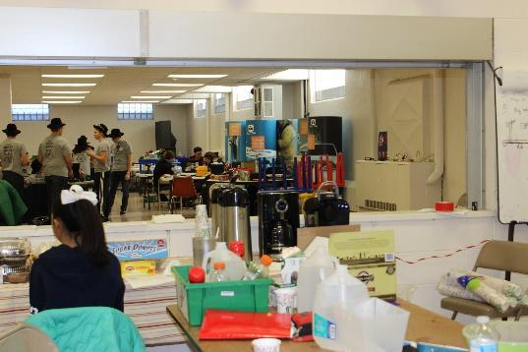 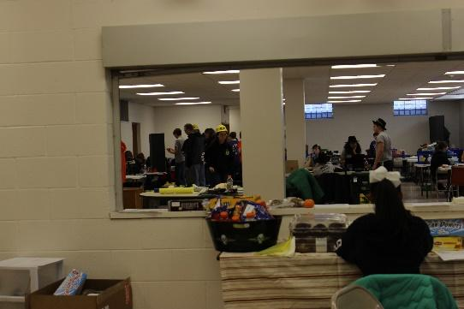

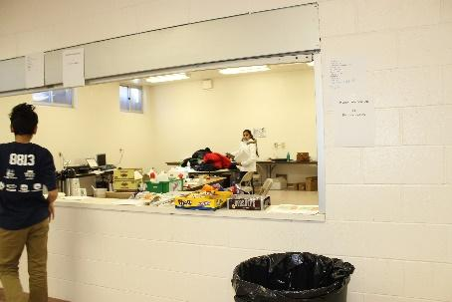 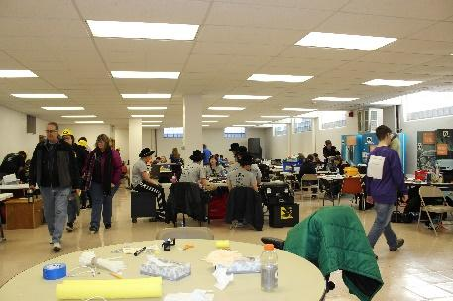

.

**Submitted by Uma**





# Robot Design Process &

**Research**

#### [Electrical Aspects](#_2nusc19) 127

* 1. [Electrical Wiring](#_37m2jsg)
  2. [Encoder Wiring](#_46r0co2)
  3. [USB Connectivity](#_4k668n3)
  4. [Battery Power Options](#_3mzq4wv)

#### [Mechanical Aspects](#_haapch) 141

* 1. [Servo Motors](#_1gf8i83)
  2. [Wheels](#_2fk6b3p)
  3. [Gears](#_3ep43zb)
  4. [Screws](#_4du1wux)

#### [Robot Design Process](#_184mhaj) 145

* 1. [The Robot All Together](#_36ei31r)
  2. [Bill of Material](#_1pgrrkc)

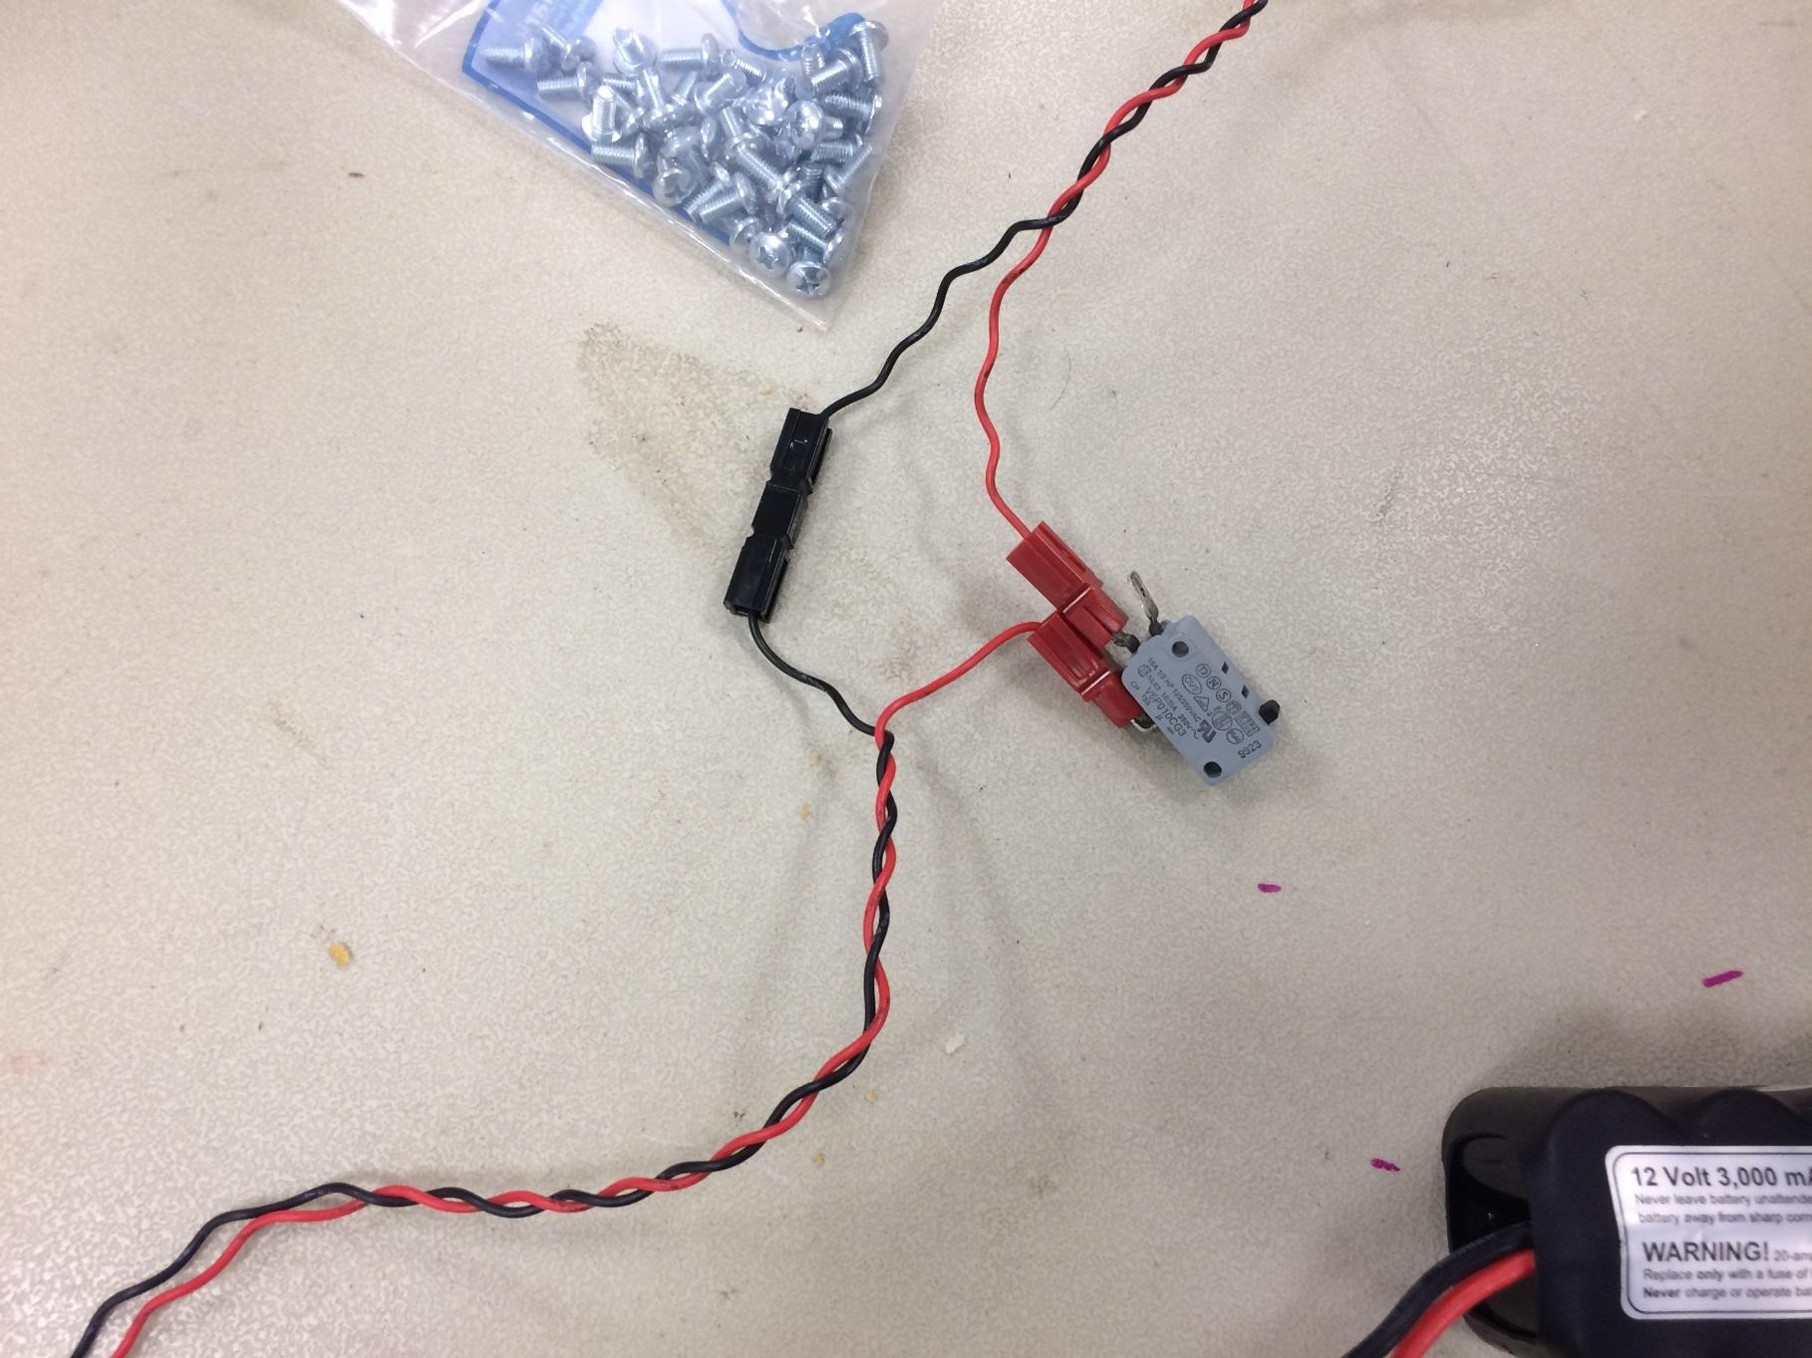





The onboard LEDs can be turned on and off using the checkboxes in the top left PWM output can be controlled using the left frame

PWM time and period can range from 0 - 65534 uS

Pressing “PWM Update” will update the controller with the user input Analog output can be controlled in the top right frame

The output mode can be changed for each port using the buttons associated Voltage in “Volt” mode can range from -4v to 4v peak

Voltage in all other modes can range from 0v to 8v peak to peak

Pressing “Update Analog Out” will update the controller with the user input Analog and Digital ports can be read in the bottom right and are auto-updating

These ports are floating when no sensor is connected and all data received on unconnected ports should be ignored during use

I2C Address List shows all the discovered I2C addresses connected to the I2C port Pressing “Refresh List” will scan for all compatible I2C addresses and display

the ones found and the Device type if it is a MRI branded sensor

I2C Commands allows one to read and write values to a register on a specific address Checking “Poll Read” will continuously update the value field with the contents

of the register selected

Pressing “READ” will perform a single read transaction to the sensor Pressing “WRITE” will perform a single write transaction to the sensor

Change Address form allows modification of the address of a specific sensor if allowed

Change Address form allows modification of the address of a specific sensor if allowed

Only MRI brand I2C sensors support the address change functionality

When changing the address only one device should be connected at one time to avoid multiple devices on the same address.

Pressing the “Change Address” button will change the address of the device and update the address list to display to ensure the address has been successfully changed Addresses can range from (16)0x10 to (254)0xFE and have to be even numbers

*Core Legacy Module*

The Core Legacy Module has six ports for connecting Legacy sensors and controllers. Each port incorporates 10kHz I2C speed transactions as well as Legacy standard analog input. All I2C values can range from 0x00 - 0xFF accordingly.

Pressing the "I2C Address" button located in each port form will auto-detect the i2c address of the device connected

Checking the box next to "Poll Read" will read the register info and analog values continuously

* The Onboard LEDs may be enabled using the checkboxes on the left side of the screen

#### BatteryPower Options

*How a Battery Works*

[12](#_3fg1ce0)The anatomy of a battery consists of two terminals at each end, marked with (-), or negativ, or (+), or positive. These indicate the anode (-) and the cathode (+). The two electrodes are separated by a separator that ensures that the anode and cathode do not touch as the electrical charge flows between them. However, on a 9-volt battery, which is one our robot utilizes, the terminals are situated next to each other on top of the battery. When these two terminals are connected by a wire, the electrons from the negative end flow to the positive end as fast as possible. To avoid possible danger of the high-energy electromagnetic reaction of the battery, a load is connected, which in this case is the Core Power Distribution Module. The medium which the electrons flow through is known as the electrolyte, and the collector conducts the charge to the outside of the battery and through the load.

*Desired Battery Setup*

The basic desired setup of the battery is that the 9-volt unit is connected to the Core Distribution Power Module directly, with nothing else interfering. This ensures the most direct flow of electricity and decreases the possibility of other variables that could disrupt the electricity flow.

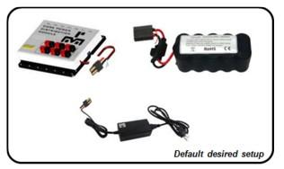

*Battery Failure*

Batteries can fail for a number of reasons. One cause could be faulty factory manufacturing, though that is not the main cause, as factories are usually careful about these kinds of things. The more primary reasons include aging, uncontrolled operating conditions, and improper usage.

*How to Fix Battery Failure*

Sometimes when the reason for battery failure is due to some connection issue, one way to fix it is to replace the battery with Anderson pole connectors or Tamiya connectors. Changing the connectors will help eliminate the issue. The same applies with chargers.

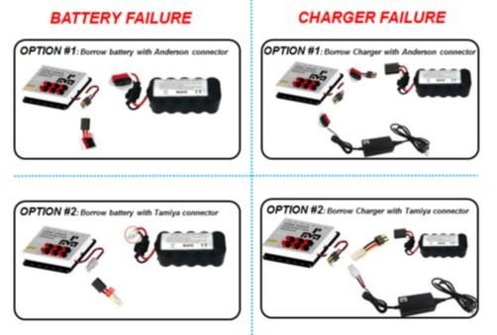

Chart depicting the steps needed to be taken in order to solve battery and charger failure.

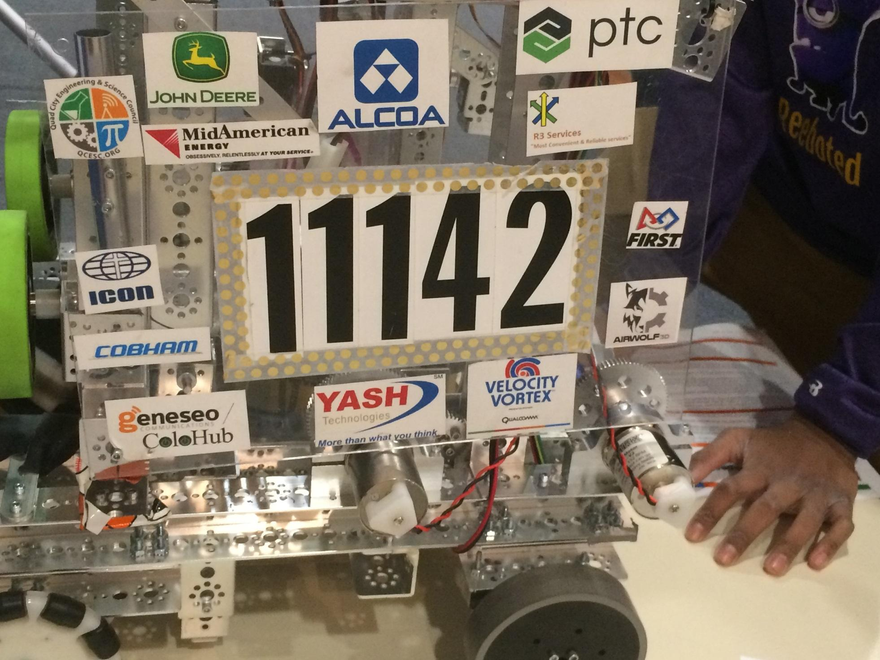

## Mechanical Aspects

#### 46.1 Servo Motors

A servo is a controllable motor and there are many kinds of them. A servo is made up of a two wire DC motor, a gear train, a potentiometer, an integrated circuit, and an output shaft.

Standard Servo

Geared down motor that has a limited range of rotation

Uses an internal electronics to identify the current angle of the motor, and using an input signal, are told what position is desired

Continuous Servo

Does not have a limit on its range of motion

Relates the input to the speed to the output and direction 180 Degree Servo

Has a limited rotation range, cannot rotate past 180 degrees 90 Degree Servo

Has a limited rotation range, cannot rotate past 90 degrees

On the game field, we can use the 180 degree servo to pull down the lever to send the climber down the zipline. We can also use the 90 degree servo to close the lid of the container that holds all the debris we collected.

*Problem*

Servo motor rotation for releasing the climbers was not working consistently.

*Detection*

We learned that servo motor rotation is based on the parameter value passed to function “xxxxxx” in program “yyyyyy”.

#### 46.2 Wheels

*Types of Wheels*

Standard Wheel

Standard cylindrical shaped wheels with rubber on the outer edge for traction are not high tech nor is it expensive

More traction than omni-wheels, mecanum wheels, and even treads More open to traction upgrades

Zip-tied standard wheels can be used for robot on the heavy side (>30lbs), and is a cheap way to gain extra grip on the field

Omni-Wheel

Wheels with smaller wheels embedded on their outer edge

Gives a vehicle equipped with these wheels the ability to move in any direction it wishes, by turning specific wheels in a given direction

The wheels are placed rather unconventionally on the corners of the robot at a 45 degree angle to give the robot the correct vectors and orientation

Stealth Wheel Tread

High chance of coming off during competition More likely to break than wheels are

Treads do not necessarily need to use four motors (two on each side) in order to have decent speed

A simple gear system could allow one motor to run and entire side length of the robot; thus freeing up two motors to be used elsewhere on the robot

Have good grip and traction

* All-Terrain Wheel
* Mecanum Wheel

Can be used to create drive trains capable of moving any direction

With each wheel independently driven, the robot will move forward, backwards, and sideways

These polycarbonate wheels are designed for superior traction

#### Gears

*Overview of Gears*

Gears are simple machines which transmit power from one part of a machine to another. Any number of gears of all shapes ans sizes can be fitted together to do one of the three following options:

Increase Speed

If the first gear has more teeth than the second gear, the second one has to turn round much faster to keep up

This arrangement means the second wheel turns faster than the first one but with less force

Increase Force

If the second wheel in a pair of gears has more teeth than the first one, it turns slower than the first one but with more force

Also known as increased rotational torque (describes later in more detail) Change Direction

When two gears mesh together, the second one always turns in the opposite direction

Specially shaped gears can be use to make the power of a machine turn through an angle

*Four Ways to Use Gears*

Gears for Speed

As explained above, if the gear ratio is greater, the greater the speed will be Gears for Force

Also mentioned above, the lower the gear ratio, the more increased the force and torque

Torque is defined as the tendency for something to produce torsion or rotation Worm Gear

A worm gear is comprised of an electric motor and a screw-like gear to drive a large gear wheel

It reduces the speed of the motor to make the large wheel turn with more force, but it’s also useful for changing the direction of rotation in gear-driven machinery Rack and Pinion Gear

In a rack and pinion gear, a slowly spinning gear wheel (the pinion) meshes with a flat ridged bar (the rack)

If the rack is fixed in place, the gear wheel is forced to move along it If the gear is fixed, the pinion shifts instead

#### Screws

We are thinking about using nylon lock nut inserts or nylon nuts to stabilize our robot. They are used to prevent turning of screws. We are going to use them instead of the 6-32 kep nuts provided in the TETRIX kit. We were thinking we could use them on the flap system because the screws used on it may be more perceptible to loosening.

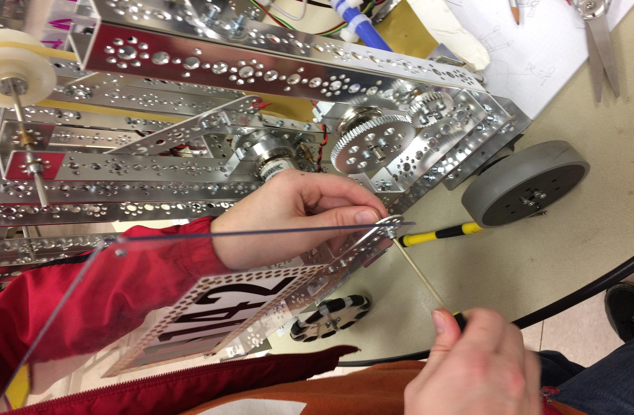

## Robot Design Process

#### Process

There are many different design processes that are available and suggested. We use the **NASA Design Process** because we enjoy the circular aspect of it (Our Goal like “Minions wants to steal the Moon” is to have a stable robot and get maximum points based on our strategy) , because of this we are constantly on a journey and will never stop progressing. Having a step by step method for determining what you are doing is incredibly helpful. It allows our team to stay on task and easily document where you are. The Design Process gives us an overall structure in building our robot and creating different subassemblies. We use as a communication tool and it helps manage robot building as well as any community outreach, programming, and business related projects going on.

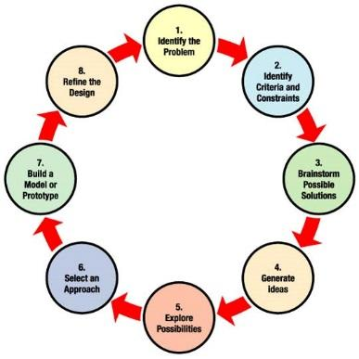

#### 

**State the Problem**: RoboMinions believe defining a clear problem is a key for success. We made sure the problem Is clearly defined before we start working on the Robot. This helped in making sure we got the desired results. Some instances. Due to not clearly defining the problem we got unforeseen problems and the robot did not perform well.

Our Problem definition for the Season is as follows:

* **Pre-Season** – Create a Robot with an arm, Chassis, Wheels (back wheels mounted with Motors and use Gears and servo to lift the arm.
* **Before league Season** – Build a robot, which can throw one ball in center vortex, dislodge the cap ball and park the Robot in center vortex and a beacon presser to change the beacons during Tele-op/
* **During League Season** – Build a robot which can throw two balls in center vortex, pick three balls and shoot in Center vortex along with capturing beacons.

We made sure that our requirements were followed by a schedule. We created defined timelines for every task and made sure that we stick to the schedule to complete the project on time.

**Generate Ideas**: The next step in our Minion design process is Generate Ideas. Each of the design team member Draws a sketch of the idea and explains it to other. We do not limit the ideas and make sure every team member ideas are shared. Then we discuss on each solution and pick the best. Each Ideas is discussed with pros and cons and then finally vote on an idea if needed.

**Build the Item**: We always made sure to build a prototype followed by PTC Creo model before we start building Robot. We used cardboard boxes to build a prototype to create a prototype of the idea. By designing the model in Creo we could see how The item will look in the computer. After the design, we build the Robot.

**Evaluate:** During this stage, we tested the each of the individual components and verifying that the results are matching our requirement. Once we are satisfied with the result we combine all components and add the power modules connecting all the components together and test the final Robot. If there are any issues during the process, we repeat the process and fix the component until we get the desired results.

Here are the ideas generated during Pre-Season, Before league season and during league season.

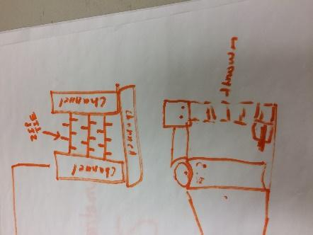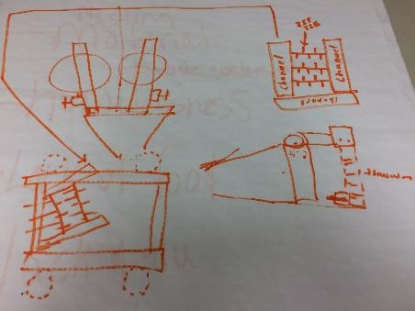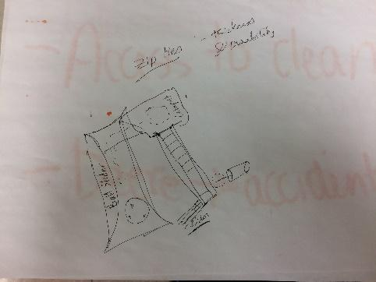

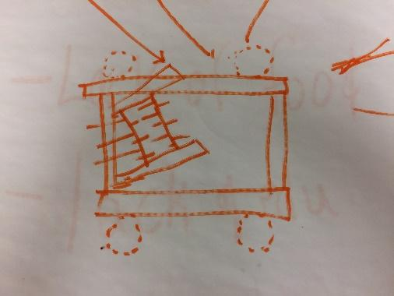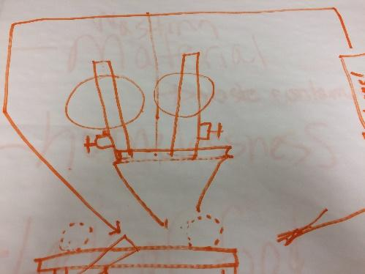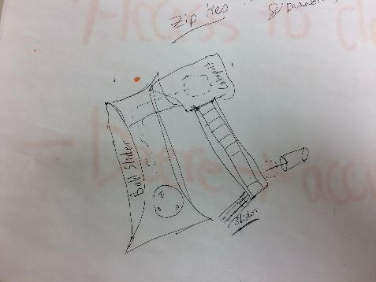

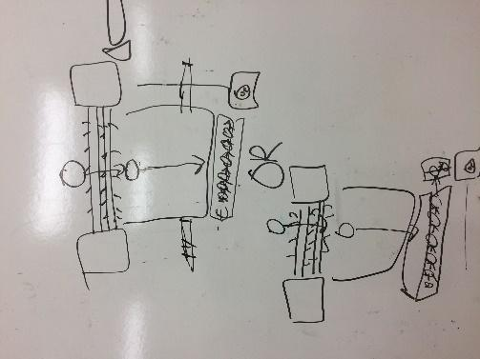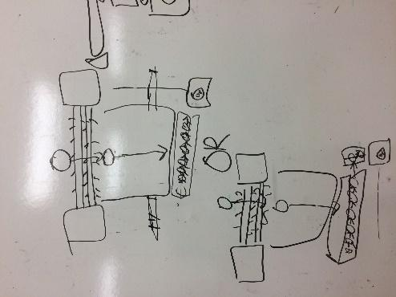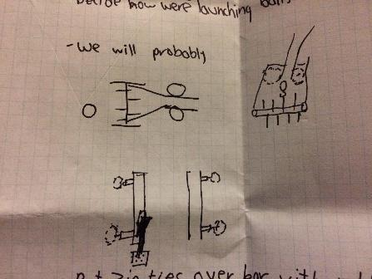

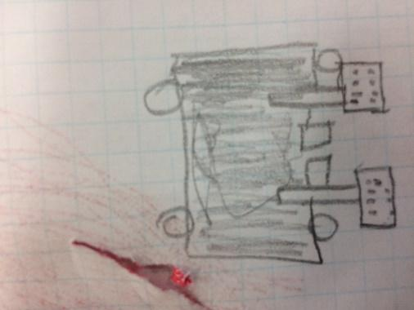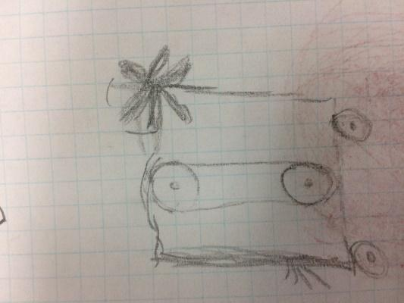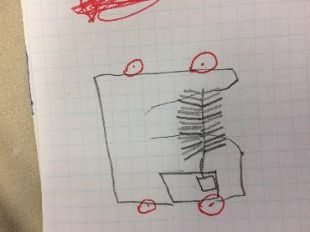

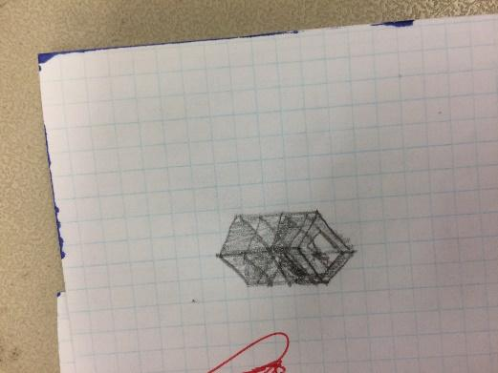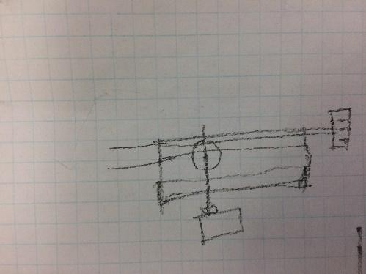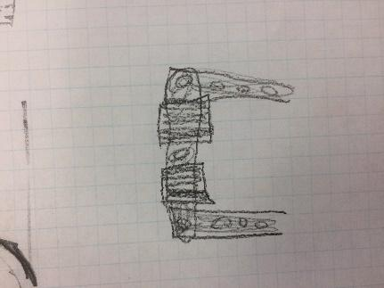

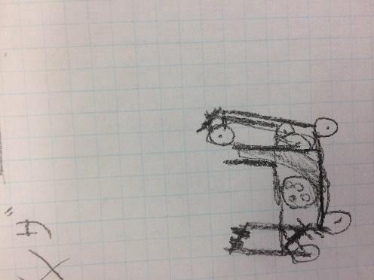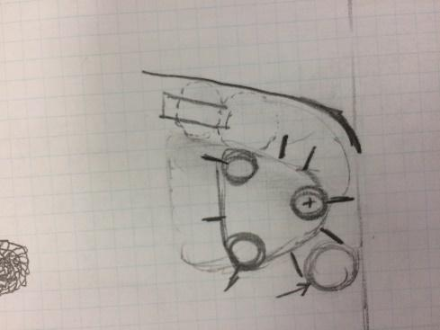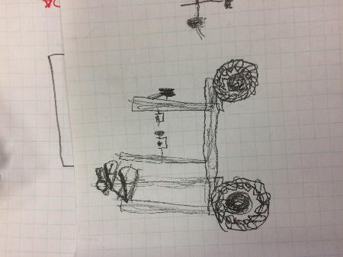

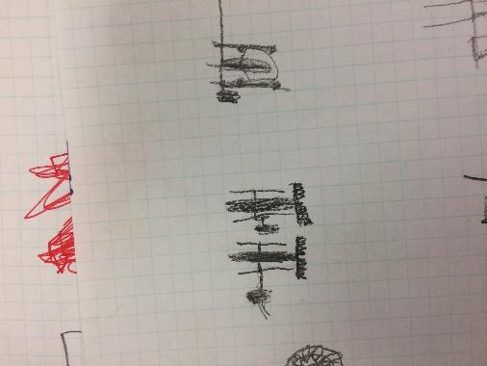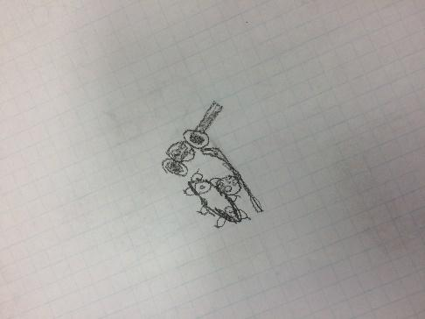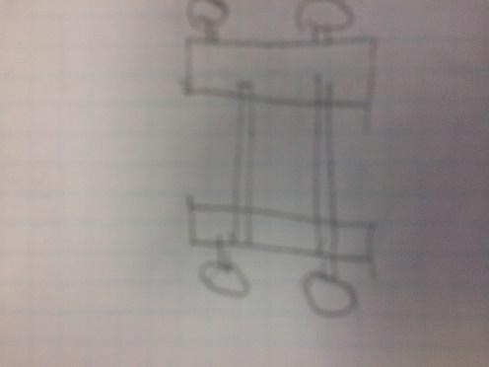

**Prototypes of our Robot during Pre-seaon, before and during league season**

**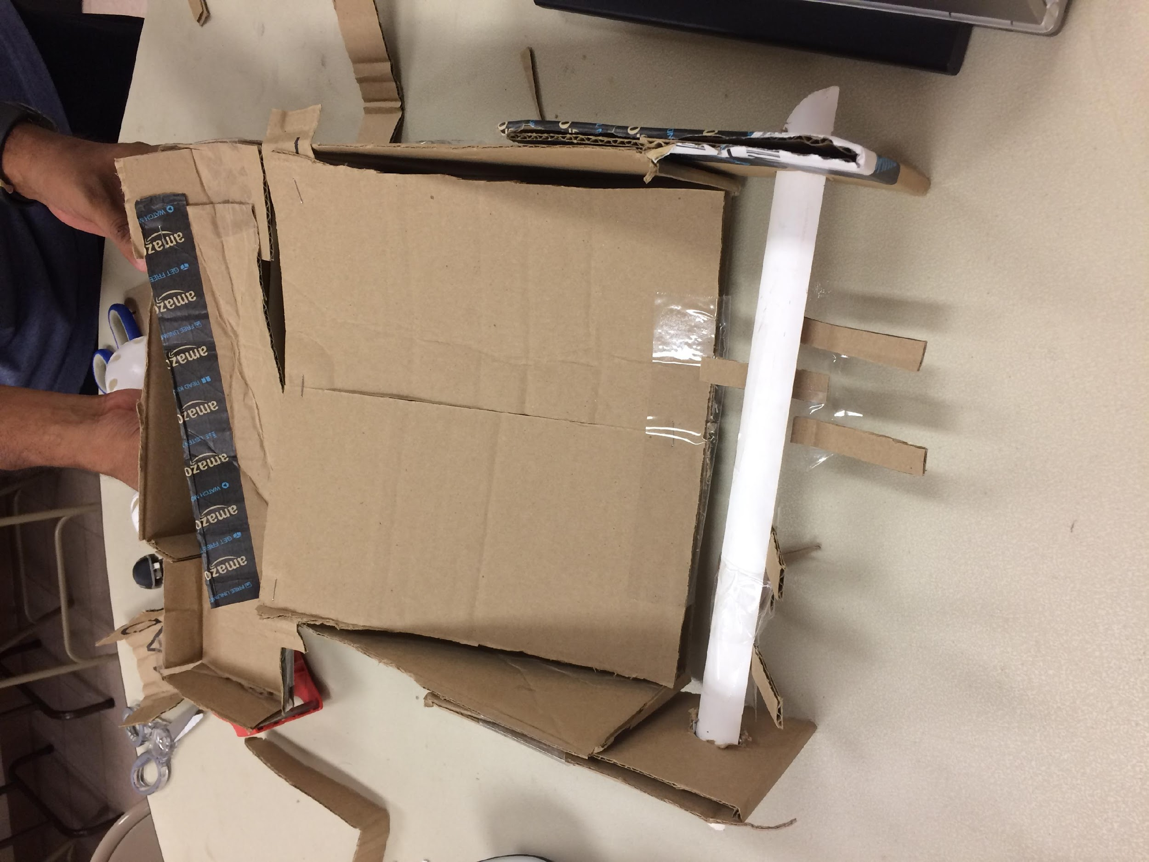** 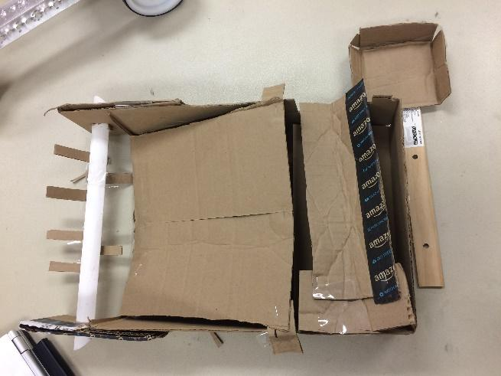

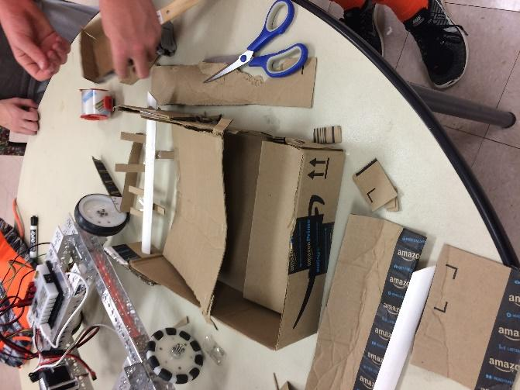 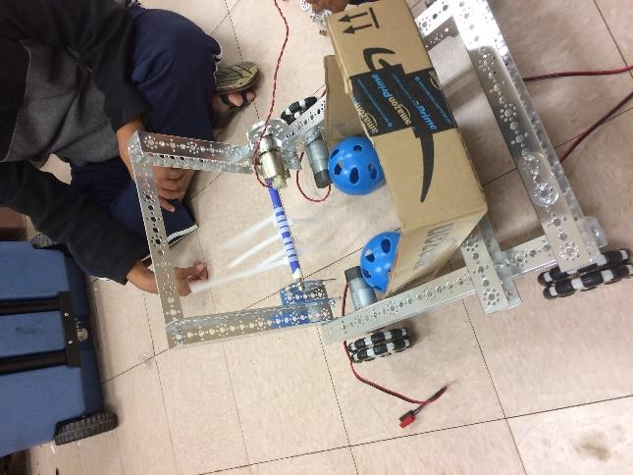

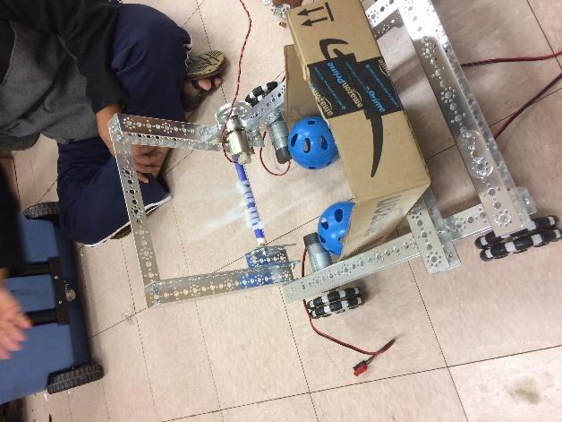

**Creo Drawings of our Robot during Pre-seaon, before and during league season**

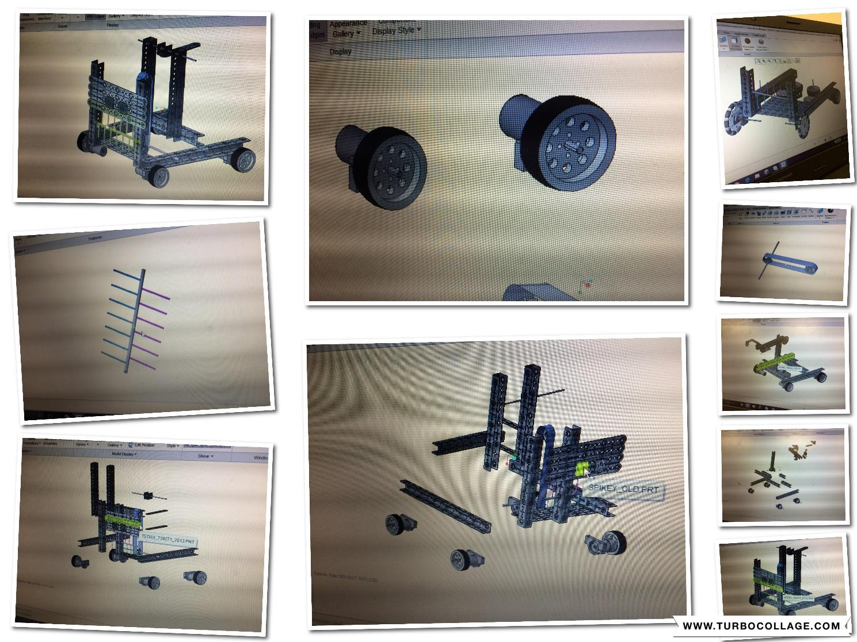

Building of the Robots:

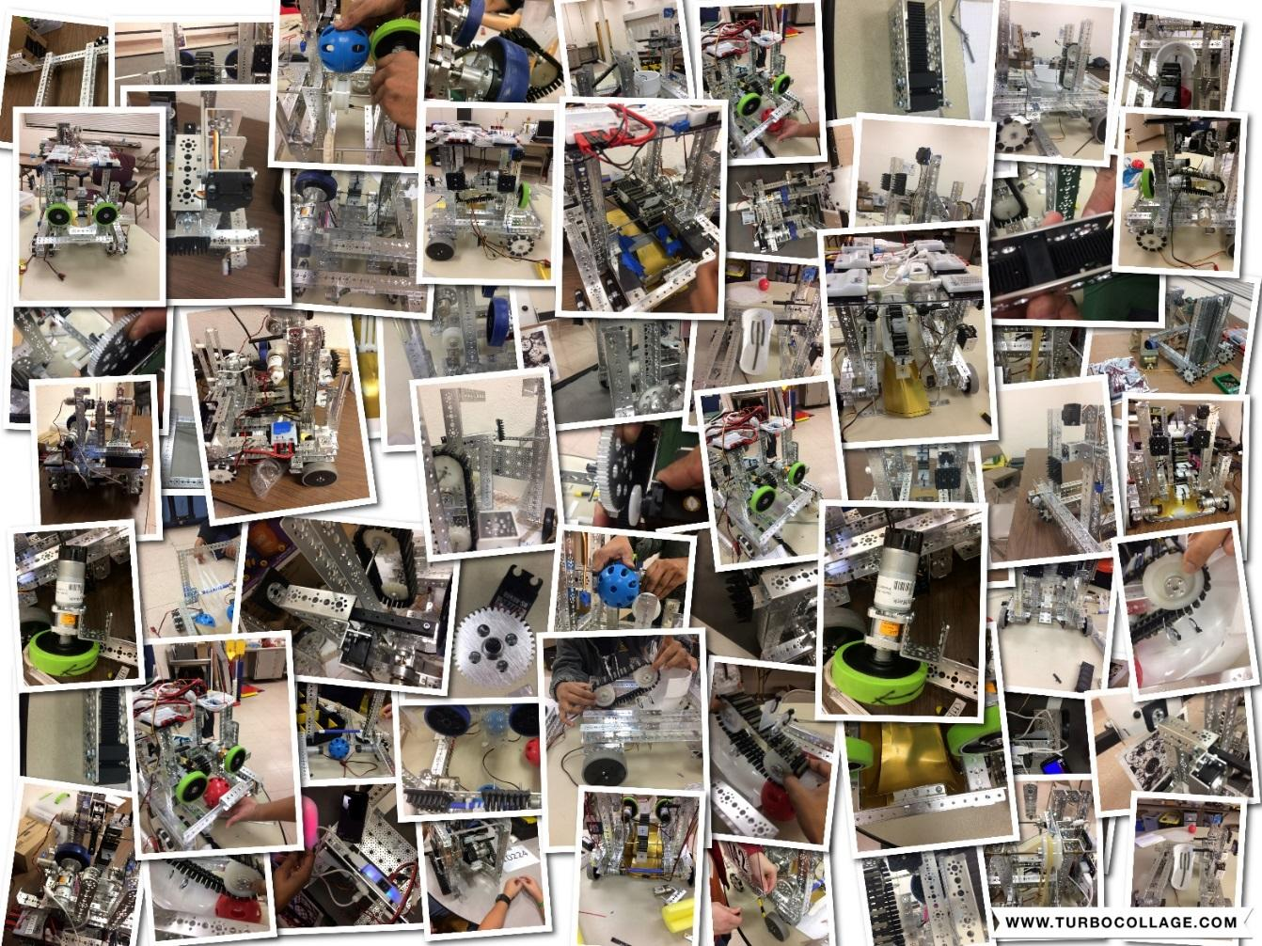

#### The Robot All Together

On the next page are pictures of the robot with all its components.

Pre-season:

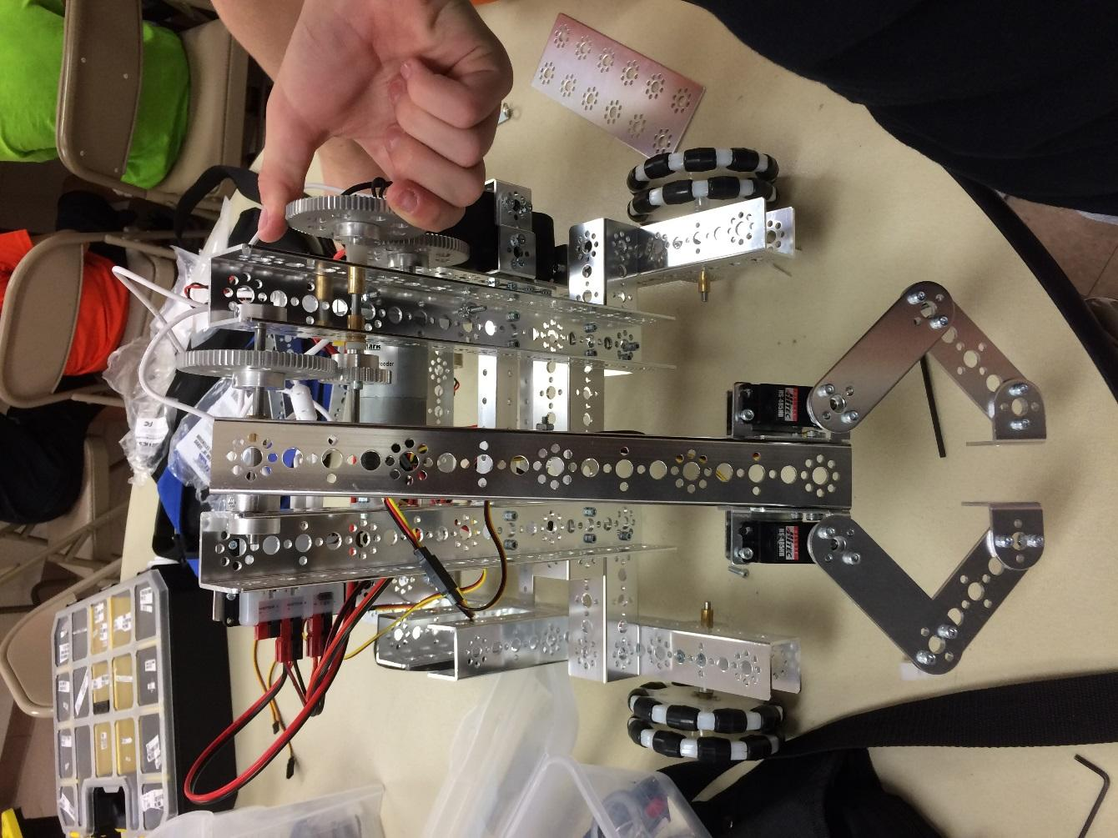

Scrimmage 1:

: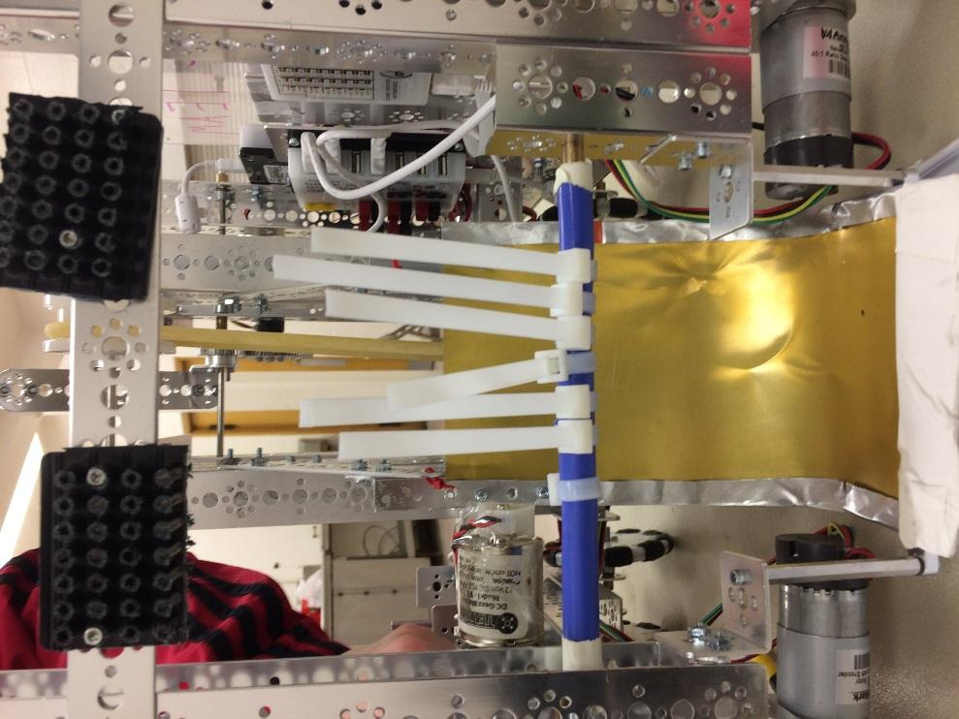

Scrimmage 2:

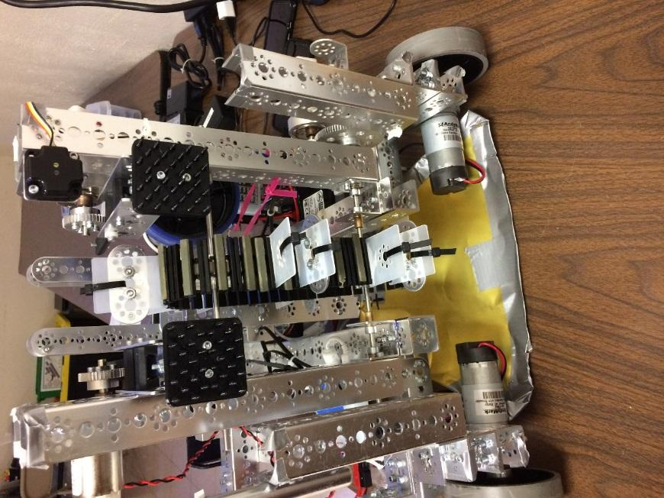

Scrimmage 3:

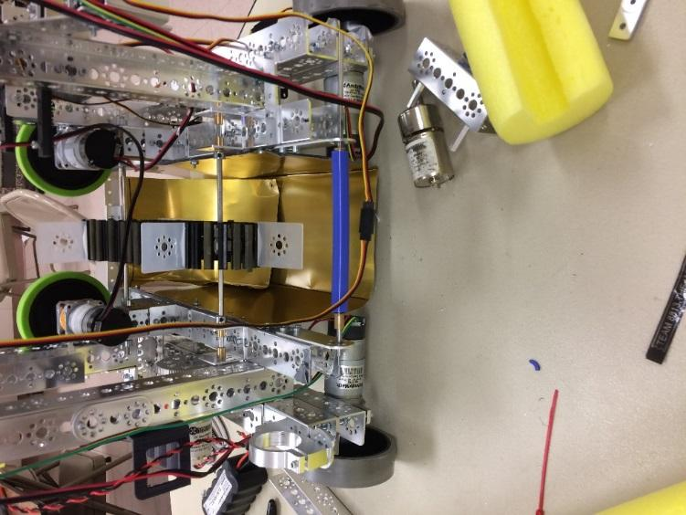

**Submitted by Vishnu**





# Programming: Autonomous &

**TeleOp**

#### [Programming Basics](#_zu0gcz) 155

* 1. [Finite State Machine](#_1yyy98l)

48.2 [Intelligent Motor Control](#_2olpkfy)

1. [**Autonomous**](#_2y3w247) **157**
2. **Control Award** **159**
3. [**Teleop**](#_2ce457m) 167

* 1. **Programming Basics**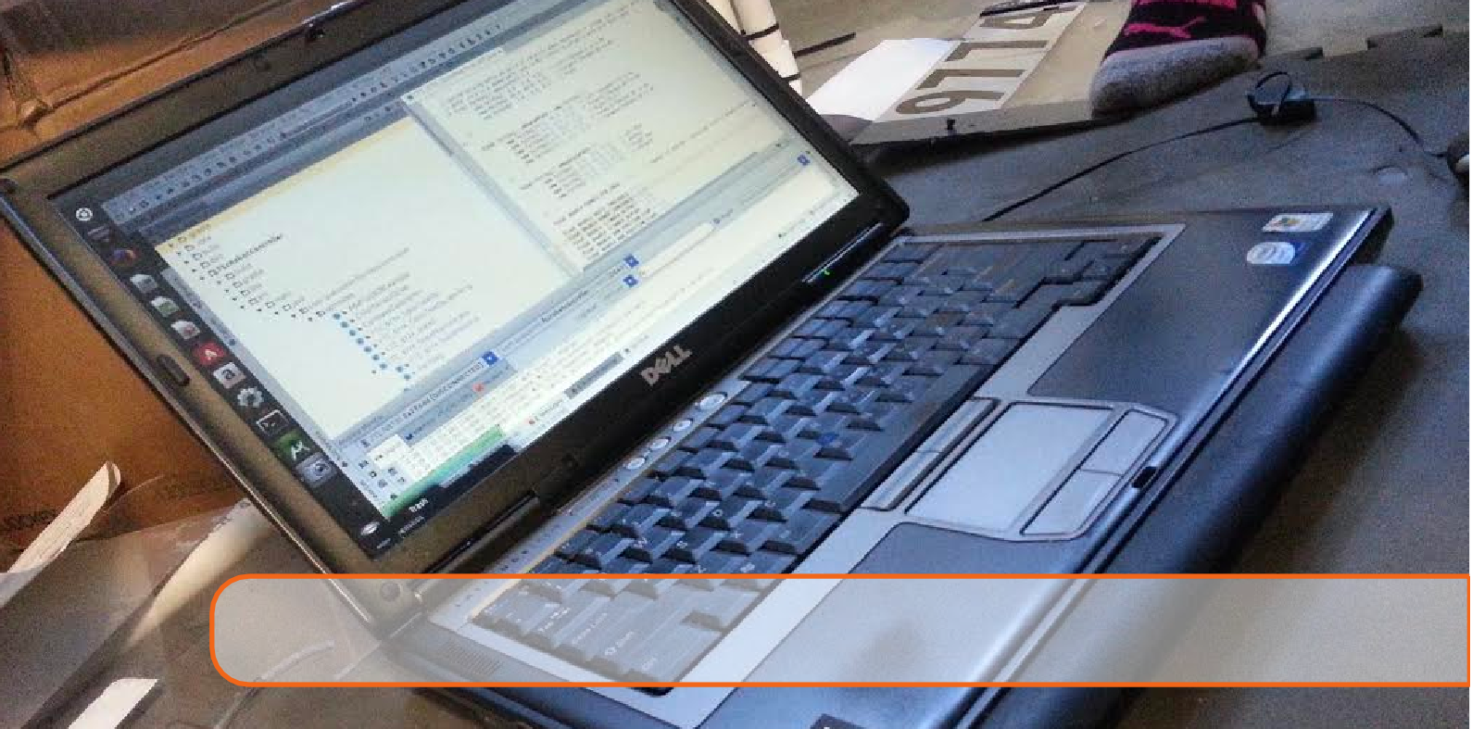

*Standard Naming Conventions*

We created a chart of standard naming conventions for the purpose that when programming and in the need of a name of a certain robot functioning part, it is a waste of time to keep going back to the part where all the parts are named. Instead, this chart will help us know what all the parts are named in the code with just knowing the standard rule of naming. Also, this comes in handy with robot configuration.

|  |  |
| --- | --- |
| Motors | m1... m2... |
| Servos | s1... s2... |
| *Touch Sensor* | *t1... t2...* |
| IR Seeker | ir1... ir2... |
| Color Sensor | cs1... cs2... |
| Optical Distance Sensor | od1... od2... |

*Autonomous Mode Strategies*

As soon as we heard the game announcement, we all had ideas for the autonomous, we all pitched in ideas and that’s what lead us to our fantastic autonomous today, if you look more below, you

will see our autonomous strategy.

*FTC Robot check*

During our time testing and connections was sometimes a big issue, we encountered error messages, unexpected interruptions and sensor or motor failure at random times, we had no way to figure out what was going on until we had found a FTC Robot Checker in which it would go through your whole robot and tell you what exactly was going wrong, this helped a lot and it made things go a whole lot faster.

*FTC forums*

When we had received something that we had issues with we usually went to the forums which helped a lot.

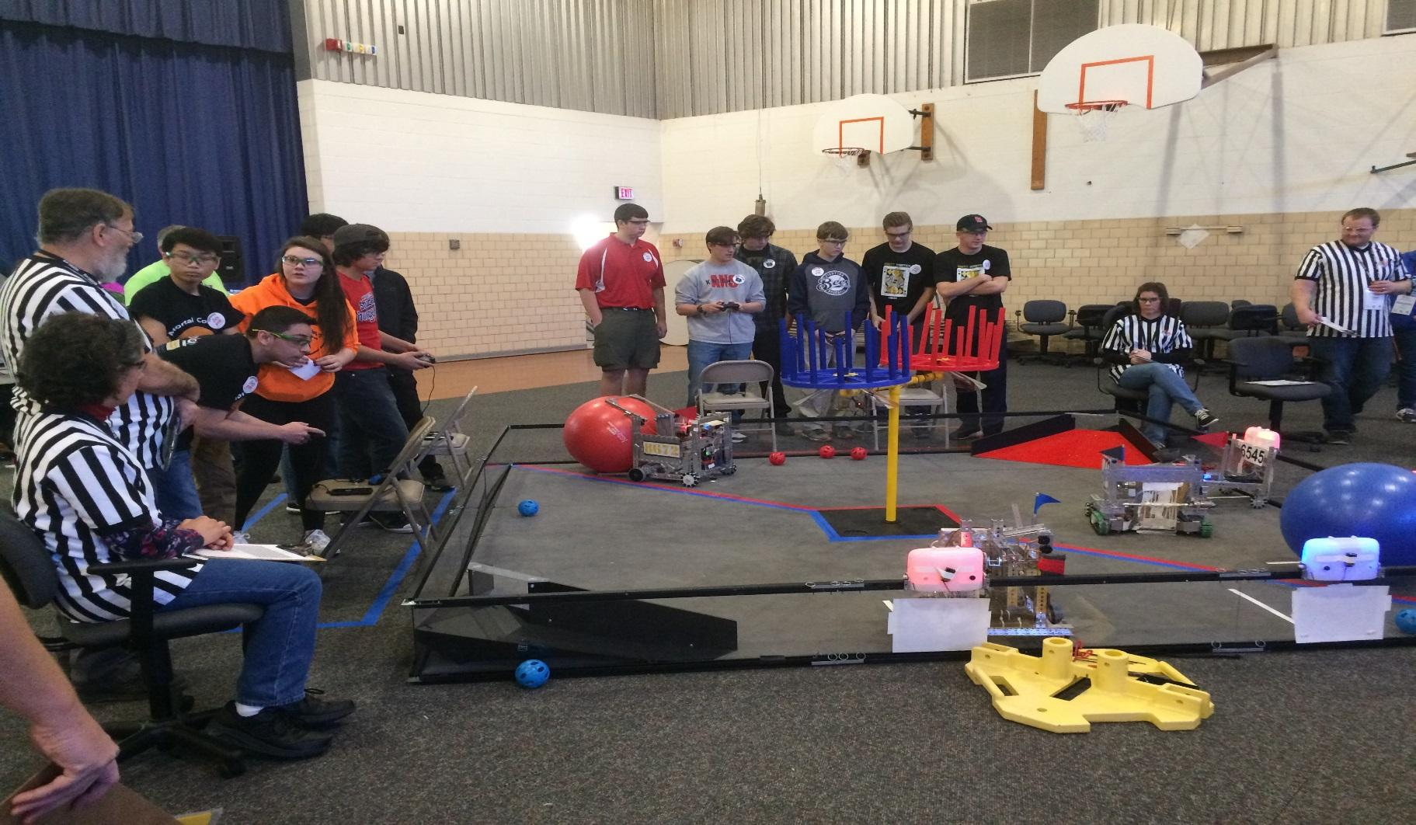

## Autonomous

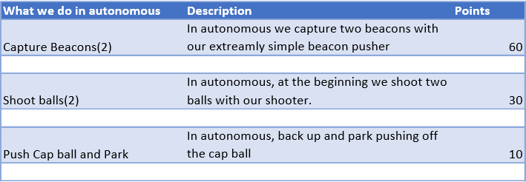

*Autonomous* is defined, by Game Manual II, as “a thirty second period in which the robots

operate and react only to sensor inputs and to commands pre-programmed by the Team onto the on-board Robot control system. Human control of the Robot is not permitted during this time."

*Explanation of Code*

Autonomous: In our autonomous, we move forward, shoot two balls, turn with our omni wheels, wait until white line is detected and proceed to capture both beacons ending the autonomous.

Driving Period: In our driving period, we really took use of our omni wheels, as they help so much for taking beacons during the full two minutes and thirty seconds of driving period. Our main point earners during driving period are capturing beacons, and holding them for the rest of the game

End game: In end game we have a cap ball lifter in which the cap ball will be lifted above the middle center vortex and put in the center.

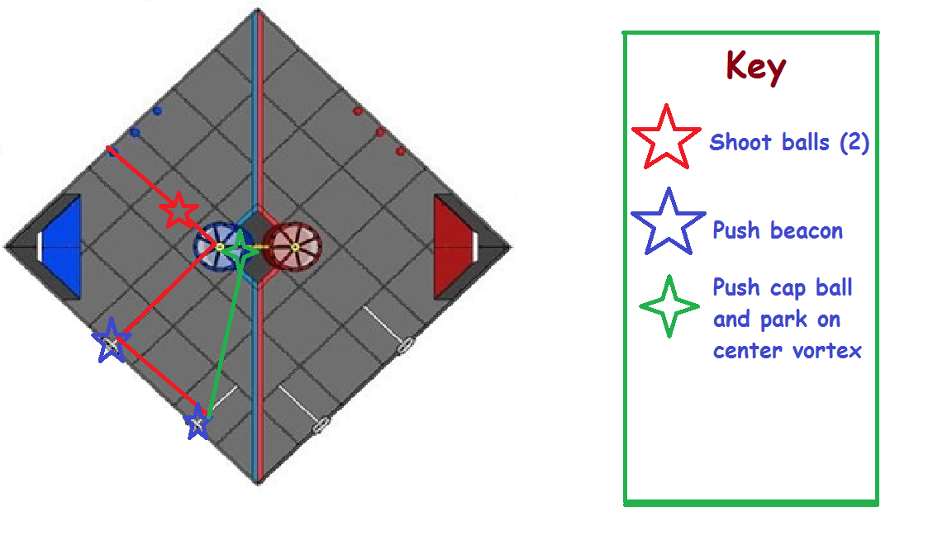

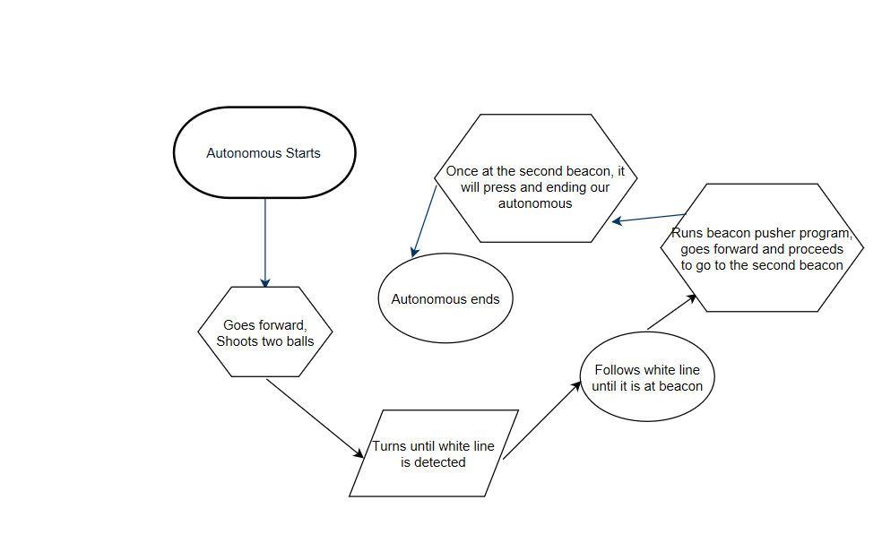



|  |  |
| --- | --- |
| **Team # 11142** | **Team Name: RoboMinions Rebooted** |

**Autonomous objectives**: In our autonomous our main goals are to shoot two balls, capture two beacons, and hitting the center cap ball off the center vortex and parking on the center, ending our autonomous with a guaranteed 100 points.

**Sensors used:** The sensors we have used for our robot are as follows:

* Optical distance sensor - Sensing the line and following
* Color sensor – Mainly used for our beacon pusher program.

**Key algorithms:** The most important algorithms we used, are the driving program algorithm, this is one of the most important algorithms because we needed to control all 4 wheels and be capable to strafe right of left for capturing and holding beacons. Our second most important algorithms we used is the beacon pusher program that works every single time.

**Driver controlled enhancements:** Our driver controlled enhancements is a driving 2.0 with the omni wheels we had received, in which we go in any direction with a very simple joystick movement. We also made a joystick which controlled the servo arms in driving period.

**Engineering notebook references:** Page 157 (Autonomous Section)

**Autonomous program diagrams:**





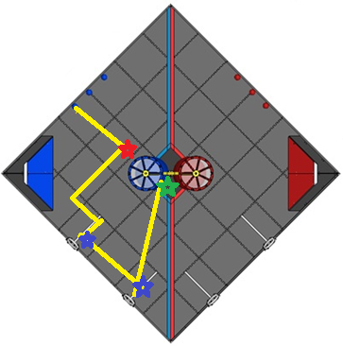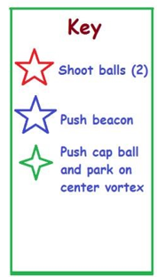

*Gracious Professionalism*® - “Doing your best work while treating others with respect and **kindness** - It’s what makes *FIRST*, first.”



**Autonomous Code: (Blue Autonomous)**

**package org.firstinspires.ftc.teamcode;**

**import com.qualcomm.robotcore.eventloop.opmode.LinearOpMode;**

**import com.qualcomm.robotcore.eventloop.opmode.TeleOp;**

**import com.qualcomm.robotcore.hardware.ColorSensor;**

**import com.qualcomm.robotcore.hardware.DcMotor;**

**import com.qualcomm.robotcore.hardware.DcMotorSimple;**

**import com.qualcomm.robotcore.hardware.OpticalDistanceSensor;**

**import com.qualcomm.robotcore.hardware.Servo;**

**import com.qualcomm.robotcore.hardware.TouchSensor;**

**@TeleOp(name="Blue Autonomous")**

**public class BlueAutonomous extends LinearOpMode {**

**DcMotor rightMotor;**

**DcMotor leftMotor;**

**DcMotor motorbackLeft;**

**DcMotor mototrbackRight;**

**DcMotor con;**

**DcMotor Ball;**

**Servo arm1;**

**Servo arm2;**

**TouchSensor ts;**

**Servo arm3;**

**ColorSensor colorSensor;**

**OpticalDistanceSensor ods1;**

**OpticalDistanceSensor ods2;**

**@Override**

**public void runOpMode() throws InterruptedException {**

**arm1 = hardwareMap.servo.get("arm1");**

**arm2 = hardwareMap.servo.get("arm2");**

**rightMotor = hardwareMap.dcMotor.get("motor\_right");**

**leftMotor = hardwareMap.dcMotor.get("motor\_left");**

**leftMotor.setDirection(DcMotor.Direction.REVERSE);**

**motorbackLeft = hardwareMap.dcMotor.get("motor\_backleft");**

**motorbackLeft.setDirection(DcMotorSimple.Direction.REVERSE);**

**mototrbackRight = hardwareMap.dcMotor.get("motor\_backright");**

**Ball = hardwareMap.dcMotor.get("shoot");**

**colorSensor = hardwareMap.colorSensor.get("sensor\_color");**

**ods1 = hardwareMap.opticalDistanceSensor.get("ods1");**

**ods2 = hardwareMap.opticalDistanceSensor.get("ods2");**

**ts = hardwareMap.touchSensor.get("ts");**

**arm3 = hardwareMap.servo.get("arm3");**

**colorSensor.enableLed(false);**

**arm1.setDirection(Servo.Direction.REVERSE);**

**arm2.setDirection(Servo.Direction.REVERSE);**

**arm1.setPosition(0);**

**arm2.setPosition(0);**

**rightMotor.setPower(0);**

**leftMotor.setPower(0);**

**waitForStart();**

**moveForward(2800, 0.1);**

**shoot(1000);**

**moveForward(700, 0.1);**

**arm3.setPosition(1);**

**moveRight(2500, 0.3);**

**moveforwardWithODSCheck(0.08);**

**moverightuntilPressed(0.25);**

**BeaconPusher();**

**moveLeft(480, 0.25);**

**turnLeft(150);**

**moveForward(600, 0.1);**

**moveforwardWithODSCheck(0.08);**

**moverightuntilPressed(0.25);**

**BeaconPusher();**

**moveLeft(600, .25);**

**turnLeft(1000);**

**moveForward(700, 0.3);**

**}**

**private void updateTelemetryStatus() {**

**telemetry.addData("ODS Raw", ods2.getRawLightDetected());**

**telemetry.addData("ODS ", ods2.getLightDetected());**

**telemetry.addData("ODS Raw 1 ", ods1.getRawLightDetected());**

**telemetry.addData("Color sensor red", colorSensor.red());**

**telemetry.addData("Color sensor blue", colorSensor.blue());**

**telemetry.update();**

**sleep(1000);**

**}**

**public void BeaconPusher() {**

**telemetry.addData("Blue Color", colorSensor.blue());**

**telemetry.addData("Red Color", colorSensor.red());**

**telemetry.update();**

**sleep(500);**

**if (colorSensor.blue() > 10) {**

**arm2.setPosition(1);**

**sleep(1000);**

**arm2.setPosition(0);**

**sleep(1000);**

**} else {**

**arm1.setPosition(1);**

**sleep(1000);**

**arm1.setPosition(0);**

**sleep(1000);**

**}**

**}**

**public void moveForward(int i, double power) {**

**leftMotor.setPower(-power);**

**rightMotor.setPower(-power);**

**mototrbackRight.setPower(-power);**

**motorbackLeft.setPower(-power);**

**sleep(i);**

**stop(100);**

**}**

**public void moveforwardWithODSCheck(double power) {**

**int i = 0;**

**while (i < 10000 && opModeIsActive()) {**

**if (ods2.getRawLightDetected() >= 2.4 || ods1.getRawLightDetected() >= 2.4) {**

**break;**

**} else {**

**leftMotor.setPower(-power);**

**rightMotor.setPower(-power);**

**mototrbackRight.setPower(-power);**

**motorbackLeft.setPower(-power);**

**sleep(1);**

**}**

**i++;**

**}**

**stop(1000);**

**telemetry.addData("Raw ODS Light ", ods2.getRawLightDetected());**

**telemetry.addData("ODS Light ", ods2.getLightDetected());**

**telemetry.update();**

**sleep(2000);**

**}**

**public void stop(int time){**

**leftMotor.setPower(0);**

**rightMotor.setPower(0);**

**mototrbackRight.setPower(0);**

**motorbackLeft.setPower(0);**

**sleep(time);**

**}**

**public void moveRight(int i, double power) {**

**rightMotor.setPower(power);**

**mototrbackRight.setPower(-power);**

**leftMotor.setPower(-power);**

**motorbackLeft.setPower(power);**

**sleep(i);**

**stop(100);**

**}**

**public void moveLeft(int i, double power) {**

**rightMotor.setPower(-power);**

**mototrbackRight.setPower(power);**

**leftMotor.setPower(power);**

**motorbackLeft.setPower(-power);**

**sleep(i);**

**stop(100);**

**}**

**public void turnLeft(int i) {**

**rightMotor.setPower(-0.3);**

**mototrbackRight.setPower(-0.3);**

**leftMotor.setPower(0);**

**motorbackLeft.setPower(0);**

**sleep(i);**

**}**

**public void shoot(int i) {**

**Ball.setPower(1);**

**sleep(i);**

**telemetry.addData("Shooting ", "");**

**telemetry.update();**

**sleep(1000);**

**Ball.setPower(0);**

**sleep(100);**

**}**

**public void moverightuntilPressed(double power) {**

**boolean tspressed = false;**

**while (!ts.isPressed() && opModeIsActive()) {**

**rightMotor.setPower(power);**

**mototrbackRight.setPower(-power);**

**leftMotor.setPower(-power);**

**motorbackLeft.setPower(power);**

**/\* if (ts.isPressed()) {**

**tspressed = true;**

**}\*/**

**telemetry.addData("Touch Sensor ", ts.isPressed());**

**telemetry.update();**

**sleep(1000);**

**}**

**stop(100);**

**telemetry.addData("Touch Sensor ", ts.isPressed());**

**telemetry.update();**

**sleep(1000);**

**}**

**}**

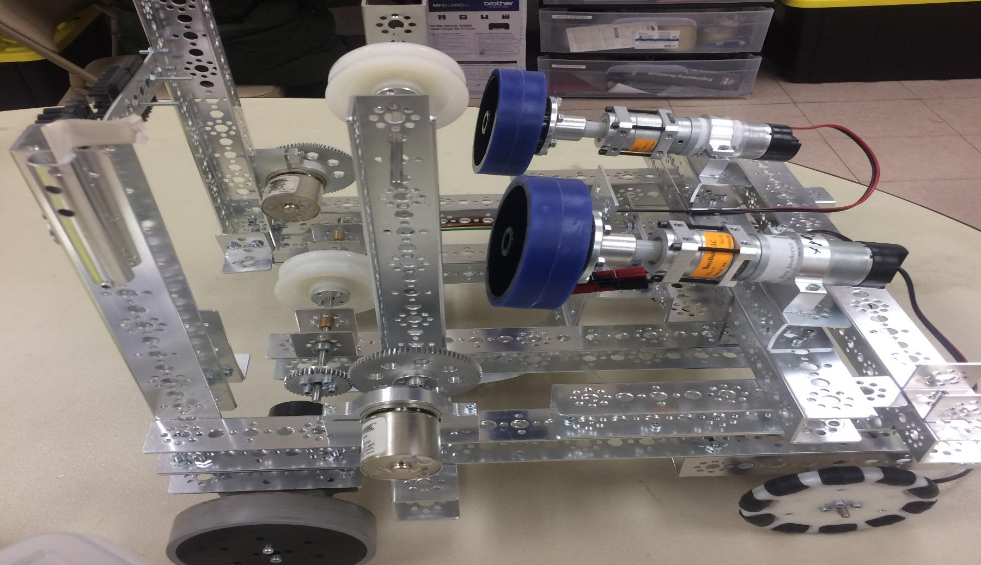

## Teleop

Teleop is a mode of programming which is utilized during the Driver-Controlled Period. It controls the gamepads and requires manual handling unlike autonomous. Driver-Controlled Period is defined, by the second game manual, as "The two minute time period in which the Drivers operate the Robots."

*Explanation of Code*.

*In our driving program, we used a collection of different functions such as servos, omni wheels, color*

*Sensor detection and those things really helped in our driving period. We have very simple controls*

*Which make the robot extremely simple to control.*

*Gamepad One*

Our programming team decided to use a two-joystick drive

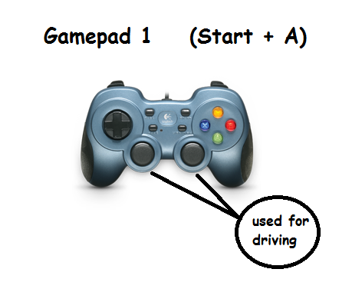

drive because it made our robot more comfortable and easier to control. We liked how the driving felt and it really made the whole process of driving simple. We have two driving modes, forward and normal turning and strafing made possible with our omni wheels.

*Gamepad Two*

*On this gamepad we used it for servo positions, since that was a main point scorer on our team, we really worked on how the servo positions work.*

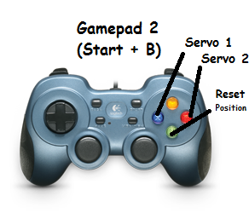



# XRoboMinions: Business Plan

#### [Executive Summary](#_13qzunr) 171

* 1. [Team](#_4anzqyu)
  2. [Connections](#_3oy7u29)
  3. [Outreach and Services Rendered](#_338fx5o)
  4. [Business Analysis](#_42ddq1a)

#### [Financial Statement](#_wnyagw) 180

#### [Strategy](#_1vsw3ci) 184

* 1. [Team Fundamentals & Conduct](#_2uxtw84)

1. [**Sustainability**](#_3nqndbk) **187**
   1. [Future Plan](#_3u2rp3q)
   2. [Expectations](#_odc9jc)
   3. [Training](#_1nia2ey)
   4. [Member Recruitment](#_2mn7vak)
   5. [Mentor Recruitment](#_3ls5o66)
   6. [Future Financial Plan](#_4kx3h1s)
   7. [Overleaf Template for FTC](#_1ulbmlt)

[**Index**](#_22vxnjd) **190**

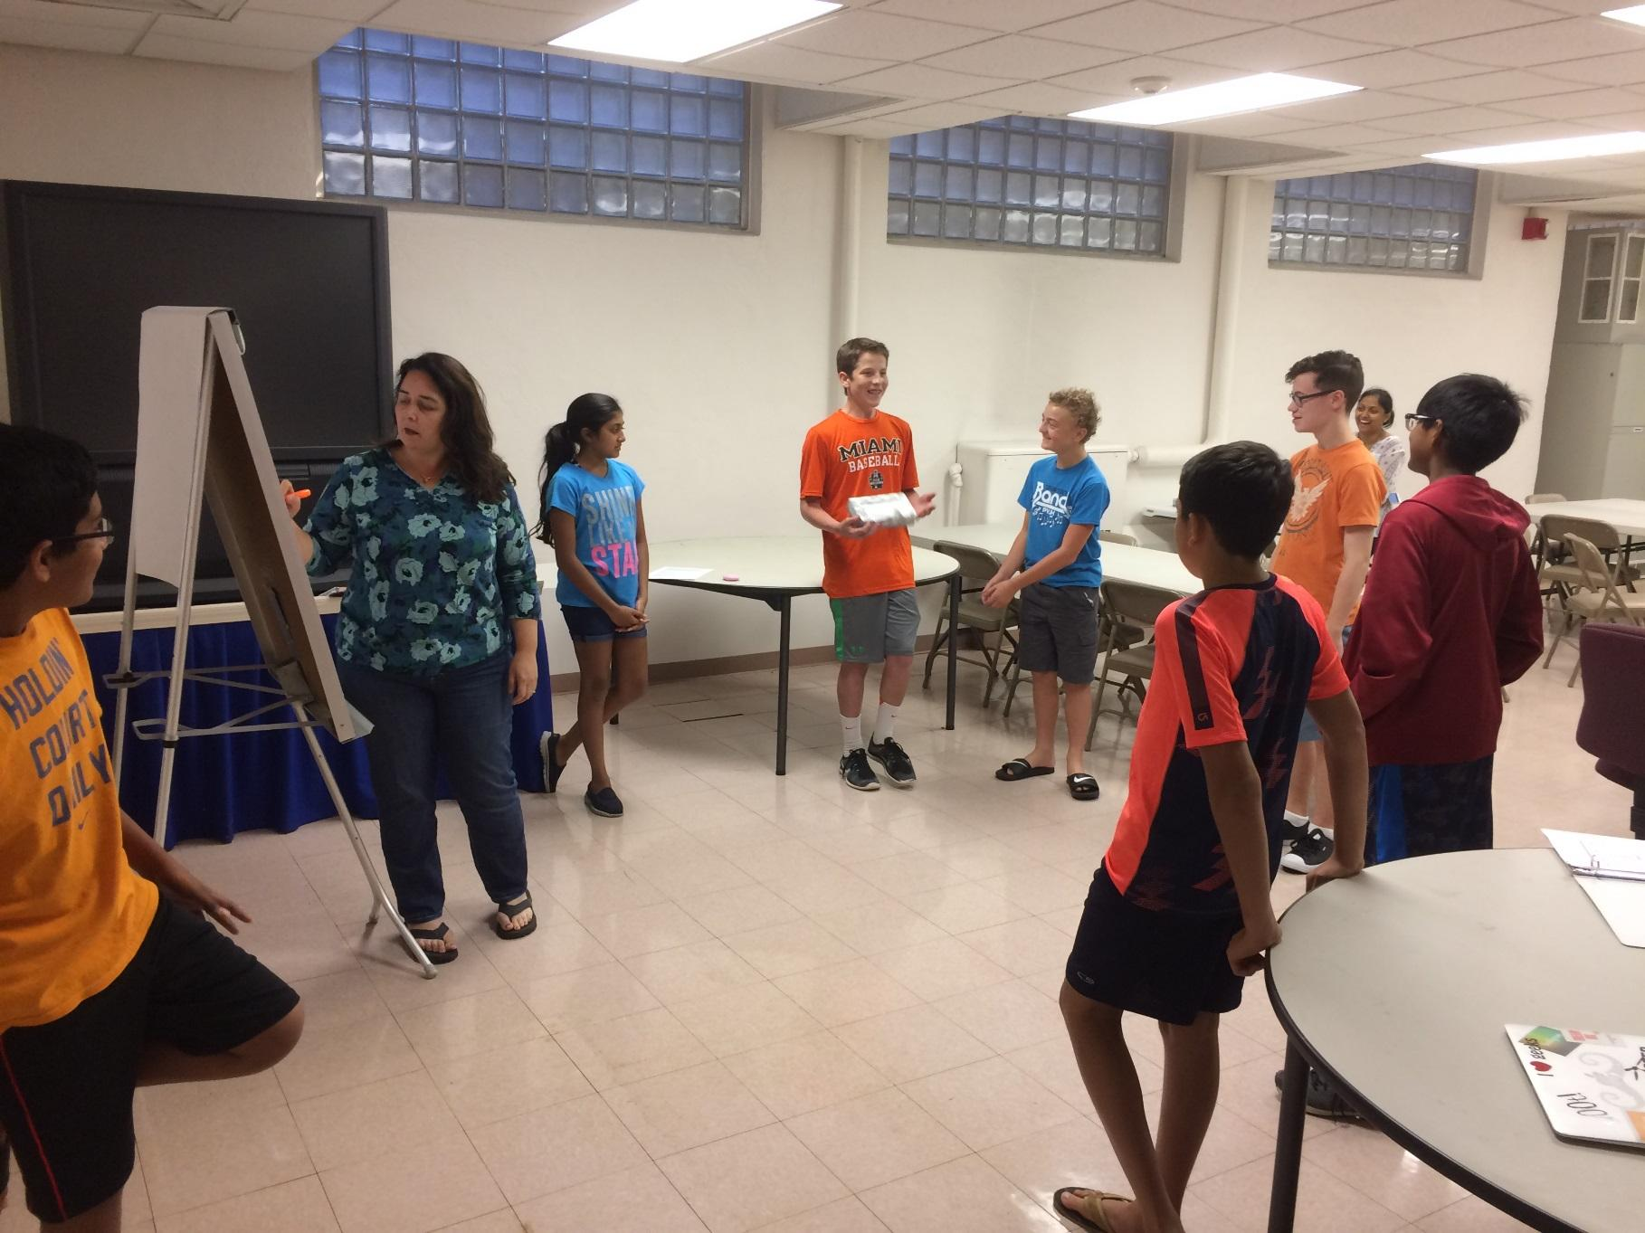

***Mission Statement***

The mission of the FTC team RoboMinions #11142 is to promote students to partake in science, technology, engineering, and mathematics (STEM) in aspiration for a brighter future. We hope our efforts inspire the younger generations to grow up knowing that they withhold the potential to create a better world through STEM.

#### Team

*Team Members*

|  |  |
| --- | --- |
| Max Broussalian | Uma Kasichainula |
| Tarun Vedula | Nikhil Ramaraju |
| Vishnu Challa | Jake Gneiting |
| Owen DeVore | Vinay Joshi |
| Ezra Lauritzson | Kyle Sehlin |

*Team Demographics*

Below are demographic pie charts of our team. As seen by the data, our team consists of

one girl and all boys. We hope that in upcoming years we can have a more diverse team and possibly consider opening up our team to girls. Grade is also something which is destined to happen. Almost all of our eight graders have said they will be continuing the next season of FTC with the RoboMinions.

*Major Milestones*

* September 10, 2016- FTC Kickoff and Game Release
* November 13, 2016- Meet #1
* December 17, 2016- Meet #2
* January 7, 2017-League Championship (Hosted by Winter Soldiers and RoboMinions Rebooted)

*Team Goals*

* Our main goal is to adhere to our mission statement, but our more specific goals are to:
* Continue promoting STEM in schools and in everything we do
* Create an outstanding robot
* Demonstrate Core Values everywhere

*Meeting Schedule*

FTC team meeting (all):

* + - Saturday 10:30am-11:30am

Outreach:

* + - Saturday 9:00am-10:30am

Programming:

* + - Thursday 6:30pm-8:00pm, Saturday 11:30am-12:30pm, Sunday 1:00pm-2:00pm

Design:

* Thursday 7:00pm-8:30pm, Saturday 9:00am-10:30am, Sunday 1:00pm-3:00pm



*Team Organization*

Our team is organized as follows. For the pre-season and early season time periods, we did not have defined divisions in specialties and sub-groups. As a rookie team, we had everyone do everything so all the members could have a taste of all the possible roles. Once league season began, each member considered their strengths and weaknesses and Decided on which groups would be the best to join. This system of organization has really helped us it has made all the experts in the groups put their heads together to form great ideas and creations.

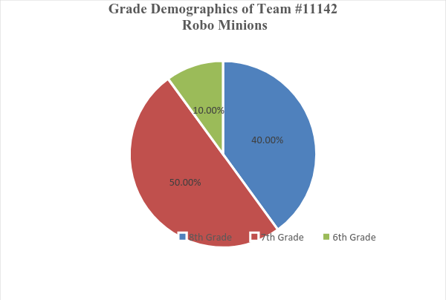

* 1. Connections 327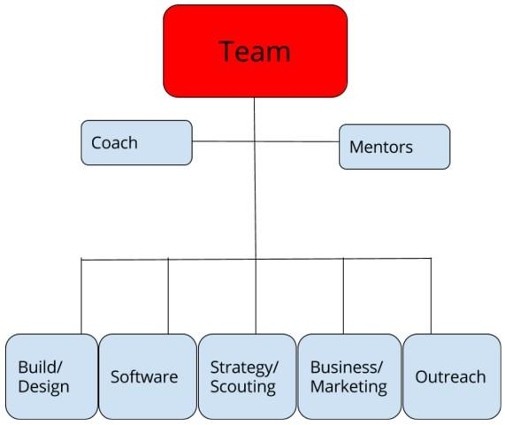

#### 66.2 Connections

*Affiliation*

We are run under and affiliated with QCESC (Quad City Engineering and Science Council) and they have given us everything we have ever needed for FTC. Being a non-profit organization all our funds come through QCESC and we manage our expenses. QCESC have also provided help for our senior team FTC team 8813 (Winter Soldiers). QCESC is in its 54th year of operation as a non-profit, umbrella organization representing ~20 engineering, science and technical societies in the Quad City area with approximately 3,000 associated professional members. Their Mission is "To Promote and support engineering, science, and technical professionals and associated societies in Quad City Region and To Encourage and support students to study in STEM (Science, Technology, Engineering, and Mathematics) related fields". QCESC help organizes Jr. FLL, FLL, FTC and FRC programs in Quad Cities. 

We sincerely thank Jeffery Richland, QCESC without his help out team would not have started.

**Chapter 66. Executive Summary**

***Sponsorship***

**John Deere** has always been a proud sponsor of the RoboMinions Rebooted since

Day one. They sponsor us by matching the amount give from an employee for a good cause. This is generically known as volunteer matching, and for Deere, is termed Dollar for Doers. We have few parents on our team whom work for or have worked for Deere, so the company is always more than happy to help us out. We thank them for all they have done for us, we truly appreciate it more than we can express.  Our mentors also work at John Deere. The company plays a key role in STEM activities in Quad cities. They also sponsor for Jr. Fll, FLL, FTC and FRC teams in all the locations where John Deere establishments are situated. Besides United States, John Deere sponsors First Teams in India, Brazil and Mexico.

**PTC** has also always been a proud sponsor of the RoboMinions Rebooted. The have been a huge sponsor to our affiliate, FIRST, therefore making them a positive and helpful sponsor of our team as well. We are grateful that they have joined the cause for spreading science, technology, engineering, and mathematics to worldwide. We cannot allow their support to go unnoticed. We cannot wait to return all the favors they have done for us. PTC   is a global technology provider of the leading IoT and AR platform and field-proven solutions transform how companies create, operate, and service products.

**Cobham** have given us financial support by giving us a donations. Their financial support has allowed us to purchase robot parts, outreach materials, and all sorts of other things for FTC. We are grateful for fulfilling all our materialistic needs. Cobham is a leading global technology and services innovator, respected for providing solutions to the most challenging problems, from deep space to the depths of the ocean.



**Airwolf3D** is known for their very innovative product: 3D Printers manufacturing.  They helped with repairing our 3D printer which was donated by John Deere to our FRC team 648. Axiom 3D din ’t charge for the Nozzle repairs and are very much committed helping STEM activities in future. We are hoping that they support and sponsor our team next year.



**Icon Charities** has also always been a proud sponsor of the RoboMinions Rebooted Since day one. They have price matched all of our donations.  They also help us in providing resources in promoting STEM activities Internationally (India). ICON Charities functions as a platform where the values and aspirations of caring and compassionate donors translate into tangible benefits for the poor and needy in our society. Their aim is to provide an open and honest environment where the willing donor gets connected with the deserving beneficiary.



**ALCOA** has also always been a proud sponsor of the RoboMinions Rebooted.  The have been a huge sponsor to our affiliate, FIRST, therefore making them a positive and helpful sponsor of our team as well. Besides sponsoring our team they are also providing their learning center to be used as our meeting space to put our Parts, Game setup and use of their Auditorium for hosting the Scrimmages.  Alcoa has been synonymous with operational excellence and leadership in the production of Bauxite, Alumina and Aluminum products. They invented the aluminum industry in 1888 and   continue to innovate with new technologies and processes.

**Yash technology** Inc have given us financial support by giving us a donations. Their financial support has allowed us to purchase robot parts, outreach materials, and all sorts of other things for FTC.  Yash Technology is a leading Quad City based Global IT Service provider supporting clients globally. They have office all over the world and are a strong supporter for STEM activities. 

**R3 services** have given us financial support by giving us a donations. Their financial support has allowed us to purchase Laptop, outreach materials, and all sorts of other things for FTC. R3 services is a global business of worldwide experiences, and   provide customized destination experiences that exceed all expectations.

**ColoHub** is also always been a proud sponsor of the RoboMinions Rebooted. The have been a huge sponsor to our affiliate, FIRST, therefore making them a positive and helpful sponsor of our team as well. Besides sponsoring our team they help in creating images for our team. ColoHub mission is to provide high quality telecommunications and associated products and services using advanced technology supported by exceptional customer service at just and reasonable prices for the mutual benefit of shareholders, customers, employees, and the community.

**Mid-American Energy** is a leading provider of Electricity in Midwest. They have started funding for STEM activities and have been a sponsor of our team.

***Facilities & Locations***

* + **Alcoa Learning Center** - Bettendorf, IA
  + Alcoa provided space in their learning center building to put our tools and the velocity vertex field setup. The Learning Center have conference rooms, tables, chairs etc.
  + **R3 Inc**, Bettendorf, IA – R3 Inc have given us a Projector & Van for transportation during scrimmage meets.
  + **FRC team 648** – FRC team 648 is also located in the same building and they helped us to use their tools and Equipment for our needs. Besides the tool room they allowed to use the 3D printer donated by John Deere to their team.

#### Outreach and Services Rendered

Below is a list of our completed/projected Outreach tasks. Completed projects are marked with an \*

* Girls on the Run Event Volunteering \*
* Scrimmage for FLL teams to prepare them for the Regional Tournament \*
* FLL Mentoring at local schools \*
* Jr. FLL Mentoring at Local Schools \*
* Providing STEM Education to kids in India using Raspberry Pi.

#### Business Analysis

#### SWOT Analysis:

#### What is SWOT? Abbreviation for Strengths, Weaknesses, Opportunities, and Threats: an analysis of a product made before it is marketed.

#### ~From [www.thefreedictionary.com/swot](http://www.thefreedictionary.com/swot)

#### In this case, we use this to determine our next steps as a team. We want to accept our weaknesses as a team and work with them to turn them into strengths. This is our first analysis as a team and it influenced our goals and objectives for the year.

#### 

*Social Media*

Social media is key in our campaign to spread robotics and STEM throughout the world. These serve to keep the community updated about our event schedule and build season.



Twitter: FTC Team 11132 @Robo\_Minions\_2



Included below are screenshots of our accounting records.

Note that with the income record log, the money under RoboMinions funding is a summation of all donations and profit achieved from fundraising.

|  |  |  |
| --- | --- | --- |
| **Income** | | |
| **Item** | **Sponsors** | Donation |
| 1 | Alcoa | $1,000 |
| 2 | Colohub | $200 |
| 3 | R3 Services | $500 |
| 4 | Yash Technologies | $250 |
| 5 | PTC | $1,000 |
| $6 | Cobham | $500 |
|  |  |  |
|  | Total | $3,450 |



**Expenses:**

|  |  |  |
| --- | --- | --- |
| Item | Date | Amount |
| Amazon | 17-Oct | $30.00 |
| Amazon | 22-Sep | $29.99 |
| Amazon | 14-Oct | $33.76 |
| Amazon | 1-Aug | $32.36 |
| Andy Mark | 17-Oct | $214.79 |
| Andy Mark | 24-Oct | $136.66 |
| Andy Mark | 9-Sep | $701.38 |
| FTC Registration IA | 8-Sep | $225.00 |
| Mc Master Carr | 31-Oct | $65.22 |
| Modern robotics | 1-Nov | $16.85 |
| Servo city parts | 19-Sep | $214.51 |
| Servo city parts | 17-Oct | $57.05 |
| Pitsco | 21-Sep | $279.44 |
| Pitsco | 19-Oct | $218.20 |
| Local Bills\_1 |  | $23.79 |
| Local Bills\_2 |  | $81.36 |
| Local Bills\_3 |  | $13.84 |
| Local Bills\_4 |  | $15.18 |
| Beanbots | 5-Dec | $36.95 |
| Andy mark | 29-Nov | $41.44 |
| Andy mark | 22-Nov | $32.44 |
| Pitsco | 13-Dec | $85.16 |
| Microsoft Store | 20-Dec | $401.74 |
| Modern Robotics | 19-Dec | $59.70 |
| Amazon | 19-Dec | $116.02 |
| Andy Mark | 9-Jan | $236.34 |
| Total |  | $3,399.17 |

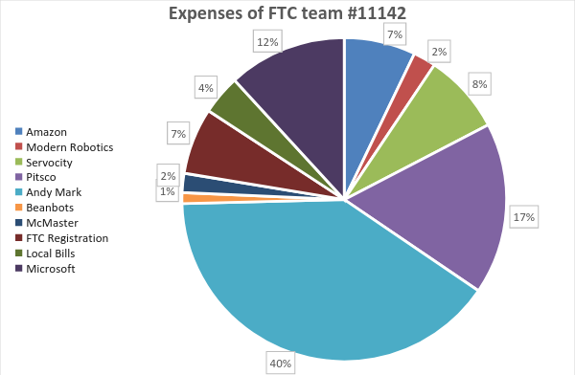

35



The RoboMinions is a large team, with ten team members with different perspectives on every detail. We try to use that to our advantage. There are so many of us that mistakes always get noticed. When we start brainstorming we narrow down to the problem and focus on a solution for it we all give our thoughts on what the solution may be. When we all decide on one or many solutions combined we draw and present the solution to the team. From the visual image we are able to start a prototype. The prototype is tested and worked on by the programming, build and CAD divisions. The prototype is refined and worked on until it is consistent and coordinated with the other components. The product never really becomes a final product. It is added onto and modified till the very end.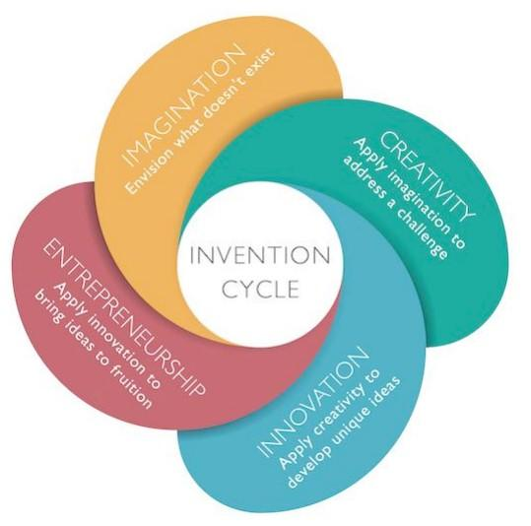

#### Team Fundamentals & Conduct

*Team Strategies*

|  |  |
| --- | --- |
| 1 | Develop a diverse and strong team |
| 2 | Gain knowledge by research and experimentation and mistakes |
| 3 | Develop strong leadership skills |
| 4 | Develop excellent team financial plans and sponsor relationships |
| 5 | Spread the word about FIRST and STEM |
| 6 | Continue to prepare for the future and upcoming seasons |

*Communication*

Communication within the team is accomplished with team meetings, sub-team meetings, email blasts, and member-to-member communication. We used Google Hangout as a Way to communicate meetings, deadlines, Tournament details etc.

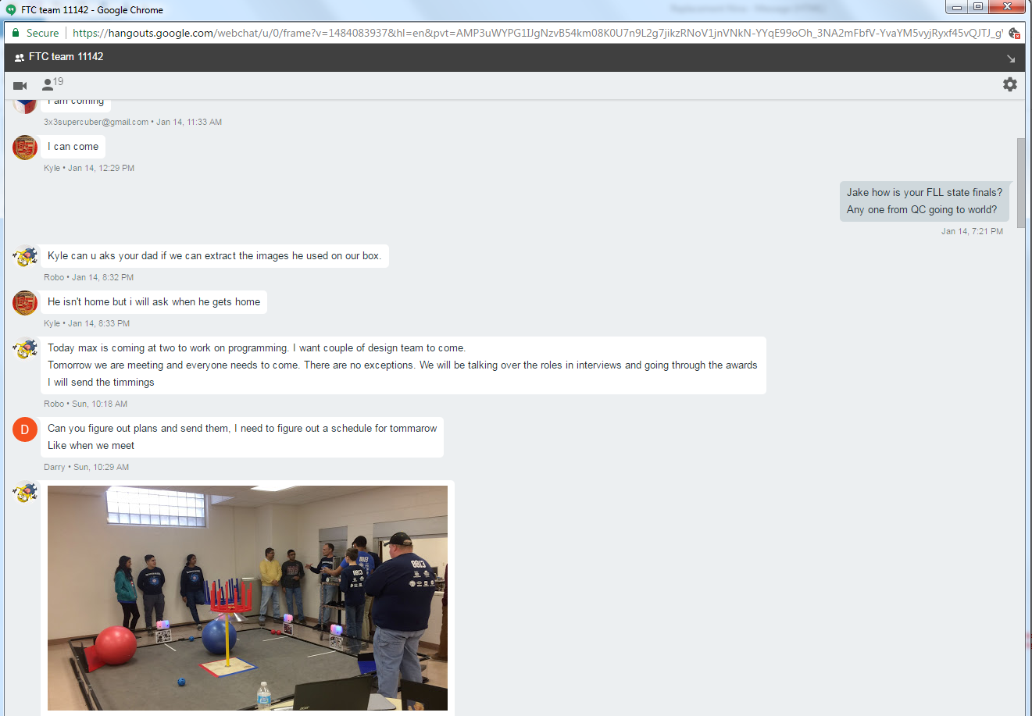

68.1 Team Fundamentals & Conduct 339

*Project Management*

Good project management is crucial to the success of our FIRST team. We have done good project management in Outreach but lacks in other areas for Programming and Design. Our goal next year is to make sure we follow the Outreach process and implement the same for Design and Programming. We did very well in Project management till the Pre-season.



#### Future Plan

Being a part of RoboMinions, we aspire to be able to spark an interest and increase the participation of STEM. Our mission is to promote Science, Technology, Engineering and Math in people everywhere and inspire them to become a part of the FIRST experience so that together we can show that everyone is fully capable of participating and enjoying robotics! We continue to do this throughout the non-FTC season.

|  |  |  |  |
| --- | --- | --- | --- |
| Strategy | Actions | Responsibility | Planned Completion |
| Expand the FIRST program | Reach out to local elementary and middle schools to introduce students and faculty to US FIRST | Team and Mentors | Spring 2017 |
| Recruit new team members | Host informational meetings at the local libraries | Team and Mentors | Summer 2017 |
| Robotics Camp (FTC & FLL) | * Develop budget * investigate Locations to hold camp * Develop plan to recruit campers * Develop schedule of activities | Team and Mentors | Summer 2017 |

#### Expectations

With fun comes rules and our main rules revolve around member behavior and safety. We expect all members to arrive on time to large events, competitions, matches, and major Meetings. Of course there are exceptions, but we encourage our members to try their best to attend as many meetings as possible. We always encourage members with schedule. Conflicts to come early to the next meeting that they can attend and catch up on what they missed. It is also beneficial that subgroups have regular meetings and communications with each other separate from whole group meetings. Regular updates on progress are required. Our team expects the sub-team to conduct their meetings orderly and intelligently. Grades are not a large concern for us, as we are a FTC team in which all of the members are from the same junior high. Every member of the RoboMinions Rebooted is a hardworking and dedicated individual- we really do not have to worry about their school activities. Participation is key in this team and practically all other teams.

#### Training

We make sure that EVERY team member gets a feel for everything. That way when older member graduate out them won’t have trouble filling in for other roles. We are also considering setting up off-season camps and workshops for new members so they can get an introductory taste of FTC.

#### Member Recruitment

For us, anyone, either a girl or a boy, with the drive and interest in STEM is all we need. New team members do not really need to know everything about FIRST, after all this is a Learning experience for everyone. We need commitment from the Member who wants to join our team.

#### Mentor Recruitment

We are here to learn as much as we can. Any mentor that has experience has can teach us well we do. We are always on the lookout for new mentor during outreaches and fundraising. We have a lot of mentors who are experts in their field who help us continuously. We are very grateful for the help they have given.

#### Future Financial Plan

We plan that with our upcoming years of FIRST, we shall carry forth whatever money is left over. That is what we have been doing for the next year. We also order new parts after the previous season is over in preparation of the next season. Our registration system is also to complete it as soon as possible. We are usually the first teams to finish registration. Also we are confident our Sponsors this year will continue supporting us for next year also. Some of our Sponsors are asking us as how they could help to get more kids take advantage of this programs.

